Label each of the structures in the cell shown.
Year 8 Exam Revision Name:
Control centre of cell.

Controls what goes into and out of the cell
Contains green pigment called chlorophyll
Storage organelle

Provides cell with a support

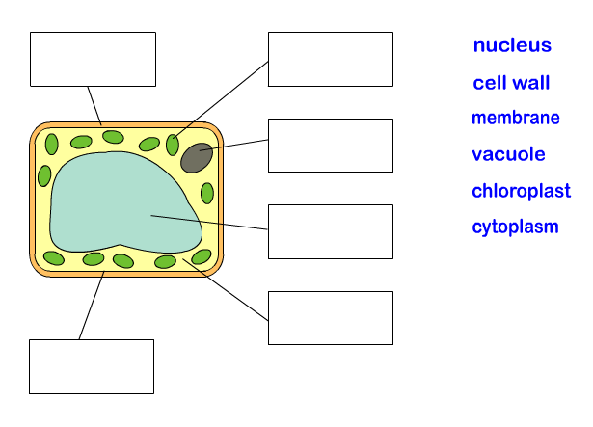
What type of cell is shown above? Circle the correct response Plant Animal
On the diagram, draw in some mitochondria. What is the function of mitochondria?

List the following in order from simplest to most complex tissue, system, cell, organ

Label the following structures on the digestive system diagram.
mouth | oesophagus | stomach | pancreas | Small mintestine | Large intestine

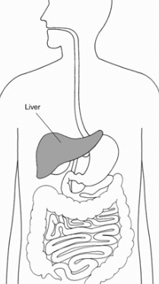
Provide the function/s of each of the followin structures of the digestive system.
mouth | 1.  2.
oesophagus
stomach | 1.  2.
panctreas
Small intestine | 1.  2.
Large intestine
Draw the following specialised cells. Explain how each is specialized.
Nerve cell | Skeletal muscle | sperm | Root hair cell | Guard cell

Label the following structures on the respiratory system | larynx | trachea | epiglottis | bronchi | lungs
Draw a diagram of some bronchioles with alveoli attached. Label some features of the alveoli.
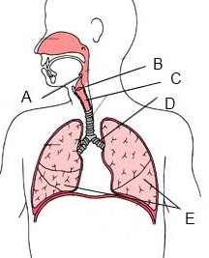
Function | Respiratory System Structure
Is also known as the windpipe

Tiny blood vessels that surround the alveoli

Tiny air sacs where gas exchange takes place

Air passage that branches of the trachea

Warms, moistens and humidifies the air before it enters the lungs
The flap of tissue that covers the trachea when a person swallows
Small passageways for air that have alveoli at their end.

On the diagram below label the four chambers of the heart. Draw in the flow of blood through the heart, use arrows to show direction. Use a blue pen for deoxygenated and red pen for oxygenated blood.
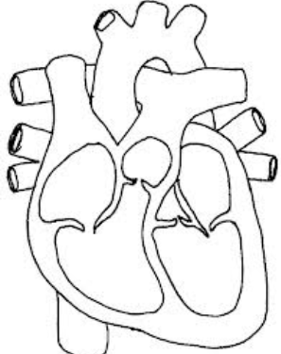defence
C
D
B
A
Letter | A | B | C | D
Name of vessel
Which chamber of the heart has the greatest muscle thickness? Explain why.

Name the following components of blood
Name of component
Diagram | 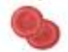 |  | 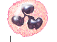 | Fluid component
Function

Provide two advantages of sexual reproduction | Provide two disadvantages of sexual reproduction

Provide two advantages of asexual reproduction | Provide two disadvantages of asexual reproduction
The female pistil is made of the ______________, ___________, and ___________. The stigma is the sticky knob at the top of the _______________. The style leads to the ________________ that contains the female egg cells called ________________. The male stamen is made up of the __________ and ___________. The anther produces ______________ (male reproductive cells).
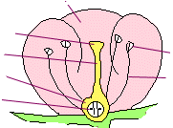
What is mitosis? Where does it take place? What does it produce?

What is meiosis? Where does it take place? What does it produce?

