HUMAN BIOLOGY

Unit 1

2016

Solutions

TIME ALLOWED FOR THIS PAPER

Reading time before commencing work: Ten minutes
Working time for the paper: Two hours 30 minutes.

MATERIALS REQUIRED/RECOMMENDED FOR THIS PAPER

To be provided by the supervisor:
- This Question/Answer Booklet
- Multiple Choice Answer Sheet

To be provided by the candidate:
- Standard items: Pens, pencils, eraser or correction fluid, ruler, highlighter, ruler.

- Special items: Calculators satisfying the conditions set by the Schools
Curriculum and standards authority for this subject.

IMPORTANT NOTE TO CANDIDATES

- No other items may be taken into the examination room. It is your responsibility to ensure that you do not have any unauthorised notes or other items of a non-personal nature in the examination room. If you have any unauthorised material with you, hand it to the supervisor before reading any further.

Structure of this paper

Section | Suggested working time | Number of questions available | Number of questions to be attempted | Marks | Percentage
SECTION ONE:  Multiple-choice | 40 minutes | 30 | All | 30 | 30
SECTION TWO:  Short answers | 70 minutes | 7 | All | 103 | 50
SECTION THREE:  Extended answers | 40 minutes | 3 | 2 | 40 | 20
 |  |  | Total marks | 173 | 100

Instructions to candidates

1. The rules for the conduct of Western Australian external examinations are detailed in the Year 12 Information Handbook 2016. Sitting this examination implies that you agree to abide by these rules.

2. Answer the questions according to the following instructions.

Section One: Answer all questions on the separate Multiple-choice Answer Sheet provided. For each question shade the box to indicate your answer. Use only a blue or black pen to shade the boxes. If you make a mistake, place a cross through that square, do not erase or use correction fluid, and shade your new answer. Marks will not be deducted for incorrect answers. No marks will be given if more than one answer is completed for any question.

Sections Two and Three: Write your answers in this Question/Answer Booklet.

3. You must be careful to confine your responses to the specific questions asked and to follow any instructions that are specific to a particular question.

4. Spare pages are included at the end of this booklet. They can be used for planning your responses and/or as additional space if required to continue an answer.
- Planning: If you use the spare pages for planning, indicate this clearly at the top of the page.
- Continuing an answer: If you need to use the space to continue an answer, indicate in the original answer space where the answer is continued, i.e. give the page number. Fill in the number of the question(s) that you are continuing to answer at the top of the page.

Section One: Multiple-choice 30% (30 Marks)

This section has 30 questions. Answer all questions on the separate Multiple-choice Answer Sheet provided. For each question shade the box to indicate your answer. Use only a blue or black pen to shade the boxes. If you make a mistake, place a cross through that square, do not erase or use correction fluid, and shade your new answer. Marks will not be deducted for incorrect answers. No marks will be given if more than one answer is completed for any question.

Suggested working time: 40 minutes.

- In an experiment, measurements are made and the results are recorded in a table. Sometimes there are numbers that are well beyond the range of the rest of the measurements. Such numbers are referred to as

(a) trials.
(b) outliers.
(c) mean averages.
(d) mode averages.

- A person weighing 115 kg lost 4 kg in a month. What was the percentage decrease of their weight?

- 7.2%
- 115%
- 28.75%
- 3.47%

Look at the results table below and answer the question that follows.

Temperature (̊C) | Enzyme Activity (mg of maltose produced)
10 | 4
15 | 7.5
20 | 11
25 | 14
30 | 17
35 | 19
37 | 23
40 | 22
45 | 18

- What type of data is shown and which graph would best represent this data?

- Discontinuous and bar graph
- Discontinuous and line graph
- Continuous and line graph
- Continuous and bar graph

- The cell theory could best be described as

- all living organisms are made up of cells and materials produced by cells.
- all living organisms are made up of cells and progressively become more complex.
- the structure of all living organisms and the way they function result from the activity of all its cells.
- all living organisms cells are small so they can exchange materials effectively.

- In which order would cellular wastes flow through, to reach the plasma?

- Intercellular fluid Intracellular fluid Extracellular fluid
- Intracellular fluid Intercellular fluid Extracellular fluid
- Extracellular fluid Intracellular fluid Intercellular fluid
- Extracellular fluid Intercellular fluid Intracellular fluid

- When body systems work together to make sure the cellular environment is kept constant, this is known as

- cellular respiration.
- endocytosis.
- homeostasis.
- pinocytosis.

- The two types of carrier-mediated transport are

- diffusion and osmosis.
- diffusion and endocytosis.
- facilitated diffusion and active transport.
- facilitated diffusion and osmosis.

- Phagocytosis is best represented as which of the following transfer mechanisms?

- Active transport
- Exocytosis
- Pinocytosis
- Endocytosis

- Which of the following lists best shows the levels of structural organisation of the human body?

- Atoms, Molecules, Tissues, Organs
- Cells, Tissues, Organs, Systems
- Molecules, Atoms, Cells, Tissues
- Molecules, Tissues, Organs, Systems

- Which of the following lists best describes the smallest parts of a carbohydrate and a lipid, respectively?

- Monosaccharides and Triglycerides and fatty acids.
- Monosaccharides and Triglycerides and nucleic acids
- Saccharides and Triglycerides and fatty acids.
- Polysaccharides and amino acids.
Use the diagram below of a nephron and its associated blood supply to answer the following TWO questions.
A
B
C

D
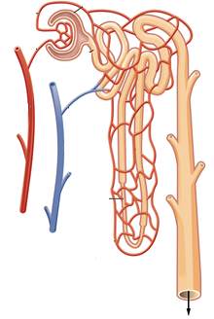

E

F

- The proximal convoluted tubule is indicated by label

- A.
- B.
- C.
- D.

- Glomerular filtration would involve structure(s) labeled

- A.
- A and B.
- D.
- D and E.

- Which of the following chemical equations shows the process of deamination?

- Ammonia + carbon dioxide + energy urea + water
- Oxygen + carbohydrate energy + water + carbon dioxide
- Oxygen + lipid carbohydrate + ammonia
- Amino acid + oxygen carbohydrate + ammonia

- A student used a 10X ocular lens and a 40X objective lens to view a sample of tissue. A field of view of 300μm was measured. When the objective lens was changed to 10X, what would be the new field of view?

- 1.2 mm
- 7.5 mm
- 120 μm
- 75 μm

- The white blood cell, red blood cell and platelet, could also be described as:

- Erythrocyte, leucocyte and thrombocyte.
- Thrombocyte, leucocyte and erythrocyte.
- Leucocyte, thrombocyte and erythrocyte.
- Leucocyte, erythrocyte and thrombocyte.

- Carbon dioxide is carried in a number of ways in the blood. Which of the following methods is the one that carries the most in the blood?

- The carbon dioxide is dissolved in the plasma.
- The carbon dioxide binds to haemoglobin to form carbaminohaemoglobin.
- The carbon dioxide is carried in the plasma as bicarbonate ions.
- The carbon dioxide is carried in the plasma as hydrogen ions.

- The cardiac cycle is the sequence of events that occurs in one complete beat of the heart. Which of the following phases occurs after atrial systole?

- ventricular systole
- ventricular diastole
- atrial diastole
- ventricular systole and atrial diastole

- Which of the lists BEST describes the sequential order of vessels that blood would flow through?

- Capillary, venule, artery
- Aorta, capillary, vein
- Capillary, vein, vena cava
- Arteriole, capillary, venule

- A blood sample was mixed with plasma that contained Anti-A and, in a separate test, with plasma containing Anti-B. The blood sample coagulated in the presence of the Anti–A but NOT in the presence of the Anti-B.

The blood sample could be classified into which of the following blood groups?

- blood type B
- blood type A
- blood type O
- blood type AB

- Which of the following is NOT a problem associated with the respiratory system?

- asthma
- bronchitis
- pneumonia
- meningitis

- Name the structure that contains vocal cords:

- pharynx
- larynx
- epiglottis
- adenoids

- Which of the following respiratory disorders is NOT contagious?

- influenza
- pneumonia
- emphysema
- tuberculosis

- The gall bladder stores which chemical and releases it into which organ respectively?

- gastric juice and duodenum
- bile and stomach
- gastric protease and duodenum
- bile and duodenum

- The removal of metabolic wastes from the body is best described as

- elimination.
- defecation.
- asphyxiation.
- excretion.

- People with coeliac disease are unable to tolerate a protein called gluten. The only treatment is to follow a gluten-free diet. Which of the following foods should a person with coeliac disease avoid?

- dairy products
- wheat based products
- rice based products
- carbohydrates

- Which of the following properties all allow muscles to work together to create movement?

- Contractibility, extensibility and elasticity
- Contractibility, extensibility, elasticity and tension
- Contractibility and extensibility
- Contractibility and elasticity

27. The axial skeleton includes the

- clavicle.
- pelvis.
- humerus.
- coccyx.

28. When a muscle is at rest, it is not completely relaxed but is in a state of partial contraction. This is referred to as

- flexion.
- muscle fatigue.
- muscle tone.
- muscle protraction.

29. Sutures are a type of:

- synovial joints.
- immovable joints.
- pivot joints.
- gliding joints.

30. Which one of the following refers to the membrane which tightly encloses vertebrate bones, to which muscles and tendons are attached?

- sarcolemma
- periosteum
- peristome
- peridermis

End of Section One

Section Two: Short answer 50% (100 Marks)

This section has seven (7) questions. Answer all questions. Write your answers in the spaces provided.

Spare pages are included at the end of this booklet. They can be used for planning your responses and/or as additional space if required to continue an answer.
  - Planning: If you use the spare pages for planning, indicate this clearly at the top of the page.
  - Continuing an answer: If you need to use the space to continue an answer, indicate in the original answer space where the answer is continued, i.e. give the page number. Fill in the number of the question(s) that you are continuing to answer at the top of the page.

Suggested working time: 70 minutes.

Question 31 (13 marks)

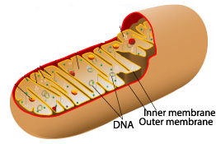

Identify the organelle above. Mitochondria (1 mark)

Skeletal muscle cells contain many of these organelles. Explain why this is the case.

- Skeletal muscles require a lot of energy
- Energy is acquired from cellular respiration
- Cellular respiration occurs in the mitochondria
(3 marks)

- Using either a word or chemical equation, describe the chemical reaction that would occur within the organelle above and explain how this can result in the formation of ATP. (2 marks)
- Cellular respiration would occur in the mitochondria to produce energy and can be summarized as follows
- glucose + oxygen → carbon dioxide + water + energy OR
- C₆H₁₂O₆ + 6O₂ → 6CO₂ + 6H₂O + energy (1 mark)
- The energy is used to form ATP from ADP (1 mark)
The following hypothetical cells are cuboidal in shape, with the length, breadth and heights as indicated.

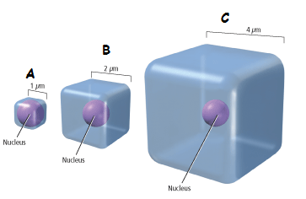

- Which of the cells in the diagram above (A, B or C) would have the smallest surface area to volume ratio?

- C (1 mark)

- Which of the cells in the diagram above (A, B or C) would supply its organelles with the substances they require most efficiently? Explain your reasoning.

- Cell “A” (1 mark)
- Cell “A” has the greatest surface area to volume ratio (1 mark)
- Cell “A” has the least distance between the cell membrane and the center of the cell, (1 mark)
- so nutrients and wastes can move in and out of the cell the fastest (1 mark)
(4 marks)

- Name two (2) inputs and two (2) outputs of typical animal cells.

Inputs Oxygen, monosaccharides/glucose, amino acids, tricylcerides/fatty acids/glycerols, water, ions/salts. (1 mark for 2 correct)

Outputs Carbon Dioxide, Lactic acid, ions/salts, water, urea, ammonia/nitrogenous wastes. (1 mark for 2 correct)
(2 marks)

Question 32 (15 marks)
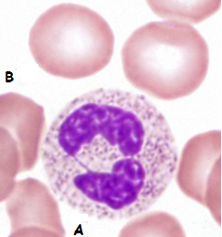

- Looking at the picture above, state which of the four main tissue types is being shown.
Connective Tissue (1 mark)

- Provide a reason for your answer in part (a).

- The cells are not close together / separated by non-cellular material/matrix / do not occur on free surfaces (any 1, 1 mark)
(1 mark)
- Identify each of these cells and state their basic function.
- Leucocyte / White blood cells / neutrophils (1 mark)
Function: destroying pathogens / phagocytosis of pathogens (1 mark)
- Red blood cells/erythrocytes (1 mark)
Function: combine with/carry oxygen to cells (1 mark)
(4 marks)
- Describe three (3) reasons why the cells labeled with a “B” in the picture above are well suited to their function. (6 marks)
Any 3 of the following 4 reasons.
- Contains haemoglobin (1), which is able to combine with oxygen (1)
- Does NOT contain a nucleus (1), leaving more room for haemoglobin (1)
- Biconcave shape (1) provides greater surface area for oxygen to combine with haemoglobin (1)
- Thick edges gives larger volume (1) so haemoglobin can combine with more oxygen (1)
- Flexible due to biconcave shape (1) therefore able to fit through capillaries (1)
- With reference to the lymphatic system, explain why exercising can reduce the chances of you getting a bacterial infection.
(3 marks)
- Muscle contractions / increased heart rate, increases the rate at which lymph moves through the lymphatic system (1 mark)
- The lymph will circulate through the numerous lymph nodes more often
(1 mark) and
- Therefore increasing the chances of any pathogens being deactivated by macrophages/lymphocytes (1 mark)

Question 33 (10 marks)
The diagram shown below is a representation of the human digestive system.

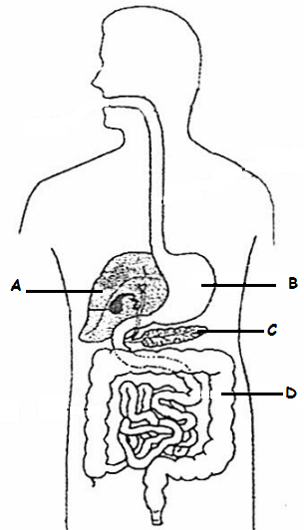

(a) State one (1) function for each of the parts listed in the above diagram. (4 marks)
A: Deamination / hydrolyses of alcohol / gluconeogenesis / bile production / albumin production. (Any 1 for 1 mark)
B: Mechanical digestion / Chemical digestion of protein / absorption of alcohol/ absorption of some drugs or aspirin / storage of food as it is eaten (Any 1 for 1 mark)
C: Production of pancreatic juices/enzymes/protease/amylase/lipase / Production of hormones (insulin/glucagon). (Any 1 for 1 mark)
D: Water absorption / site for decomposition of remaining organic material by bacteria / vitamin production via bacteria (Any 1 for 1 mark)

The diagrams below show structures found in the small intestine and lungs.

Structural Feature 1 Structural Feature 2
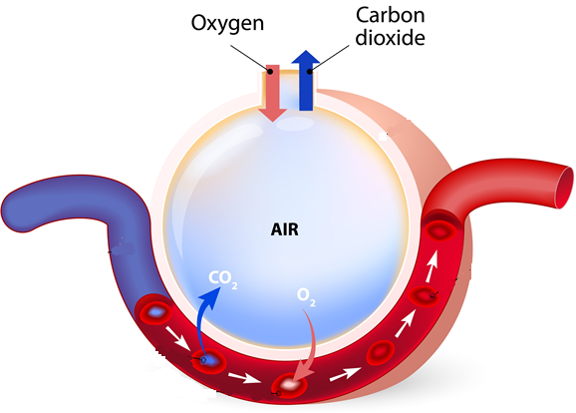
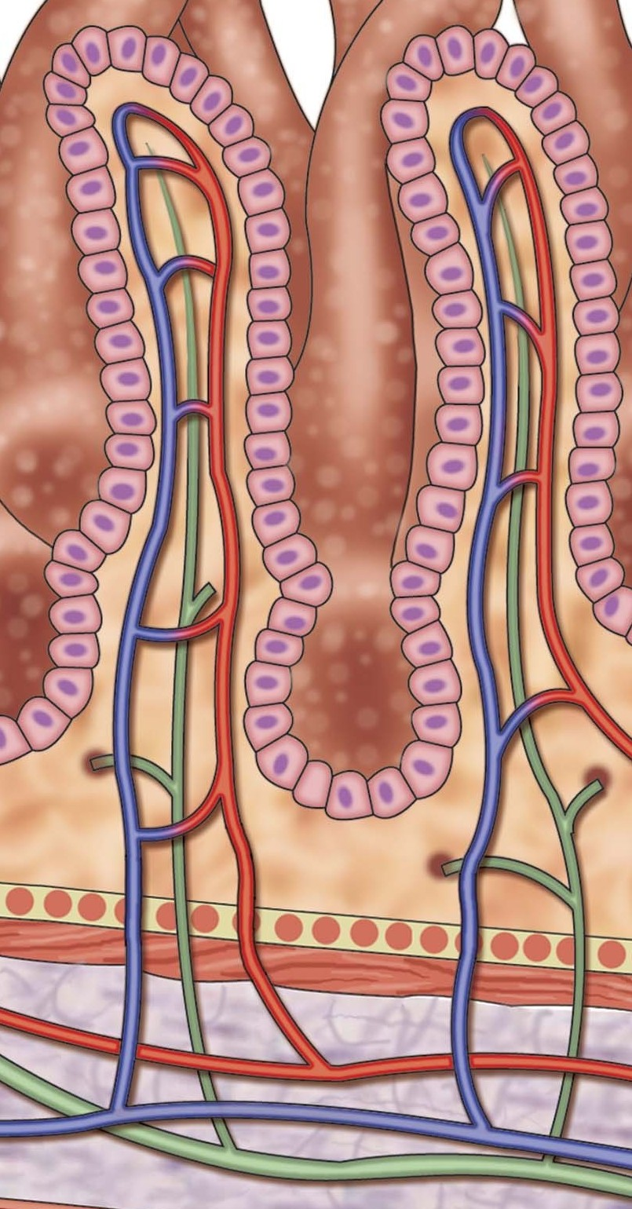
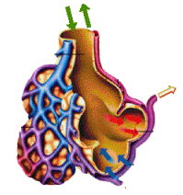

The exchange surfaces of the small intestine and lungs rely on concentration differences so that substances can cross the surfaces rapidly and constantly.
(b) Identify structural features 1 and 2 and describe four (4) similarities that allow them to maintain the concentration gradient.
(6 marks)
- Structural feature 1: Villi of the small intestine. (1 mark)
- Structure feature 2: alveoli (1 mark)
- Both features are covered with a single layer of cells, so the nutrients in the villi and the oxygen in the alveoli, do not have to travel far to move into the blood stream (1 mark)
- Both features are covered with a network of blood capillaries, so that as much blood as possible is close to the nutrients in the villi / oxygen in the
alveoli (1 mark)
- The shape of the villi and the alveoli generate a large surface area for the nutrients/gases to be rapidly exchanged in a short amount of time (1 mark)
- The blood flow through the capillaries is rapid, maintaining the concentration gradient (1 mark)

Question 34 (6 marks)

Cartilage is a connective tissue, just like bone. Name the three (3) different types of cartilage and describe the structure of each:

Hyaline (1 mark) | Closely packed thin collagen fibers  (1 mark)
Fibrocartilage (1 mark) | Thick not so closely packed collagen fibers (1 mark)
Elastic Cartilage (1 mark) | Contains elastic fibers  Less densely packed collagen fibers  (1 mark)

Question 35 (13 marks)

This question refers to the diagram shown below.
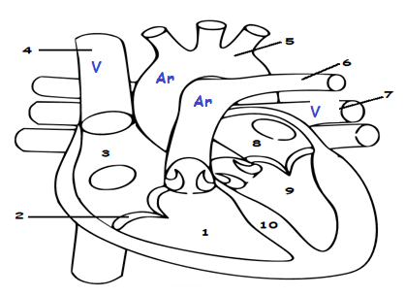

- Identify the above labeled structures:

1. Right Ventricle (1 mark)
2. Atrioventricular valve/Tricuspid valve (1 mark)
7. Pulmonary vein (1 mark)
8. Left Atrium (1 mark)
10. Septum (1 mark)
(5 marks)

- What are the functions of structures 2, 5 and 6?

Structure 2: Stop blood flowing back into Right Atrium (1 mark)
Structure 5: Guide blood to rest of body. (1 mark)
Structure 6: Guide blood to lungs. (1 mark) (3 marks)

- Label all the veins and arteries on the diagram above, with a “V” and an “Ar” respectively.
- 1/2 mark all veins labelled.
- 1/2 mark all arteries labelled
(1 mark)

- How does the heart muscle receive nutrients and remove metabolic wastes?
Via the coronary arteries and coronary veins, respectively. (1 mark)

- Arteries differ in structure and function to that of the veins.

Give two (2) structural differences and one (1) functional difference between arteries and veins.

Any 2 of the following STRUCTURAL differences, 1 mark each.

- Arteries have thick / elastic muscular walls, veins have thin / non-muscular / inelastic walls.
- Veins have valves, arteries do not.
- Veins have a wide lumen/ arteries have a narrow lumen

Any 1 of the following FUNCTIONAL differences, worth 1 mark.

- Arteries carry blood away from the heart; veins carry blood to the heart.
- Arteries have a higher blood pressure; veins have a low blood pressure.
- Arteries blood pressure changes with cardiac cycle, veins have relatively constant blood pressure.
(3 marks)

Question 36 (12 marks)

Study the diagram below and answer the questions that follow.

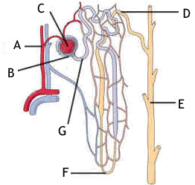

- Provide labels for structures:

A Renal arteriole
B Glomerular capsule (Bowman’s capsule)
E Collecting Tubule/Duct

F Loop of Henle (4 marks)

- Briefly explain how the afferent arteriole and efferent arteriole assist Structure C to carry out its function.
The afferent arteriole leading to the glomerulus has a wider diameter than the efferent arteriole leaving it (1). This narrowing of the efferent arteriole increases resistance to the flow of blood and produces a higher pressure in the glomerulus, forcing the fluid out, through the capsule (1)
(2 marks)

Water is reabsorbed via the cells that line the whole length of the nephron. The method of transport used to absorb the water in the proximal convoluted tubule (PCT) and Loop of Henle is different to the method used in the distal convoluted tubule (DCT) and collecting duct (CD).

- State which of the four tissue types the cells that regulate water reabsorption could be classified into.
Epithelial tissue (1mark) (1 mark)

- Explain how water molecules move from the PCT and Loop of Henle into the blood stream.
- Water molecules move passively/ without using energy (1 mark)
- from an area of high concentration to an area of low concentration (1 mark)
- via osmosis through a channel protein (1 mark)
(3 marks)
- Name and describe how most of the water moves from the DCT and CD into the bloodstream.
This is a active process/under hormonal control / ADH (1 mark), and is referred to as facultative reabsorption (1 mark)

(2 marks)

Question 37 (20 marks)

In the 1960s a doctor working for the Red Cross in the Congo region of Africa, saw pregnant women drinking tea from the leaves of the Kalata-Kalata plant. These women believed that drinking the tea increased the speed at which they gave birth.

Scientist later discovered that a protein (named Kalata B1) in the leaf caused the contractions of the uterus in women. In an effort to help women who were overdue, scientists wanted to find out what concentration of Kalata B1 was needed to start contractions in women, who were in their 41st week of pregnancy, as soon as possible after consuming the tea.

Five different concentrations of Kalata B1were tested. Each concentration was tested on 5 different women, who were all tested in the one hospital.

The results from this experiment can be seen below.

Concentration of Kalata B1 (g/mL) | Time elapsed before contractions started (seconds)
 | Trials
 | 1 | 2 | 3 | 4 | 5 | Average
0.01 | 35 000 | 38 000 | 36 500 | 33 240 | 37 005 | 35 949
0.02 | 28 000 | 27 000 | 26 980 | 29 009 | 27 101 | 27 618
0.03 | 26 000 | 27 809 | 25 807 | 26 500 | 27 709 | 26 765
0.04 | 23 000 | 22 908 | 23 776 | 22 809 | 23 005 | 23 100
0.05 | 18 000 | 17 986 | 18 203 | 18 246 | 18 009 | 18 089

- Write a suitable hypothesis for this experiment. (1 mark)

- Provide a definite statement with only ONE independent variable that can be tested.
- The effect the independent variable will have on the dependent variable is predicted.
E.g. If the concentration of Kalata B1 is increased, then the average time that will elapse before the contractions begin will decrease.

- Name the:
- Independent variable Concentration of Kalata B1(1 mark)
- Dependent variable Time elapsed before contractions
started (seconds) (1 mark) (2 marks)
- Calculate the average time elapsed for the 0.05 g/mL Kalata B1 concentration and place it in the table above.
18089 (1 mark)

- Plot the results on the graph paper supplied on the next page. (5 marks)
- Graph should show a linear negative correlation.
- Bar graph (minus 1 mark, data is continuous)
- Line graph drawn (1 mark)
- Title with independent and dependent variable (1 mark)
- Independent variable on x axis and labelled (1 mark)
- Dependent variable on y axis and labelled (1 mark)
- Numbers scaled appropriately on the axis (1 mark)

- Two groups should be used in any experiment. State the name of the two groups and explain how they are different to each other.

- Experimental (1 mark) and Control group (1 mark)
- The experimental group has the independent variable and the control group has all the same conditions as the experimental group, but does not have the independent variable / has a placebo (1 mark)
- marks)

- A placebo should have been used as this experiment was trialing a drug.
Define what a placebo is and describe how it should have been used in this experiment.
A placebo is an inactive substance / has no effect, that looks and tastes like the tested
drug (1 mark). In this experiment, a drink of tea that looks and tastes like the Kalata B1 tea (1 mark) needed to be provided to a control group (1 mark).
(3 marks)
- Excluding the placebo, name a controlled variable that was used in this experiment and explain why it was used.
- To gain 1 mark, all of the following listed controlled variables need to be supported by a reasonable and valid reason as to why they were used.
- The type of drug being used, Kalata B1.
- The number of weeks the lady has been pregnant / 41 weeks pregnant.
- The hospital the women were patients in.
- When the timer is started, after the women has drunk the medicine/tea.
- Drug / placebo only administered as a cup of tea / consumed as a liquid.
(2 marks)

- The same factors that influence the activities of enzymes, affect proteins.

Explain two (2) reasons why scientists were amazed that the Kalata B1 protein remained active and had an effect on the women’s uterus.

Despite being exposed to:
- high temperatures when boiled in the tea (1 mark) and
- the acidic conditions in the stomach (1 mark),
- the protein was not denatured and still had an effect (1 mark).
(3 marks)

Question 38 (14 marks)

The table below shows three different stages of a muscle contracting using the sliding filament model.
Picture | Stage | Title
 | 1 | Relaxed
 | 3 | Fully contracted
 | 2 | Partially contracted

- Complete the table by numbering the stages in their correct order, starting with a relaxed muscle. Provide an appropriate title to indicate what is occurring during each stage.
- 1 mark for all correct stages.
- 1 mark for each correctly labeled stage.
(3 marks)

- Label the parts shown in the diagrams above:

A Myosin fibres (1 mark)
B Actin fibres (1 mark)
C Sacromere (1 mark)
(3 marks)

- State what occurs to parts A, B and C when the whole muscle fibre contracts.
When the muscle contracts, the thin actin fibres slide over the thick myosin fibres (1 mark). When this happens, the Z lines are drawn closer together, shortening the sarcomere (1 mark) This results in a shortening of the muscle fibre and the whole muscle (1 mark). (3 marks)

- Identify whether the process of muscle contraction is a passive or active process and explain your answer.
- Muscle contraction is an active process (1 mark) because
- Energy is needed for the shortening of the muscle fibres / actin to slide over myosin (1 mark) (2 marks)

End of Section Two

Section Three: Extended answer 20% (40 Marks)

This section contains three (3) questions. You must answer two (2) questions. Make sure you clearly indicate which question you are answering and write your answers in the space provided.

Spare pages are included at the end of this booklet. They can be used for planning your responses and/or as additional space if required to continue an answer.
  - Planning: If you use the spare pages for planning, indicate this clearly at the top of the page.
  - Continuing an answer: If you need to use more space to continue an answer, indicate in the original answer space where the answer is continued, i.e. give the page number. Write the number of the question(s) that you are continuing to answer at the top of the additional space page.

Responses could include clearly labeled diagrams with explanatory notes; lists of points with linking sentences; clearly labeled tables and graphs; and annotated flow diagrams with introductory notes.

Suggested working time: 40 minutes.

Question 39 (20 marks)

- Draw and label the structures that have a role in the movement of air into the lungs.

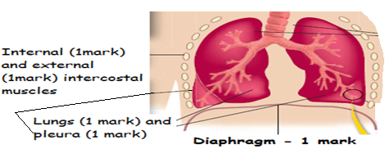
(5 marks)

- A common war injury is the “Sucking chest” wound. This is where shrapnel or a bullet has penetrated the victim’s sternum and pleura. A hissing sound can be heard as the person attempts to breathe. This injury can be fatal within a few minutes, as their lung(s) will collapse.

Describe the process that normally occurs to increase and decrease the volume of the chest cavity during inspiration and expiration and explain why a “Sucking chest” wound would make breathing physically impossible and cause the collapse of the affected lung.
(10 marks)

To increase the volume of the chest cavity:
- The diaphragm contracts and becomes flatter (1 mark)
- The external intercostal muscles contract and the internal intercostal muscles relax which (1 mark)
- Causes the rib cage to lift upwards and outwards (1 mark)

To decrease the volume of the chest cavity:
- The diaphragm relaxes and bows up (1 mark)
- The internal intercostal muscles contract and the external intercostal muscles relax which (1 mark)
- Causes the rib cage to move downwards (1 mark)

- For air to enter the lungs, the air pressure must be less inside the chest cavity than the outside (1 mark)
- If there is a hole in the sternum/pleura the air pressure is equalised and the lungs cannot fill with air. (1 mark)
- If the lungs are detached from the pleura, then the lungs cannot expand as the rib cage moves upwards/outwards (1 mark)
- As a result, the lungs cannot fill with air and they collapse (1 mark)

- Describe the process that can lead to the development of a “smoker’s cough” and explain how the “smoker’s cough” can lead to the sufferer developing emphysema. Explain why the sufferer needs to consciously make an effort to exhale.
(5 marks)

- Inhaled smoke particles constantly irritate the mucous membranes that line the air passages, this results in excessive mucus (1 mark)
- Accumulating mucus cannot be removed, causing “smoker’s cough”. (1 mark)
- Irritating particles damage alveoli and they are replaced with
scar/fibrous tissue. (1 mark)
- Alveoli lose their elasticity and so the lungs are constantly inflated (1 mark)
- Breathing out no longer occurs passively, but requires a voluntary effort (1 mark)

Question (20 marks)

- Mammals have a double circulatory system. Explain what is meant by double circulation and describe how it works. What is the advantage of double circulation?

- Mammals have a 4 chambered heart. Each side is involved in one form of circulation (1 mark)

- Right side = pulmonary circulation = blood to and from the lungs (1 mark)
- Deoxygenated blood from right ventricle to the lungs via pulmonary artery (1 mark)
- Oxygenated blood from lungs to left atrium via pulmonary veins (1 mark)
- Right ventricle is the pump for pulmonary circulation (1 mark)

- Left side = systemic circulation = blood to and from the body (1 mark)
- Oxygenated blood from left ventricle to body via aorta (1 mark)
- Deoxygenated blood from body to the right atrium via vena cava (1 mark)
- Left ventricle is the pump for systemic circulation (1 mark)

- Blood passes through the heart twice in one circulation, therefore double circulation (1 mark)

- This double circulation has the advantage that after blood goes through the lungs and losing much of its pressure, the heart pumps the blood again before going to the body cells (1 mark)
- This means blood is kept moving rapidly and therefore the cells get the requirements they need (1 mark)
(12 marks)

- Draw a table of the ABO and Rh blood groups, showing the antigens and antibodies present in each group, to explain why an adverse reaction occurs when incompatible blood types are mixed. State why people with blood type O negative can donate their blood to anyone, whereas people with blood type AB positive can receive blood from anyone.
Blood group | Antigens on RBC | Antibodies in plasma
A | Antigen A | Antibody B
B | Antigen B | Antibody A
AB | Both Antigen A and B | No antibodies
O | No antigens | Both antibodies
Rh+ | Rh antigen | No anti Rh antibody
Rh- | No Rh antigen | Anti Rh antibody
- No ½ marks awarded. 1 mark deducted for each incorrect blood group. Maximum 4 marks.

- The reaction is called agglutination / red blood cells/erythrocytes clump together (1 mark)
- It happens when the receiver’s blood has antibodies present in the plasma that react with the antigens on the donors blood cells and they cause the foreign red blood cells to clump together (1 mark).
- People with blood type O- can donate to anyone as they do not have any antigens on the surface of their red blood cells, so they do not trigger an immunity response in a recipient. (1 mark)
- People with AB+ can receive blood from anyone as they do not have any antibodies that will respond to any antigens present on any blood cells that may receive. (1 mark)

(8 marks)
Question (20 marks)

There are six main methods in which materials are transported across cell membranes.

- Describe how four (4) of these methods occur, the type of material that is transferred and a specific example of where it occurs in the body.

Any 4 methods, 3 marks each.
Method | How method occurs | Body part | Type of material
Diffusion | - Liquid/gas particles randomly move from an area of high to low concentration.  - Particles keep moving until they have evenly spaced themselves out in the available area.  (1 mark) | - PCT and Loop of Henle of kidneys.  - Alveoli of lungs  - Villi of small intestine  - Mouth and Stomach wall  - Large intestine  (1 mark) | - Oxygen and carbon dioxide.  - Alcohol  - Fat soluble vitamins.  (1 mark)
Facilitated diffusion | - Particles move from an area of high to low concentration THROUGH a carrier protein.  - Particle binds to carrier protein, protein changes shape and moves particle to other side.  (1 mark) | - Kidneys  - Small intestines,  - Liver  (1 mark) | - Substances that are too large to fit through the plasma membrane, such as glucose / amino acids.  (1 mark)
Osmosis | - The movement of a solvent (usually water) from an area of high to low concentration THROUGH a semi-permeable membrane.  (1 mark) | - Kidney nephrons and small intestines.  - All cells of the body.  - Large intestines  - Stomach wall  (1 mark) | - Water.  (1 mark)
Active transport | - Liquid/gas particles move from an area of low to high concentration across the cell membrane.  - Large molecules are taken across the cell membrane via carrier proteins  (1 mark) | - PCT  - Small intestine/villi  - Kidneys  - Small intestines,  - Liver  - Fat soluble molecules through any cell membrane.  (1 mark) | - Glucose  - Amino acids  - Na⁺ / K⁺  - Steroids  - Some vitamins.  (1 mark)
Endocytosis | - When a cell surrounds some extracellular material with a fold of the cell membrane.  - The enfolding membrane then breaks away, and the material is enclosed within the cell in the form of a small membrane-bound vesicle.  - Two types, phagocytosis (solid engulfing) and pinocytosis (liquid engulfing).  (1 mark) | - White blood cells/leucocytes.  - All cells carry out pinocytosis, therefore any organ.  (1 mark) | - Pathogens  - Any liquid.  (1 mark)
Exocytosis | - When the contents of a vesicle are pushed out through the cell membrane.  - The membrane around the vesicle fuses with the cell membrane and the vesicle contents are passed to the exterior.  (1 mark) | - Mammary glands.  - Saliva glands  - Pancreas  - Liver  - Gastric pits.  - Hormonal /endocrine gland.  (1 mark) | - Milk  - Saliva  - Digestive enzymes  - Hormones  (1 mark)

(12 marks)

- There are 6 different types of synovial joints within the human body. State what a synovial joint is and explain the types of movement the hinge, saddle and gliding joint provide. In your answer, give an example of where each of these types of joint could be found in a human body.

- The site where two bones come together (1 mark) and are freely moveable (1 mark)

Type of joint | Movement | Example
Hinge | Flexion and extension (1 mark) | - Elbow  - Knee  - Ankle (Any one,1 mark)
Saddle | Side to side and back and forth movement. (1 mark) | Thumb (1 mark)
Gliding | Allow movement in any direction, in a side to side or back and forth motion.  (1 mark) | - Between carpal bones  - Between tarsal bones  - Between sternum and clavicle  - Between scapula and clavicle (Any one, 1 mark)

(8 marks)

End of questions.

