ACTIVITY 9: FOLDING

If rocks move gradually towards each other then the layers of rock can form folds.

DEMONSTRATIONS:
- Get a piece of paper, hold it in both hands and then push the ends towards the middle. You have made a fold. Folds range from tiny crinkles in rocks to large mountains ranges more than 100 km across. Folds are formed by compression forces.
- Get a sheet of newspaper. Fold the paper in half. Continue to fold the paper as many times as you can.
The paper becomes more difficult to fold. With each folding the amount of paper doubles. After seven foldings there are _______?______ sheets. The Earth’s crust, like the paper, requires a small amount of force to fold thin, lighter layers on the surface. Tremendous forces are required to fold over large, denser sections of rock.

If a fold is ∪-shaped it is called a syncline (trough).

If a fold is ∩-shaped it is called an anticline (arch).

A single sided bend with a -shape is called a monocline.

FAULTING

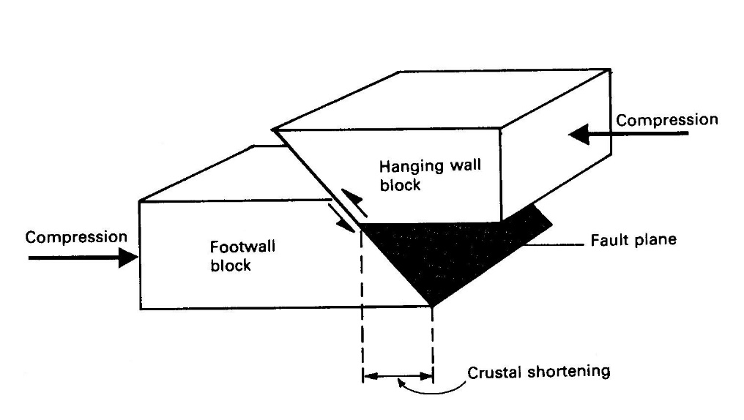
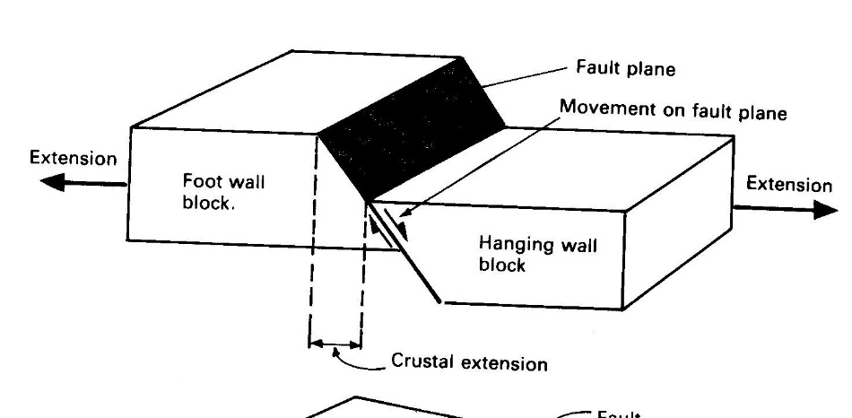
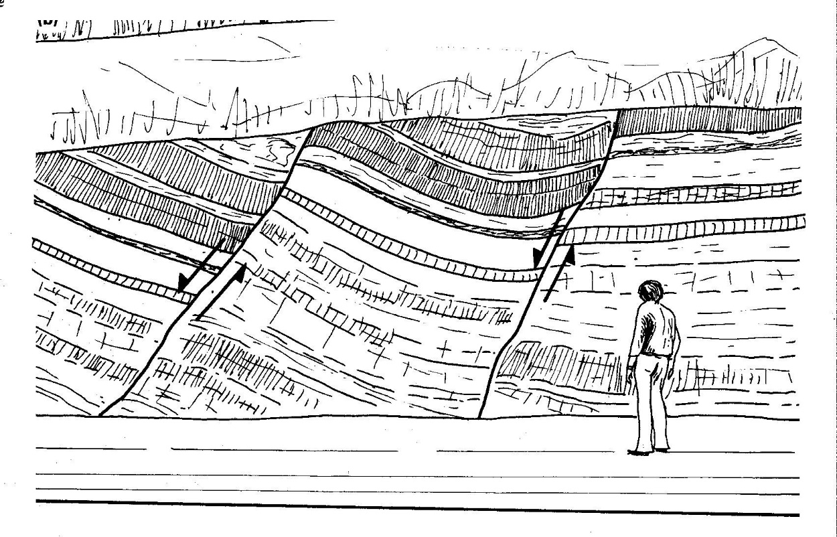
Sudden movements, such as earthquakes, can cause breaks or cracks in rocks called faults. They can be on a small scale or like the Darling Fault scarp can be hundreds of kilometres long.
Reverse faults are produced by compression forces that result in crustal shortening
Normal faults are produced by tension forces that result in crustal extension.
The formation of the Darling Scarp is an excellent example.
The arrows indicate the movement either side of the fault line in a quarry.

ACTIVITY 10: FAULTY CROSS-SECTIONS
Challenge: Find out more about the Darling Scarp. How long is the Darling Scarp? When did the fault movement take place? How much movement took place? Where is the fault line now?

HOW DO FAULTS RELIEVE STRESS IN THE EARTH’S CRUST?
What you will need:
Cardboard and scissors

There are several ways that the Earth’s crust may be stressed. Two of them are tension (stretching, like a rubber band) and compression (squeezing). Rocks often break (fault) under these stresses. The type of fault can tell us the type of stress that was involved.

40 cm
10 cm
- 5
- 4
- 3
- 2
- 1

Procedure:
- Take a piece of cardboard, and cut it carefully as shown in the diagram above. You may like to draw some rock layers on it.
- Set up your cross-section so that it is a 40 x 10 rectangle. Now we fault it, by moving the even numbered blocks upwards. Make sure there are no gaps between the blocks.
- Complete a table like that below:

 | Type of Fault | Width before faulting | Width after faulting | Type of stress  Tension/compression
Even numbered blocks pushed up | Normal
Odd numbered blocks pushed up | Reverse

- Set up your cross-section so that it is a 40 x 10 rectangle again. Now we fault it, by moving the odd numbered blocks upwards. Make sure there are no gaps between the blocks. Write your results in the table.

