TEAM WORK

Your spaceship has just crashed on mars. You were scheduled to rendezvous with a mother ship 200 kilometres away on the lighted surface of the mars, but the rough landing has ruined your ship and destroyed all the equipment on board except for the 15 items listed below.
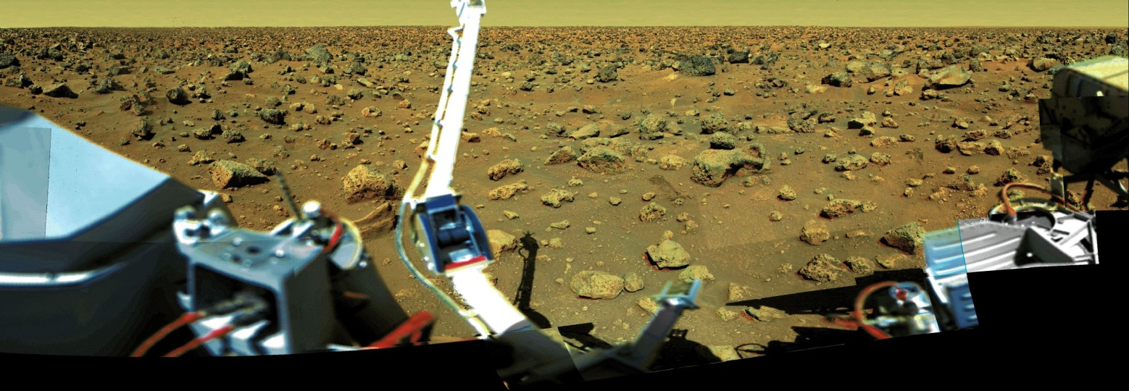
Lost on Mars
from NASA

Your crew's survival depends on reaching the mother ship, so you must choose the most critical items available for the 200 Kilometre trip.
Your crew’s task is to rank the 15 items in terms of their importance for survival. ALL the crew MUST agree on the rank.
Place a number 1 by the most important item, number 2 by the second most important, and so on, through number 15, the least important.

Your Crew’s Names ________________________________________________________________________________________________________
ITEM | RANK
Box of matches
Food concentrate
50 m of nylon rope
Parachute silk
Stellar map
Magnetic compass
Signal flares
Solar-powered portable heating unit
Two 9mm calibre pistols
One case of dehydrated milk
Two 50 kg tanks of oxygen
Self-inflating life raft
25 litres of water
First-aid kit containing injection needles
Solar-powered FM receiver-transmitter

