THE NUCLEUS OF A CELL
Any cell you have looked at will have a part stained darker than the rest. This part is called the nucleus.
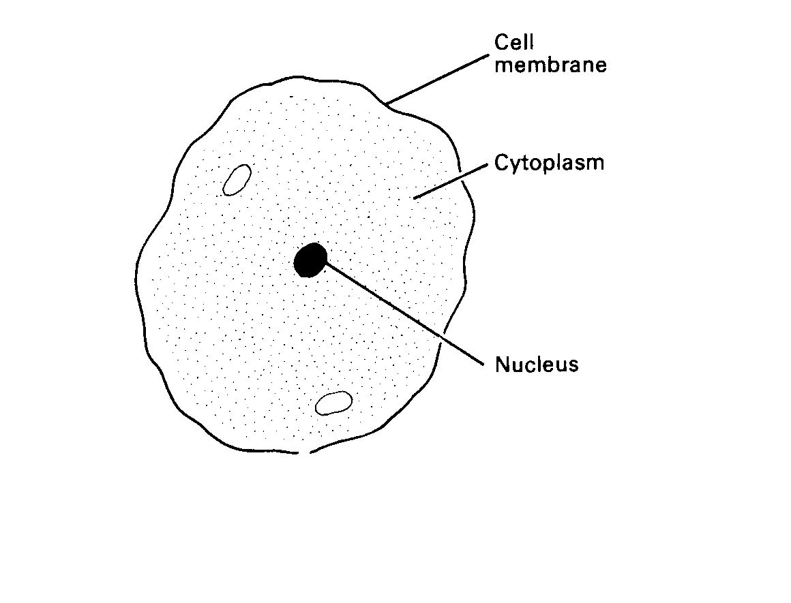
Cytoplasm
Cell membrane
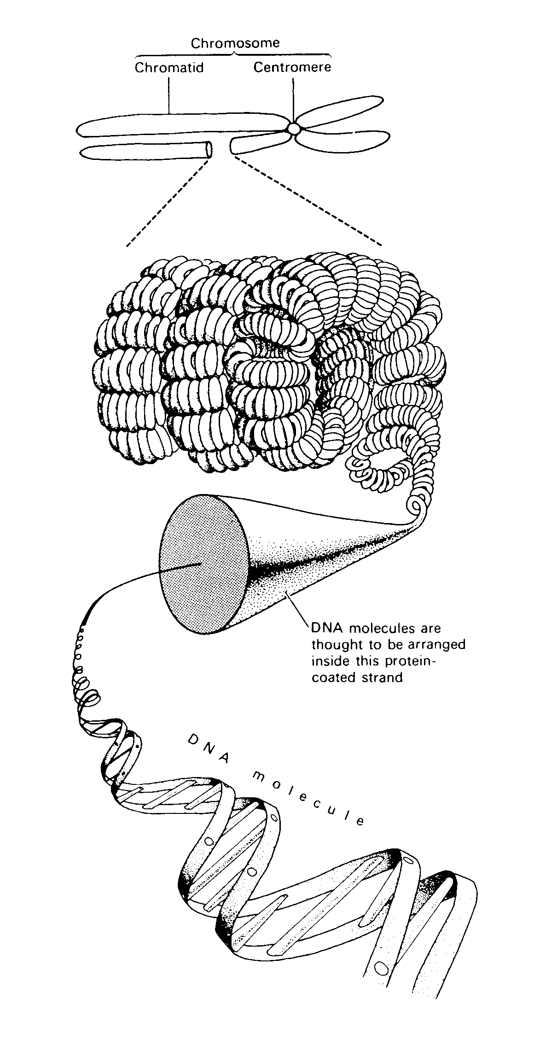
Chromosome
Centromere
Chromatid
Nucleus
Thread-like chromosomes within the nucleus of the cell

The nucleus contains the information telling a cell how to form and how it can work.
Inside the nucleus are thread-like structures called chromosomes. These can only be seen using a microscope and only when a cell is dividing. Chromosomes are made of a chemical called DNA. (Deoxyribonucleic Acid).
Sections of the DNA form genes. Genes can only be seen under a very powerful electron microscope and then they appear as patterns of banding across the chromosome. Each gene controls a particular feature of an organism e.g. height of a pea plant, shape of a nose in humans or colour of hair in a mouse.

DNA is able to copy itself exactly as a cell divides so that each new cell carries exactly the same gene messages encoded in its chemical structure.
DNA molecules are arranged inside this protein-coated strand
When a thread of DNA copies itself before it divides, the two copies, each called a chromatid, are held together at a point called the centromere.
A chromosome at this stage is shown in the diagram in middle of this page.

Copy and complete these statements into your notebooks:

1. Chromosomes are found in the of a cell.
2. Chromosomes are made of a chemical called .
3. Sections of the DNA form which are the chemical instructions guiding the cell’s activity.
4. Before a cell divides each chromosome is made of two strands called that are held together by a .
5. Draw a chromosome and label its parts.

Different organisms have different numbers of chromosomes present in their cells. This number is called its chromosome number. This diagram shows a photograph taken of a human cell while it was dividing. The thread-like chromosomes have shortened and appear as double threads.

How many chromosomes does this cell have?

This chromosome number is common to almost every human. There are exceptions that will be examined later.

Here is a list showing the chromosome numbers of some other animals and plants:
Animals:
Australian fur seal 36
Butterfly 190
Cat 38
Dog 78
Honeybee 32
Housefly 12
Platypus 52
Rabbit 44
Tiger snake 34

Plants
Crimson bottlebrush 22
Edible pea 14
Iceland poppy 14
Kangaroo paw 12
River red gum 22
Silky oak 20
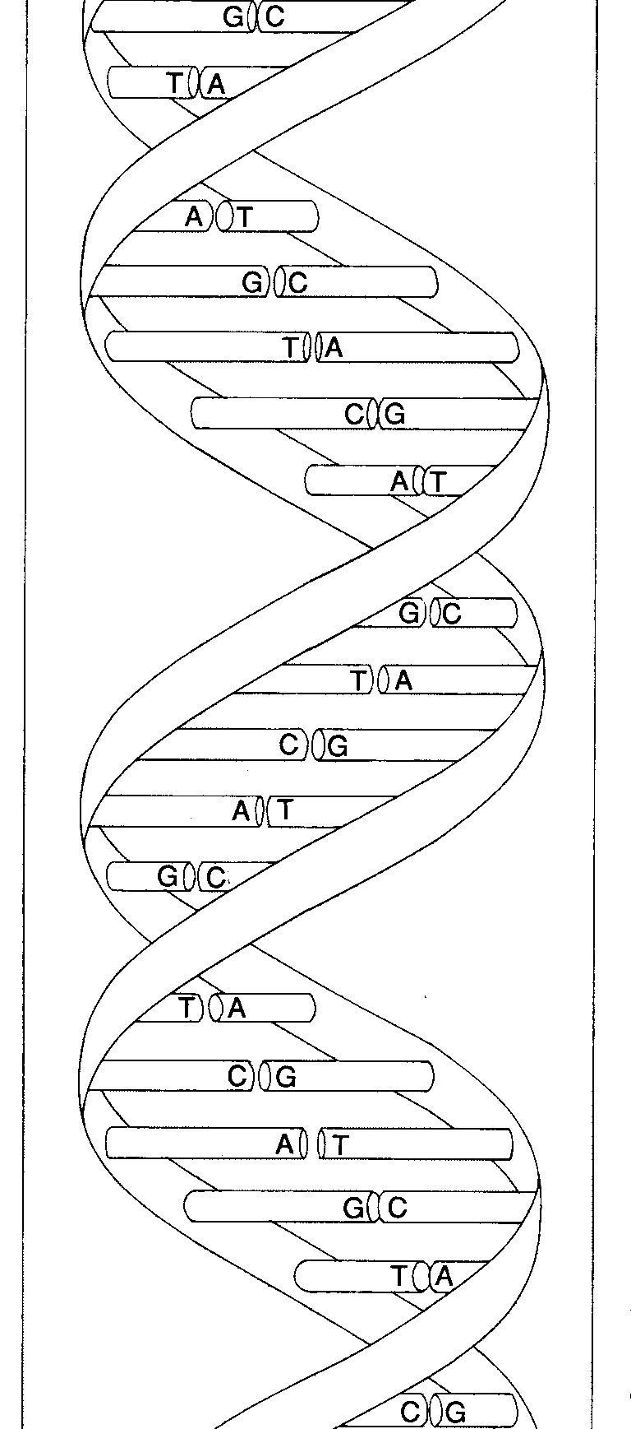Silver wattle 26
Tomato 24

DEOXYRIBOSE NUCLEIC ACID (DNA FOR SHORT!!!)

WATSON and CRICK first showed the chemical structure of DNA
in 1953. Their work earned them the Nobel Prize in 1962.
Their discovery opened the door to modern understandings of genetics.

DNA is a large molecule consisting of different types
of smaller molecules called bases. These include
A (adenine), T (thymine), C (cytosine) and G (guanine).

The bases attach in pairs to spiral backbone molecules made of sugar and phosphate.

QUESTION
Write down a rule for the pairing between bases.
This is a diagram showing the structure of a DNA molecule.
You can see how the molecule is formed of two spirals linked by bases which always pair in a special way.

