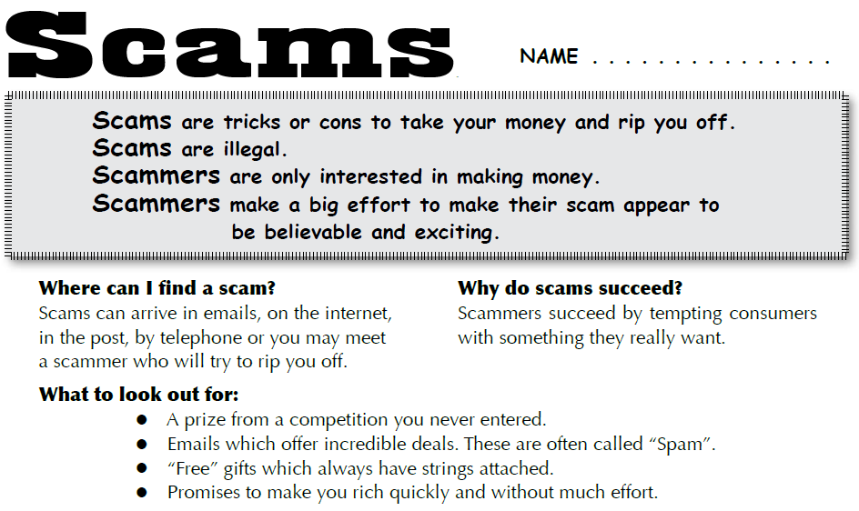
Exercise 1 - Find the scams
Using the following websites, list as many different types of scams as you can find.
www.scamwatch.gov.au
http://www.scamnet.wa.gov.au/scamnet/Home.htm

Exercise 2 - Scam Investigation
Working in groups, choose one type of scam to investigate and write a response that covers the following points:
– examples of this type of scam
– advice on how to recognise them
– an explanation why people become victims of this type of scam

Exercise 3 - Scambusters poster
Create a scambusters poster so that everyone knows how to deal with scams

Exercise 4 - Create your own scam
Working in small groups, create your own scam. Explain your strategy and the reasons why you think it will be successful.

