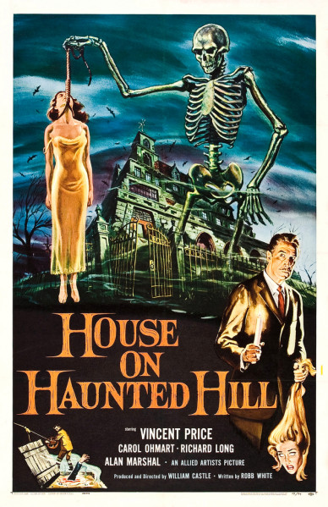
Research the movie poster designer Reynold Brown to explain how the poster below is typical of his style.

How is the poster for House on the Haunted Hill like other horror and sci fi films from the 1950s?

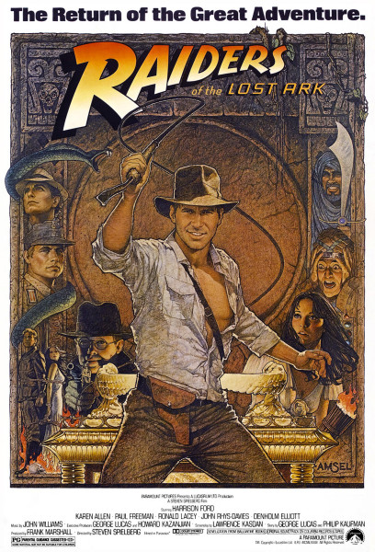

How is the Indiana Jone’s poster a development in the style of Richard Amsel’s poster? Research how his techniques changed from the 1970s to the 1980s.

How does the poster reinforce an archetypal image of masculinity?

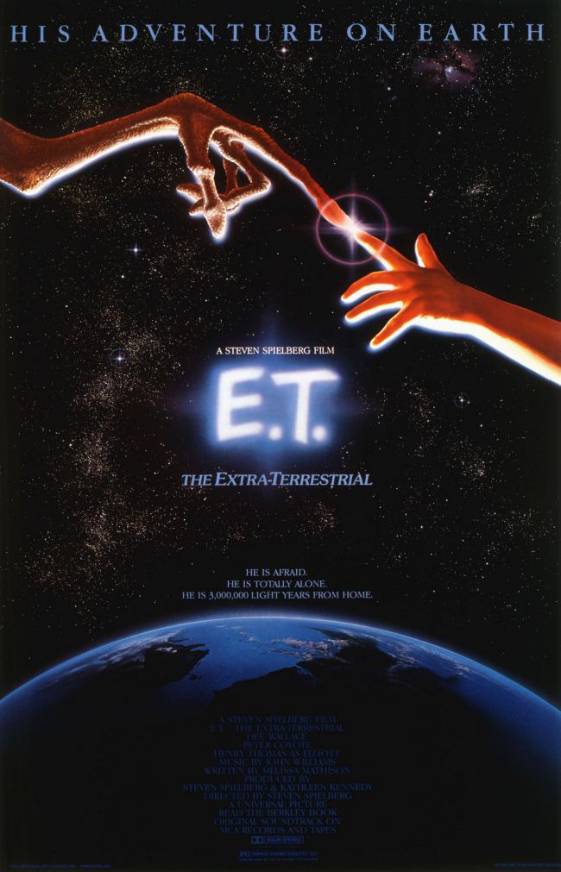
Why does the poster for E.T. allude to Michael Anglelo’s The Creation of Adam? How does the visual metaphor contribute to the viewer’s understanding of the film’s themes?

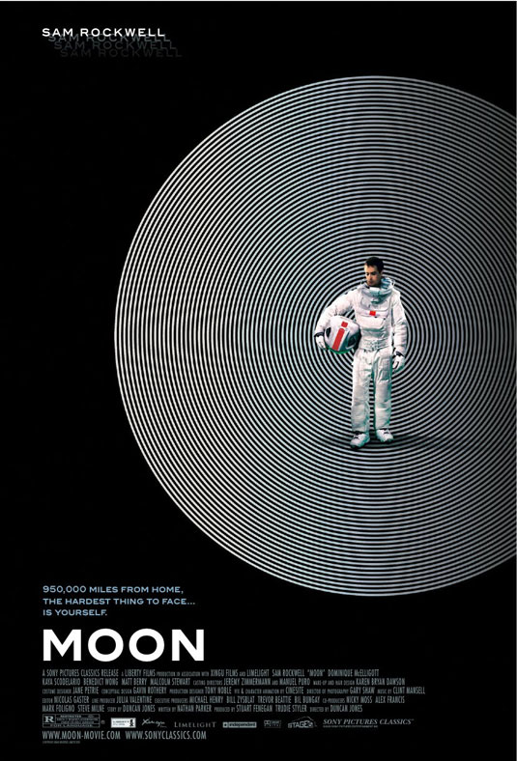

From the London agency's official notes on The Moon poster: "The main themes from the film are loneliness, isolation, madness and rebirth. We created an image that explored these themes and stylistically took influences from 60s and 70s sci-fi."
Explain how the poster suggests these themes and references films from these eras.

