Biological Sciences ATAR YR 12
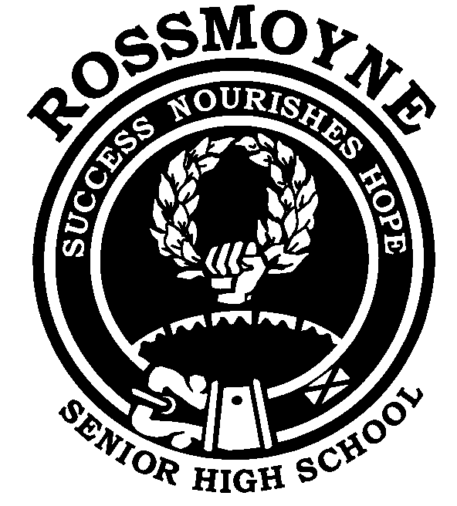
Inheritance of One Pair of Characteristics: Monogenic Inheritance

INTRODUCTION:

From the work of Gregor Mendel and the research workers who followed him, we know that genes control the various hereditary characteristics. These genes occur in pairs, e.g., you have two genes for your type of ear lobe, one gene inherited from your father and one gene from your mother. However, reproductive cells or gametes contain the haploid chromosome number and therefore only have one gene member of each gene pair.
Also one gene in a pair may mask the other gene. The gene that does the masking is called the dominant gene and the masked gene is the recessive gene. Dominant genes are represented by a capital letter and recessive genes by the corresponding lower case letter e.g. in pea plants the gene for tallness is dominant to the gene for dwarfness, therefore, “T” represents the gene for tallness and “t” the gene for dwarfness.

Learn the following terms before continuing with this exercise.
Homozygous: the paired genes for a particular characteristic are identical e.g. TT or tt.
Homozygous organisms are also known as pure breeding because they can only form one kind of gamete for the characteristic. e.g. a TT plant can only form gametes containing the gene T.
Heterozygous or hybrid: the paired genes for a particular characteristic are different e.g. Tt. A hybrid organism is the offspring of across between two parents that differ in one or more characteristics e.g. if we cross a pure breeding tall pea plant (TT) with a pure breeding dwarf pea plant (tt) then the offspring (Tt) is a hybrid. Heterozygous or hybrid organisms can form two kinds of gametes for the characteristic e.g. T or t
Genotype: the genes carried by an organism and indicated by paired symbols e.g. the genotype of a pure breeding tall pea plant is TT, the genotype of a hybrid tall pea plant is Tt.
Phenotype: the effect of an organism's genotype e.g. a hybrid tall pea plant has the genotype Tt and its phenotype is tall.
Punnett square: this is a grid system used for working out all the possible combinations of gametes in various crosses.
Alleles: these are the alternate forms of a gene. e.g. the alleles for height of pea plants are “T” and “t”.

Procedure:
In this exercise you will use the punnett square method to show diagrammatically the inheritance of one pair of characteristics. Study the type example very carefully, paying particular attention to the setting out.

TYPE EXAMPLE
A pure breeding tall pea plant is crossed with a pure breeding dwarf pea plant. Given that the gene for tallness is dominant to the gene for dwarfness, determine the genotypes and phenotypes of the first (F1) and second (F2) generation offspring.

Let the symbol “T” represent the gene for the tallness character in pea plants. Let the symbol “t” represent the gene for the dwarf character in pea plants.

Parents: phenotypes Tall X Dwarf
genotypes TT tt
Possible gametes: T and T t and t

1st Generation Offspring (F1)

 | t | t
T | Tt | Tt
T | Tt | Tt

Genotypic ratio: all Tt
Phenotypic ratio: all tall hybrids

To obtain the second generation offspring (F2) you cross two of the first generation offspring i.e. the tall hybrids:

Parents: phenotypes Tall X Tall
genotypes Tt Tt
Possible gametes: T and t T and t
2nd Generation Offspring (F2)

 | T | t
T | TT | Tt
t | Tt | tt

Genotypic ratio: 1 TT : 2 Tt : 1 tt
Phenotypic ratio: 3 tall : 1 dwarf

You should now try the following question yourself. Remember to set out your work neatly so that it can easily be followed.

QUESTIONS
- Cross a pure breeding, black coated guinea pig with a pure breeding, white coated guinea pig. Given that, in guinea pigs, black coat colour is dominant to white coat colour, determine the genotypes and phenotypes of the first and second generation's offspring.

- A hybrid black guinea pig is crossed with a pure breeding white guinea pig. Determine the genotypes and phenotypes of the offspring, given that, in guinea pigs, black coat dominant to white coat.

- A purebred wire-haired terrier is crossed with a purebred smooth-coated dog. Given that, in dogs, wire-hair is dominant to smooth hair, determine the genotypes and phenotypes of the F1 and F2 generations.

- In guinea pigs, rough coat is dominant to smooth coat. Determine the possible genotypes and phenotypes of the offspring if two rough coated hybrid guinea pigs are mated.

- In fruit flies, red eyes are dominant to white eyes. Determine the possible genotypes and phenotypes of the offspring if a pure breeding red eyed fruit fly is crossed with a hybrid red eyed fruit fly.

- Given that, in guinea pigs, black coat is dominant to white coat, you can have three possible genotypes for coat colour in guinea pigs e.g. BB; Bb and bb. However, guinea pigs with the genotypes BB and Bb have the same phenotype, black coat colour. Find out what is meant by a “test cross” and show how it can be used to determine if a black coated guinea pig is homozygous (BB) or heterozygous (Bb).

BIOLOGICAL TERMS TO LEARN:
- dominant
- recessive
- homozygous
- pure breeding
- heterozygous
- hybrid
- genotype
- phenotype

