Biological Sciences ATAR YR 12
Review: Genetics problems

- The next question refers to the following information.

This pedigree shows the occurrence of a genetically inherited condition in this family. The shaded individuals have the condition.

I
1 2

II

1 2

From the pedigree we can say that the most likely mode of inheritance of the
condition is

- sex linked recessive.
- autosomal dominant.
- autosomal recessive.
- impossible to say without further information.

- A mother is a carrier for red-green colour blindness, whilst a father does not exhibit the trait. What is the probability that their son will be red-green colour blind?

  - 25%
  - 50%
  - 75%
  - 0%

- The following family tree shows the incidence of a sex linked genetic condition. It is a non-fatal condition.

I
1 2

II
1 2 3 4 5 6 7 8

1 2 3 4 5 6 7 8 9
III
(a) Is the condition inherited as a dominant or recessive trait? Give one

reason for your answer. (2 marks)

(b) Using the letters A and a, state the genotypes of the following
individuals. (3 marks)

I 2: _______________
II 8: _______________
III 5: _______________
(c) What is the probability of individuals II 3 and II 4 having another son
who has the condition? Show all working out. (3 marks)

Answer: _______________________

(d) Individual II2 has no family members that have been afflicted with this trait. What is the probability then, of individuals II 1 and II 2 having a child who has the condition? Show all working out. (3 marks)

Answer: _______________________

- (9 marks)

The diagrams below show several stages that occur during meiosis.

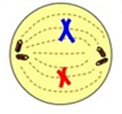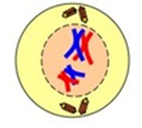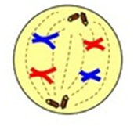

- In the spaces above, name each of the cell stages and then list them below in the correct sequence of events.

(4 marks)
- Meiosis is important in producing variation in offspring. Describe three different ways that this is achieved during meiosis.

(3 marks)
- (12 marks)

Below is a pedigree chart showing a family history of a disease.

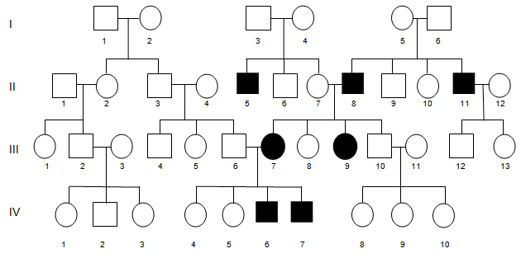

- Using the pedigree chart, determine the mode of inheritance. Explain how you were able to determine this.

- marks)

- Determine the probability that person III: 12 will inherit the disease. Show all working in your answer.

(2 marks)

After WATP HBS2AB 2011, 12, 13

