ATAR YR 12 BIOLOGICAL SCIENCES
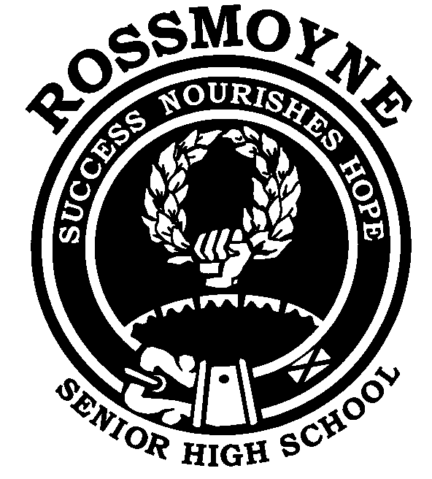
SEX LINKAGE PROBLEMS

When setting out sex linkage problems follow the same format as outlined previously, however, when indicating genotypes ensure they are always placed on the X chromosome.
This will enable you to be sure of phenotypic outcome in terms of the trait and gender.
In sex linkage questions, gender should always be stated in the answer.

- Red-green colour blindness is a relatively common condition that is inherited as
an X - linked recessive. A normal woman whose father was red-green colour-
blind marries a man who has normal vision.

a) What proportion of her sons would you expect to be red-green colour-blind?
b) If she married a man who was red-green colour-blind, what proportion of
their sons would you expect to have normal vision?
c) If she married man who was red-green colour-blind, what proportion of their
daughters would be carriers?

- Is the inheritance of the trait shaded in the following pedigree consistent with it being determined by

a. an autosomal recessive gene?
b. autosomal dominant gene?
c. a sex linked recessive gene?

- Haemophilia is inherited as an X - linked recessive trait. If an apparently normal
woman whose father was a haemophiliac marries a normal man:
a) What proportion of their sons will have haemophilia?
b) What proportion of their daughters will have haemophilia?
c) What proportion of their daughters will be carriers?

- If 'n' is the sex-linked gene for red-green colour blindness and the gene 'N' determines normal colour vision, use the correct symbolisation to identify the genotype of each individual represented. (Shaded individuals are colour-blind).

- Study the human pedigree below. Shaded individuals have haemophilia.

a. Work out the genotype of each individual.
b. Do you think individual 12 will be able to become pregnant and give birth to a
child of her own?
1 2
3 4 5 6 7
8 9 10 11 12

- A sex-linked recessive gene 'c' produces red-green colour blindness in humans.
A normal woman whose father was colour-blind marries a colour-blind man.
a) What genotypes are possible for the mother of the colour-blind man?
b) What are the chances that the first child from this marriage will be a
colour-blind boy?
c) Of all the girls produced by these parents, what percentage is expected to be
colour-blind?
d) Of all the children from these parents, what proportion is expected to be normal?

- A sex-linked gene causes a condition known as anhydrotic ectodermal dysplagia (non-functional sweat glands). A man who has this condition and a woman who is normal have four children, two boys and two girls.
- How many of the sons would you expect to have this condition?
- How many of the daughters would you expect to have this condition?
- One of the daughters, having grown up, intends having children. Before she does, she seeks advice on whether her children will, or will not inherit the disease. What
would you tell her if you were her doctor?
- Would you say the same thing if one of the sons approached you?

- A sex-linked dominant gene causes a rare condition in humans resulting in abnormal tooth enamel. Teeth are worn to the gums at a very early age, necessitating the use of
false teeth.. A woman who is heterozygous for this condition marries a normal man.
- What proportion of her sons would be expected to inherit this condition?
- What proportion of her daughters?
- Suppose the woman was normal and her husband had the condition. Would the same proportions occur?

