DOUBLE INSULATION

Some appliances have double insulation.
These appliances only need live and neutral wires.
They do not need an earth wire.
An appliance that is double insulated
has the whole of the inside contained in plastic,
underneath an outer casing.
If anything goes wrong with the appliance,
no live conductor can touch the
outer casing because of the insulating plastic.
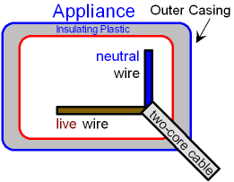
Appliances that are double insulated
include TVs, computers, printers and hairdryers.
The symbol for double insulation is shown below.

You will see this symbol printed
on the appliance which is double insulated.

