What is a fuse and how it works.
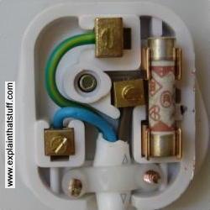
A fuse is a safety device to prevent excess current flowing in an electric circuit. It consists of a thin metal wire of low resistance and low melting point. When an electrical appliance or some other piece of electrical equipment becomes faulty, therefore allowing an excess electric current to flow through its circuit, this causes the wire inside the fuse to melt and thus break the flow of current.
Fuses, by design are a one-time-use protective device - once they are used ("burn out"), they're worthless. That is why homes typically use circuit breakers: a breaker acts similarly to a fuse in that it opens a circuit when excessive current flows, but - because nothing actually melts inside it - it can then be reset without having to be replaced by a new one, as has to be done for a fuse.
If there were no fuse in the circuit, serious damage could be caused to the wiring which feeds the equipment. It could get so hot that it catches on fire, which might start a fire in the building or vehicle in which the electrical equipment is installed.

Short circuits

A short circuit (sometimes abbreviated to short) is an electrical circuit that allows a current to travel along an unintended path, often where essentially no (or a very low) electrical resistance is encountered. A short circuit is a low-resistance path, usually made unintentionally, that bypasses part of a circuit. This can happen when two bare wires in a circuit touch each other. The part of the circuit bypassed by the short circuit ceases to function, and a large amount of current could start to flow. This can generate a lot of heat in the wires and cause a fire.

A common type of short circuit occurs when the positive and negative terminals of a battery are connected with a low-resistance conductor, like a wire. With low resistance in the connection, a high current exists, causing the cell to deliver a large amount of energy in a short time.

A large current through a battery can cause the rapid buildup of heat, potentially resulting in an explosion or the release of hydrogen gas and electrolyte (an acid or a base), which can burn tissue, cause blindness or even death. Overloaded wires can also overheat, sometimes causing damage to the wire's insulation, or a fire

