Student worksheet answers

6.4 The galaxies are moving apart
Pages 146–147

Spectra, the Doppler effect and galactic motion
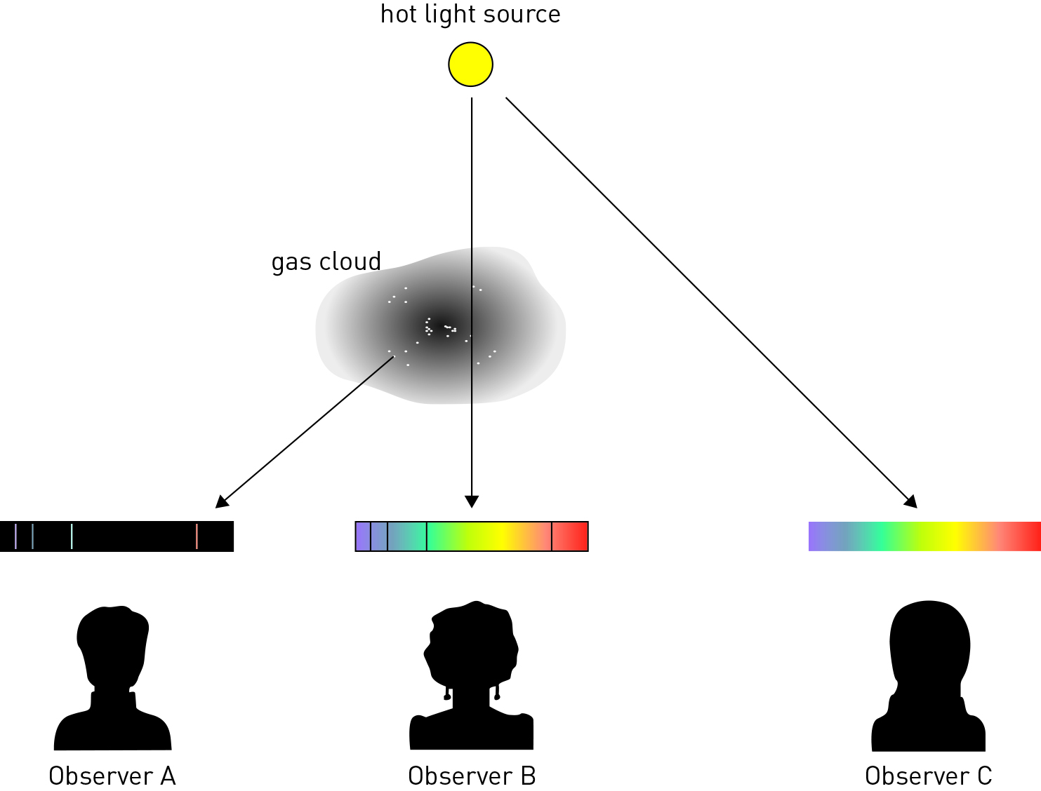

1 In the diagram above, which observer would see:
a a continuous spectrum?
Observer C will see a continuous spectrum.
b an emission spectrum?
Observer A will see an emission spectrum.
c an absorption spectrum?
Observer B will see an absorption spectrum.

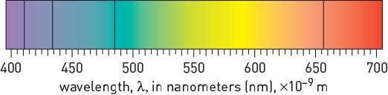  Figure 1 | 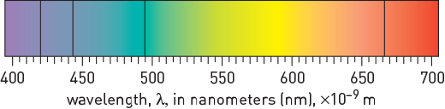  Figure 2
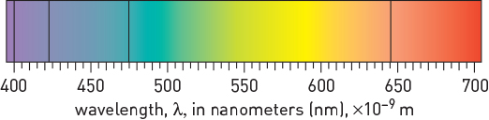  Figure 3 | 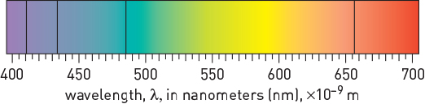  Figure 4
2 Figure 1 shows a spectrum for hydrogen obtained in the laboratory. Which of Figures 2–4 best represents the hydrogen spectrum for a galaxy that is heading towards Earth? Explain your answer.
Figure 3 best represents the hydrogen spectrum for a galaxy that is heading towards us as, due to the Doppler effect, the wavelengths of its absorption lines should be shorter – that is, they have been blue shifted.
3 What did Edwin Hubble discover about distant galaxies that helped provide evidence for the Big Bang theory?
Hubble discovered that further away a galaxy is, the faster it is moving away from us.

Extend your understanding
The Doppler Apparatus (shown below) can be used to understand how the Doppler effect works. To use it, you tie the apparatus to a rope and swing it around in circles. As the apparatus moves in circles, it produces a noise.
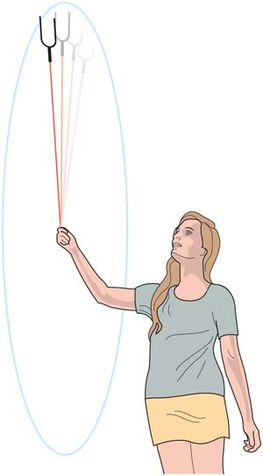
4 What would you expect to happen to the noise from the apparatus as it is swung around in a circle?
The pitch, or frequency, of the sound will increase as the sound waves in front of the apparatus are bunched up and decrease as the sound waves behind the apparatus lengthen.
5 Select an example of where else you may hear the Doppler effect in action. Describe how the effect would work in that situation.
Students’ answers will vary, but they should include a discussion of sound wave length and pitch in relation to the motion of the object.

