Student worksheet answers

6.5 The Big Bang theory is supported by evidence
Pages 148–149

Our expanding universe
1 What is the Big Bang theory?
The universe as we know it began to form from a singularity that inflated 13.8 billion years ago.
2 Why might he word ‘bang’ to describe the beginning of the universe be misleading?
Space expanded rapidly and silently; it was not an explosion as the word ‘bang’ suggests.
3 Use the table below to summarise the key evidence for the Big Bang theory.
Aspect of Big Bang theory | Key evidence
Microwave background | Scientists thought that an enormous amount of heat would have been released as part of the Big Bang, and would still exist still 13.7 billion years later. Scientists found this leftover energy existed still as background radiation. This is called cosmic microwave background radiation.
Mixture of elements | As energy cannot be created or destroyed, it stands to reason that the energy released as part of the Big Bang must have been converted into elementary matter. Scientists can see cool spots in the universe as temperature fluctuations, which are consistent with the formation of distant galaxies and old stars.
The universe is changing | Light from distant galaxies takes many years to reach Earth. This means we can see old galaxies that developed millions of years before our own Earth – we are looking back in time. This has given us a timeline consistent with what we know about the Big Bang.
4 Some scientists say that when we examine distant galaxies, we are looking back in time. What do they mean by this?
The light from other galaxies takes a very long time to reach Earth, so scientists can see old galaxies that developed millions of years ago.

Extend your understanding
In 1925 American astronomer Edwin Hubble took a series of images of the nebula M31 (now popularly known as the Andromeda galaxy) and, on comparing them, discovered a Cepheid variable star that he called V1. He measured V1’s period of pulsation to be 31.4 days.  Since a Cepheid variable star’s period of pulsation determines its variation in magnitude, as discovered by American astronomer Henrietta Leavitt, Hubble was then able to calculate how far away V1 was from Earth. He did this by measuring V1’s variation in brightness and, on comparing this with the absolute variation predicted by the relationship discovered by Henrietta Leavitt, Hubble calculated that M31 was 285 000 parsecs away from Earth – this led to it being classified as a galaxy in its own right, and not part of our Milky Way galaxy. The universe had suddenly become a very large place!  In 1929 Hubble published a paper that showed the results of his investigation of the relationship between a galaxy’s radial velocity (derived from its Doppler shift) and its distance from Earth. | 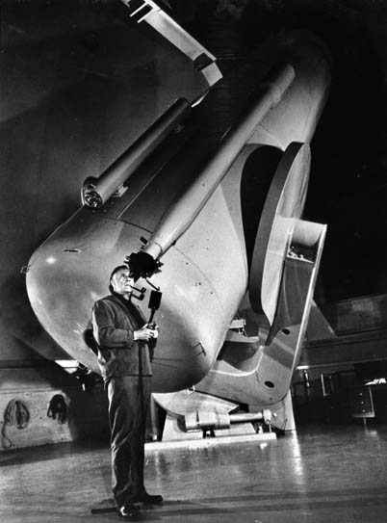  Edwin Powell Hubble
Hubble’s data
Object  name | Distance  (Mpc) | Velocity  (km/s) |  | Object  name | Distance  (Mpc) | Velocity  (km/s)
SMC | 0.032 | +170 |  | NGC 3627 | 0.9 | +650
LMC | 0.034 | +290 |  | NGC 4826 | 0.9 | +500
NGC 6822 | 0.214 | –130 |  | NGC 5236 | 0.9 | +500
NGC 598 | 0.263 | –70 |  | NGC 1068 | 1.0 | +920
NGC 221 | 0.275 | –185 |  | NGC 1055 | 1.1 | +450
NGC 224 | 0.275 | –220 |  | NGC 7331 | 1.1 | +500
NGC 5357 | 0.45 | +200 |  | NGC 4258 | 1.4 | +500
NGC 4736 | 0.5 | +290 |  | NGC 4151 | 1.7 | +960
NGC 5194 | 0.5 | +270 |  | NGC 4382 | 2.0 | +500
NGC 4449 | 0.63 | +200 |  | NGC 4472 | 2.0 | +850
NGC 4214 | 0.8 | +300 |  | NGC 4486 | 2.0 | +800
NGC 3031 | 0.9 | –30 |  | NGC 4649 | 2.0 | +1090
Note: 1 Mpc = 1 million parsecs = 1.0 × 10⁶ pc
5 Using the data in the above tables, plot a graph of radial velocity (km/s) against distance (Mpc) on the axes provided.

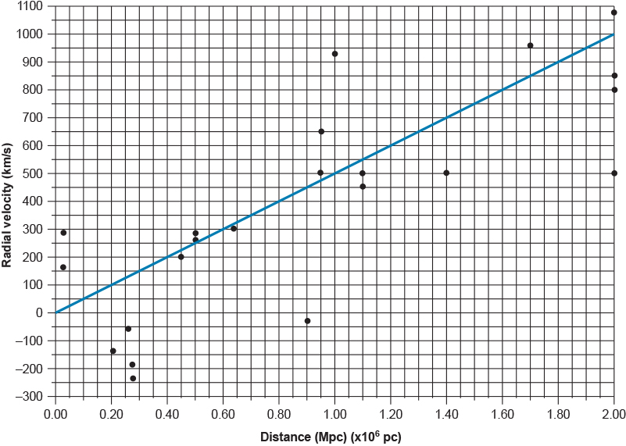
6 What does the general trend of the data suggest about what is happening in the universe? Explain your answer.
The general trend of the data suggests that the universe is expanding. The evidence that supports this is that the further away a galaxy is, the faster it is moving away from us.
7 Some of the radial velocities in Hubble’s data were negative. What does this tell us about their motion? Can you think of a reason why this might be so, given that the radial velocities of all of the other galaxies have positive values?
The galaxies with negative radial velocities are moving towards us, not away from us. Relatively speaking, they are all ‘close’ to us, so the reason why they are moving towards us could be (and is) that they are gravitationally bound together as a group.

