Literacy support worksheet answers

6.2 The Earth is in the Milky Way
Pages 142–143

Stellar magnitudes, parallax and distances
1 What are stars?
Stars are large balls of gas
2 Name three features that can make stars different from each other.
• temperature
• brightness
• size
• mass
3 What two elements are stars made of?
Hydrogen and helium
4 Use the following word list to fill in the blanks in the paragraph below.
Word list: close, positive, dimmer
The apparent magnitude scale is a measure of how bright a star ‘appears’ to be. The more positive (and the less negative) the number, the dimmer the star. A star may appear to be quite bright because it is close to the Earth; it may not actually be very bright.
5 The colour of a star is an indicator of its surface temperature. Complete the following sentences.
a ‘The hotter the surface temperature of the star, the bluer the colour.’
b ‘The colder the surface temperature of the star, the redder the colour.’
6 What is one method of measuring stars using colour?
The Hertzsprung–Russell diagram

7 How long does it take for the light from the Sun to reach:
a the Earth?
500 seconds or approximately 8 minutes
b Proxima Centauri?
4.2 years
8 Our Sun has a surface temperature of about 5700 K and an absolute magnitude of 4.77. Use this information to show where our Sun would be positioned on the Hertzsprun–Russell diagram below.
As shown on the accompanying diagram, our Sun sits on the main sequence of stars.
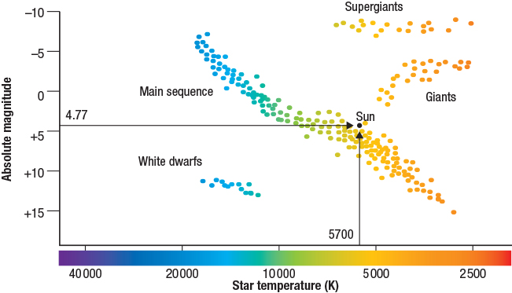

Word detective – True or false
9 Read the statement and circle whether it is true or false.
a Gases reacting at the core of a star provide energy to the star. T or F
b Nuclear fusion occurs when two atomic nuclei are repelled. T or F
c The Sun is the brightest object in the sky. T or F
d Luminosity refers to how bright a star appears to be. T or F
e Light-years measure the distance of stars from the Sun. T or F
f Proxima Centauri is the next closest star to the Earth, after the Sun. T or F
g Every night our stars and planets move across the night sky. T or F

