ACTIVITY 9 INERTIA
AIM: To investigate the concept of inertia.

EQUIPMENT: Coin supplied by students, card and beaker; 2 cans, steel rod and
string assembly; 8 slotted weights and ruler; motion trolley and
2 kg mass.

METHOD: Before trying the following activities. Predict what you think will happen, then do the activity and explain your observations.

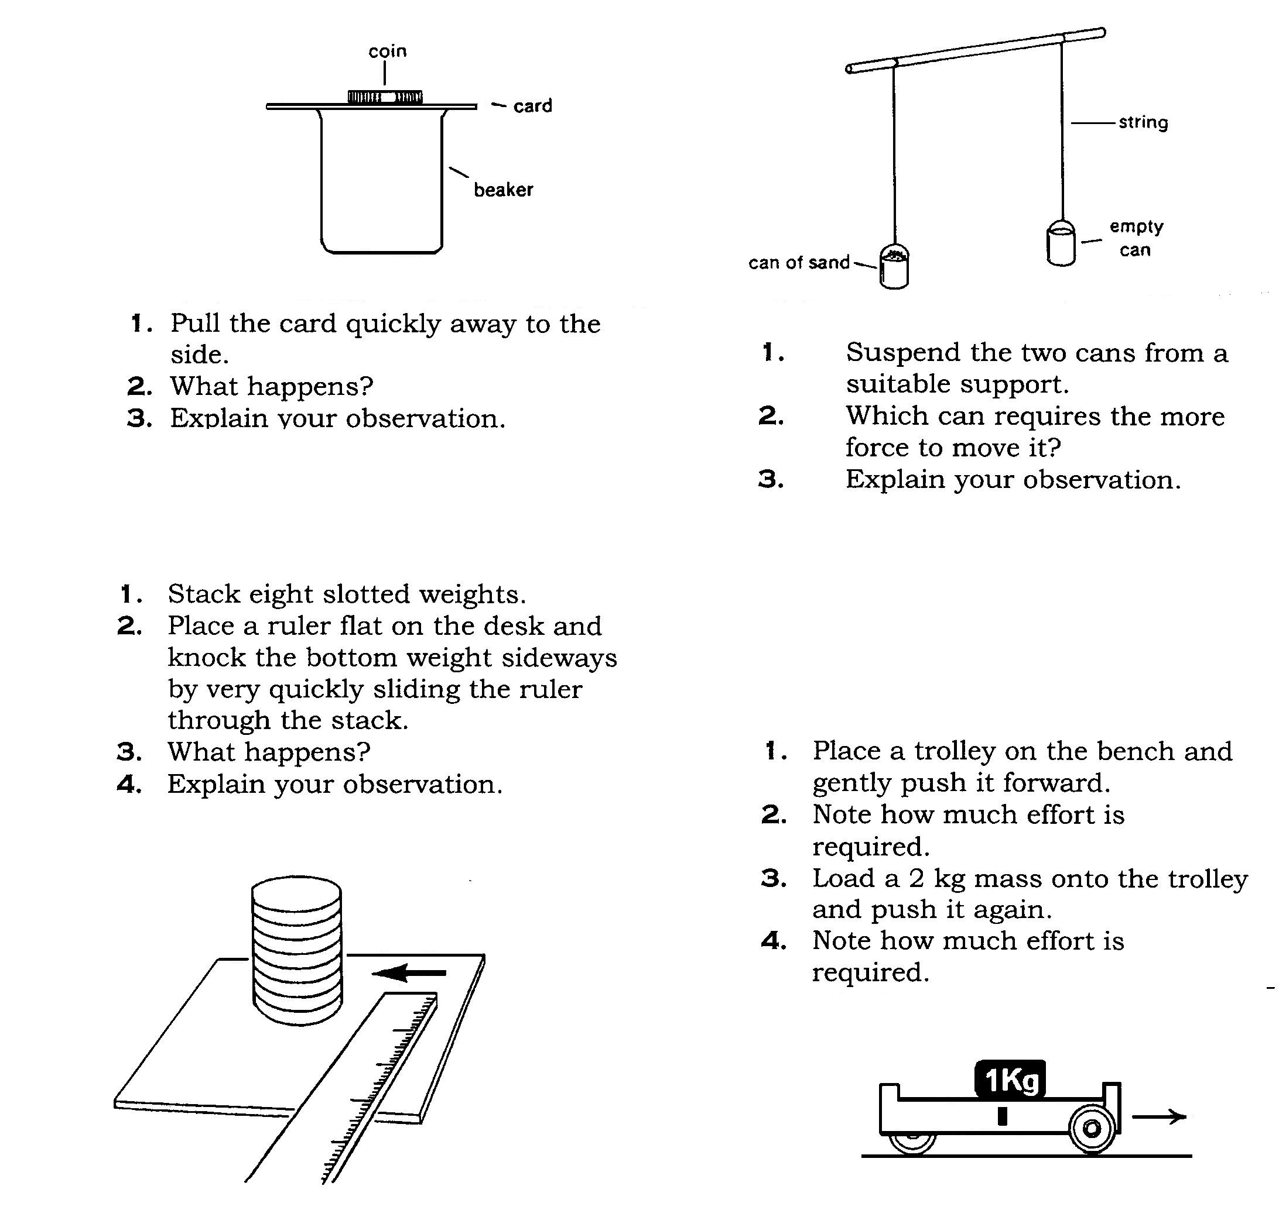
Place a trolley on the bench and gently push it forward.
Note how much effort is required to stop it.
Load a 10 kg mass onto the trolley and push it again to reach the same velocity.
Note how much effort is required to stop it.
10 kg
Pull the card quickly away to the side.
What happens?
Explain your observation.
Stack eight slotted weights.
Place a ruler flat on the desk and knock the bottom weight sideways by very quickly sliding the ruler through the stack
What happens?
Explain your observation.
Suspend the two cans from a suitable support.
Which can requires the more force to move it?
Explain your observation.

 CHALLENGE QUESTIONS FOR EXPERTS:

Imagine, for example, that you are sitting in a stationary vehicle when a fast-moving vehicle runs into the back of you.

Imagine further that your seat has no head restraint.
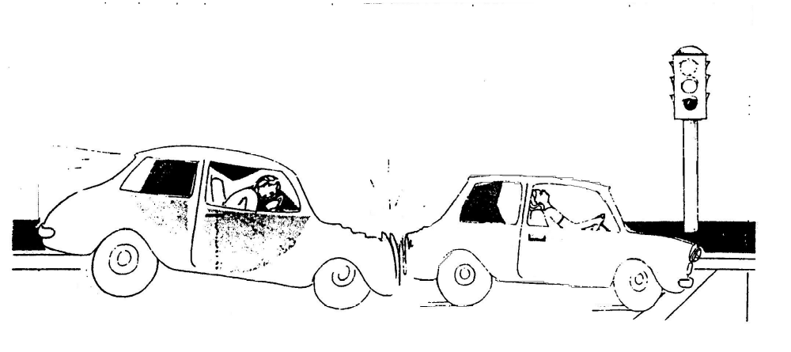

Let's see how this can be applied to the road situation:

- What happens to the passengers in a stationary vehicle when it is hit from behind by another car?

- What design feature of modern cars reduces the risks of serious injury from this type of collision?

- Explain why the passengers standing in the aisle of a bus are forced towards the back when it lurches forward on starting off.

- Why is it that cargo carrying vans should always have a strong barrier between the load and the driver’s cabin?

CONCLUSION:  Copy and complete the statement below concerning INERTIA.

Inertia refers to the reluctance of an object to alter its state of _________ .
That is, an object which is stationary tends to remain ______________ , but a moving object tends to keep ___________ .
Inertia is directly related to the ______ of the object.

