EXTRAPOLATION AND INTERPOLATION

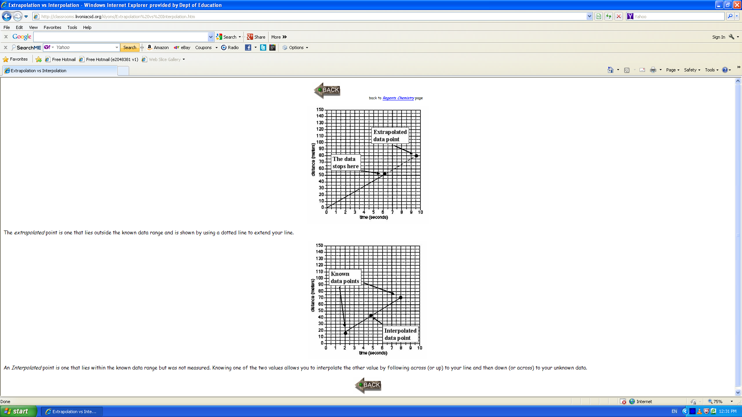

The extrapolated point is one that lies outside the known data range
and is shown y using a dotted line to extend your line.

An interpolated point is one that lies within the known data range but was not measured.
Knowing one of the two values allows you to interpolate the other value by following
across (or up) to your line and then down (or across) to your unknown data.

