Independent and dependent variables Name:

Examine each of the following statements and identify the independent and the dependent variable in each case by underlining or highlighting the correct word.

- Wheat plants will grow taller (height of plant) [independent/dependent] when they are given superphosphate fertilizer [independent/dependent].

- Obesity [independent/dependent] results from the excess intake of food [independent/dependent]

- Taking Vitamin C [independent/dependent] will reduce the time it takes to cure a cold [independent/dependent]

- The time of exposure to sunlight [independent/dependent] affects the development of the disease rickets [independent/dependent]

- Our heart rate [independent/dependent] can be affected by the length of time we spend exercising [independent/dependent]

- The ripening time of fruit [independent/dependent] can be affected by environmental temperature [independent/dependent]

- The speed of a car [independent/dependent] affects how long it takes to reach a destination (travelling time) [independent/dependent]

- Smoking [independent/dependent] causes lung cancer and other diseases of the respiratory system [independent/dependent]

- A person’s level of income[independent/dependent] is affected by his/her level of education [independent/dependent]

- The temperature (°C) at which of water boils [independent/dependent] in a container is affected by the pressure [independent/dependent] in that container.

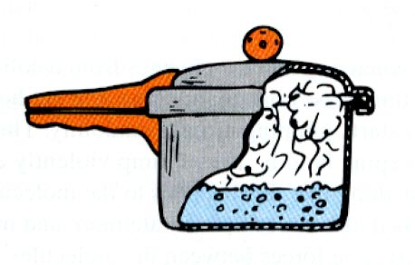

Independent and dependent variables Name:

Examine each of the following statements and identify the independent and the dependent variable in each case by underlining or highlighting the correct word.

- Wheat plants will grow taller (height of plant) [independent/dependent] when they are given superphosphate fertilizer [independent/dependent].

- Obesity [independent/dependent] results from the excess intake of food [independent/dependent]

- Taking Vitamin C [independent/dependent] will reduce the time it takes to cure a cold [independent/dependent]

- The time of exposure to sunlight [independent/dependent] affects the development of the disease rickets [independent/dependent]

- Our heart rate [independent/dependent] can be affected by the length of time we spend exercising [independent/dependent]

- The ripening time of fruit [independent/dependent] can be affected by environmental temperature [independent/dependent]

- The speed of a car [independent/dependent] affects how long it takes to reach a destination (travelling time) [independent/dependent]

- Smoking [independent/dependent] causes lung cancer and other diseases of the respiratory system [independent/dependent]

- A person’s level of income[independent/dependent] is affected by his/her level of education [independent/dependent]

- The temperature (°C) at which of water boils [independent/dependent] in a container is affected by the pressure [independent/dependent] in that container.

