PYRAMIDS AND TROPHIC LEVELS

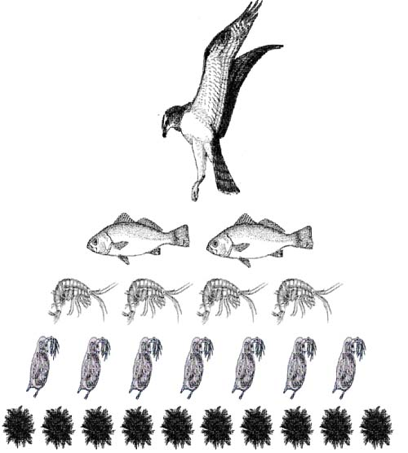
Drawing food chains only serve to illustrate who’s at the bottom of the food chain and who is at the top of the chain.

Drawing a number pyramid illustrates the change in the number of population at each trophic level. As we go up a level, the number of organisms in the higher trophic level is less than that underneath.
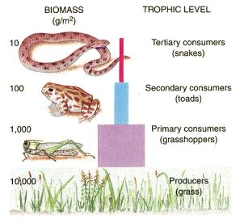

Drawing a biomass pyramid illustrates the mass of the population across different trophic levels. As we go up one trophic level, we notice that the mass is less than that underneath.

Sometimes, pyramids could be inverted(drawn upside down).
In a number pyramid, parasites outnumber the herbivore.
But this particular food chain will have a normal biomass pyramid.

Ticks
Ticks
Kangaroo
Kangaroo
Grass
Grass

Inverted number pyramid. Normal biomass pyramid.

A biomass pyramid could also be inverted. This is the case in marine food chains where phytoplankton does not have the mass to support the greater mass of zooplankton. However, this is compensated by the rapid turnover of phytoplankton. More is produced for the zooplankton to feed on.
Catfish

Prawn
Zooplankton

Phytoplankton

Inverted biomass pyramid
But, by far, the most informative and useful pyramid to ecologists is the energy pyramid. It illustrates how energy is transferred from one trophic level to another. Moreover, it shows the percentage of available energy that is transferred to the next organism, and energy lost by that organism.
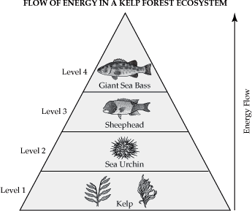

600 Cal.

~10%
6000 Cal.

~10%
60000 Cal.

~10%
600000 Cal.

In this energy pyramid you can clearly see that only around 10% of energy is transferred from sea Urchin to Sheephead. Lost energy is in the form of heat and detritus(dead organisms); and some energy is used in reproduction of the sea urchin and maintenance of bodily functions. As you go up a level you won’t have enough energy to support an organism. That’s when the food chains stops.

Energy pyramids can never be inverted because you can not create energy from nothing.

Comprehension questions:
1. What happens to the amount of energy as you move up the pyramid?

2. How is this energy lost?

3. Construct an inverted number of pyramid of your own and write the
niche of every organism next to each trophic level. (hint: look up the term
niche in your red booklet in the terminology page).

4. Why is it impossible to have a food chain of 20 or more organisms?

