FOOD CHAINS AND FOOD WEBS

A food chain is a series of steps showing feeding relationship between organisms.

The bottom organism is usually the producer. The producer makes its own food. (E.g. plants).

The next organism along the chain is the consumer. The first-order consumer is called herbivore – animal that feeds on plants only.

The next organism along the chain is also a consumer. It’s called the second-order consumer. It is a carnivore because if feeds on flesh of other animals.

Second-order consumers could be carnivores or omnivores – feeding on both plants and animals.

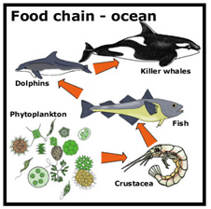

For the picture on the first page, the food chain consists of the following:

Producer: phytoplankton.
1st order consumer (herbivore): crustacean.
2nd order consumer (carnivore): fish.
3rd order consumer (carnivore): dolphin.
4th order consumer (carnivore): killer whale.

When writing a food chain flowchart it will look like this:

Phytoplankton crustacean fish dolphin killer whale.

The arrow shows the flow of energy from one organism to another. For example, fish is getting energy from crustaceans when feeding on it.

Activity 1: Write a food chain for the following diagram like the previous example, identifying producers and consumers.

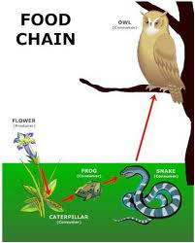

A food web is a collection of food chains that are interconnected. This will create more choices of food for an organism. One organism could eat many different organisms or it may fall prey to many predators.

In the diagram below the food web is made up of many food chains.
Food chain 1: plankton, shrimp, salmon, heron.
Food chain 2: plankton, freshwater mollusc, small fish, salmon, heron.

Here, the two food chains are connected by fish and heron. Salmon can eat fish and mollusc. Similarly, heron can eat salmon and small fish.

In a food web, killing off one animal can affect food available for other animals, therefore disturbing food chains.

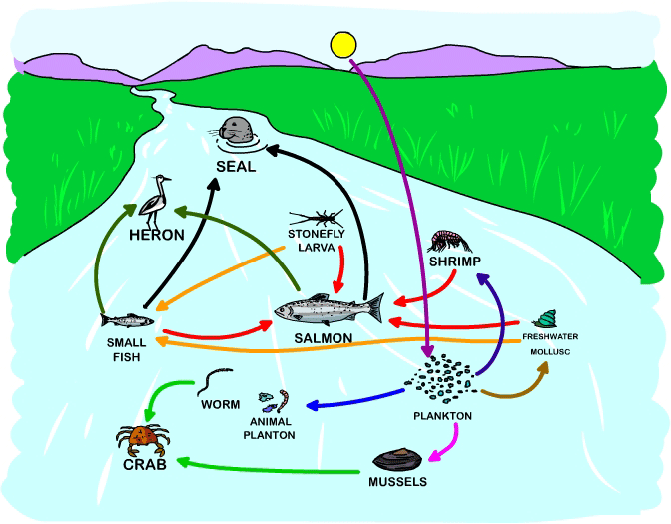

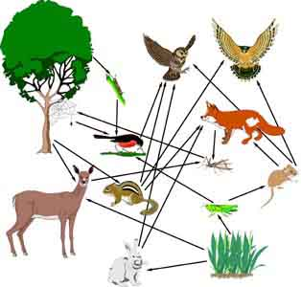

Activity 2

In the above diagram of a food web, how many food chains you can spot?

