GRAPHING CHANGES IN POPULATION SIZE
Populations do not remain constant in size. The size changes due to births, deaths as well as individuals migrating to or from an area. The factors that affect these determiners of density vary from time to time. These may be environmental factors such as light, temperature and water availability or they may be characteristic of the organism such as reproductive activity.
In many organisms, reproductive activity is seasonal. If you look at the graphs of population size against time you can identify different patterns. Before reading on, see if you can think of conditions and situations that would lead to the different patterns shown in the graphs.

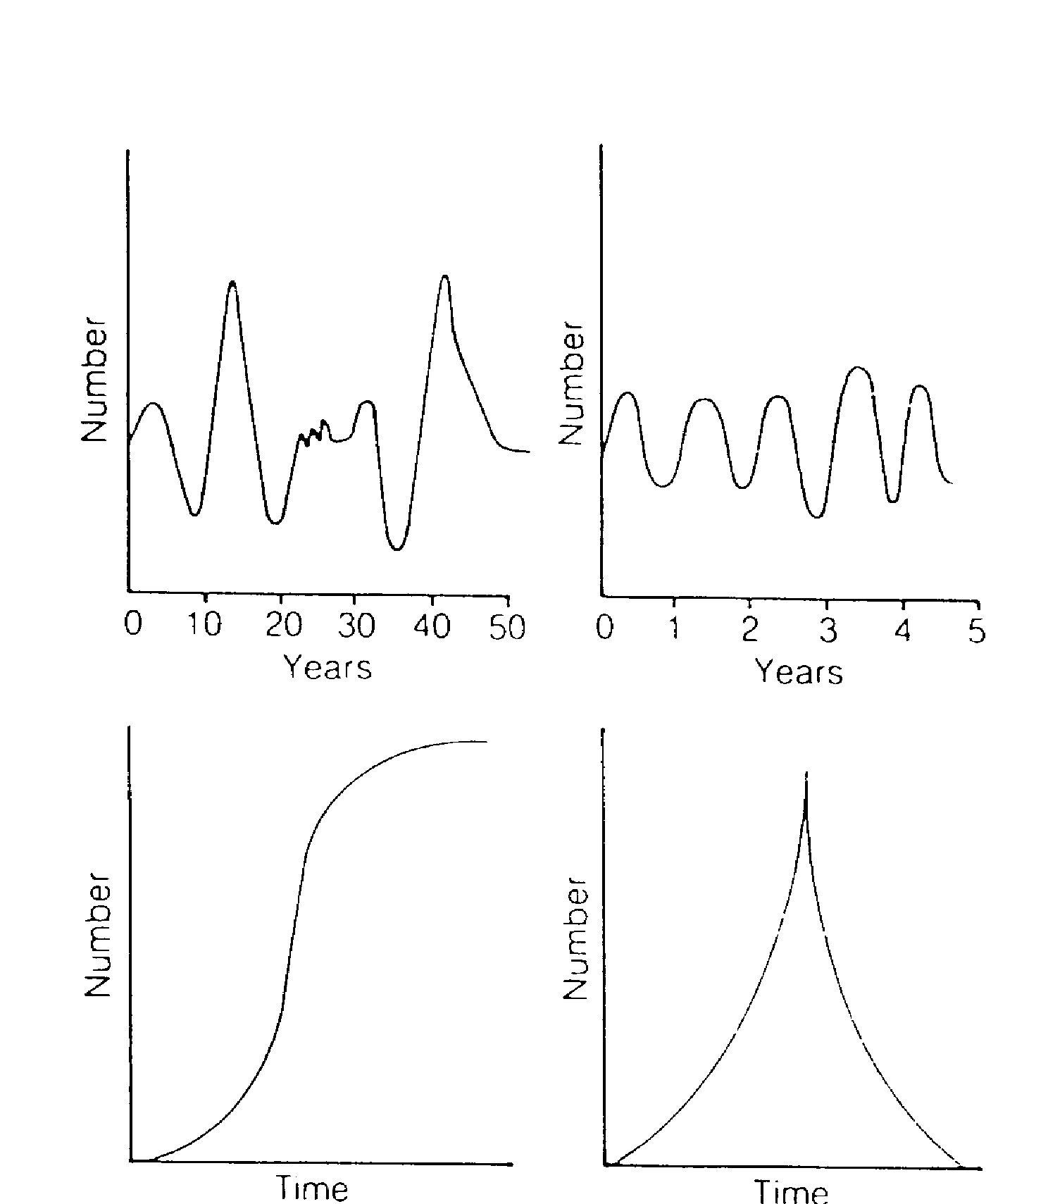
Graph 1: Fluctuations
Representational examples of changing populations: (1) fluctuation, (2) cycles,
(3) S curve and (4) J curve.

(1) (2)
(3) (4)
Fluctuations are irregular up and down movements. The graph (1) shows major and minor fluctuations that occur due to changes in conditions and organism activity. Fluctuations generally appear to be random and the causes may be difficult to determine. They can be caused by changes in predation, competition, climate, and food supply, for example.

Graph 2: Cycles
Changes may recur regularly. This may be caused by regular changes in the environment. For instance, the old and weak may tend to die in winter due to cold and because they find it hard to compete for limited food; on the other hand, births may occur in spring when water and food are abundant, and when temperatures are suitable. Such cycles
may be affected by behaviour.

Graph 3: 'S' curve
The 'S' curve is typical of the introduction of one or a few individuals into a new suitable area. At first, with few organisms, reproduction leads to a slow but accelerating increase in population. Births exceed deaths. In the next phase, food and space are still plentiful and the large number of reproducing organisms leads to rapid population increase. Many more are born than die. This may be termed a POPULATION EXPLOSION.

In the last phase, food, space or a build up of wastes slows or limits the population size as it approaches the carrying capacity of the area. When deaths equal births, the carrying capacity has been reached and the curve is a straight line parallel to the X-axis.

Graph 4:'J' curve
The 'J' curve is actually a double J curve, where the second J is back to front. It starts as an S curve but the population explosion is so rapid that an essential resource is used up, leading to a rapid decline in population size or die off completely. Alternatively, a disease might strike a densely packed population, spreading easily, and so decimate the population; or the build-up of toxic wastes may poison the whole population.

Overpopulation and plagues
Sometimes populations grow at an explosive rate and the numbers of an animal reach plague proportions. Locust plagues are well known. These insects, under the right conditions, reproduce rapidly, eat most of the vegetation in their area, and then migrate to new places.

QUESTIONS
- Match the these population changes to one of the graphs
- Human population growth over the last 10 000 years.
- Changes in blowfly population in Perth during a 10-year period.
- Population of bacteria growing in a culture dish under ideal conditions.
- Population of seagulls on the waterfront at Fremantle over a year.
- Population of blue-green algae in the Canning River over a 5 year period

2. The human population is said to be undergoing an 'explosion'.
a. List some factors that might eventually cause it to be limited.
b. Name a country where at least one of these limits is already at work.

