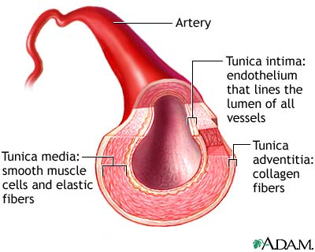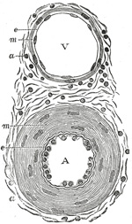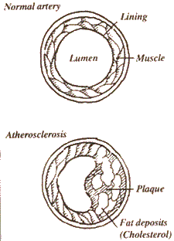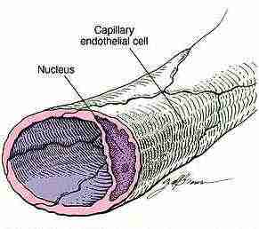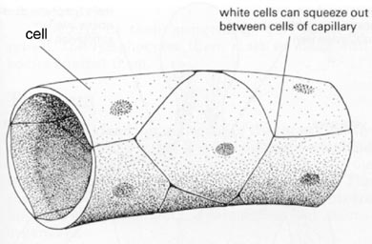
Blood vessels
lining
Healthy artery
muscle
Atherosclerosis
Endothelial cell of capillary
Nucleus
Fat deposits
Plaque
White blood cells can squeeze between the cells of the capillary

