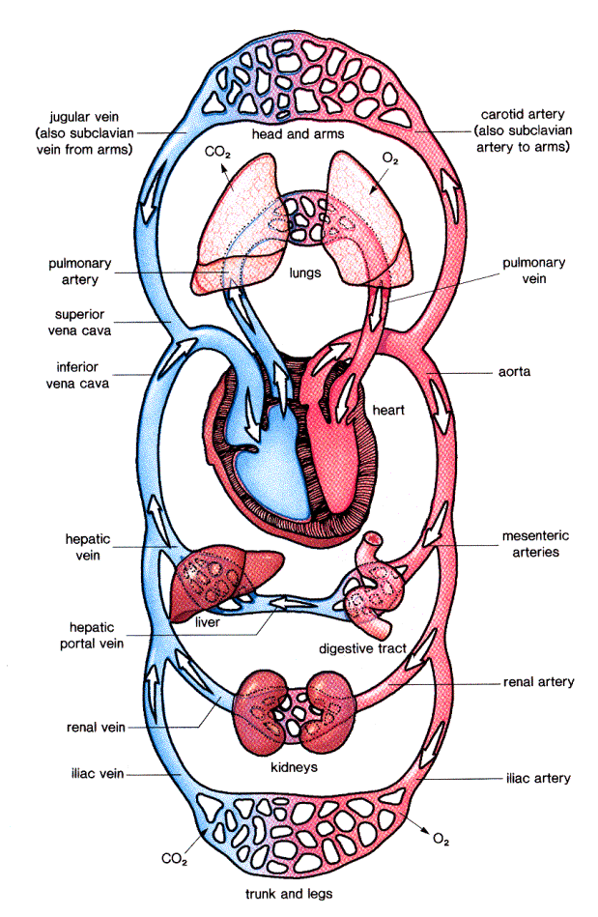
A General Plan for the Circulatory System

