The circulatory system

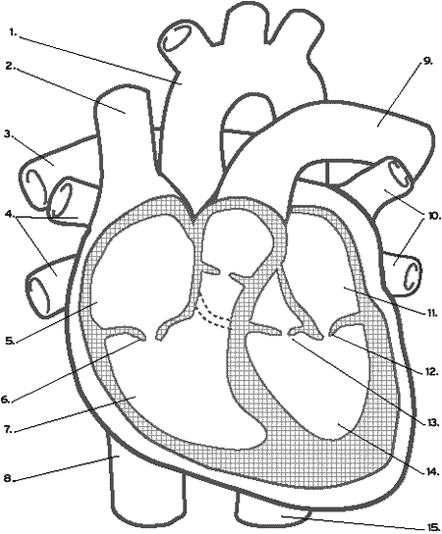
label the following structures of the heart(as many as you can).

