Circulatory System
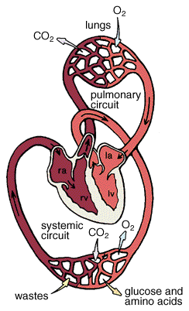
- Explain the role of
  - The pulmonary circulation:

  - The systemic circulation:

- What is the importance of the capillary networks of the circulatory system?

