Yr 9 Science Life and Living – Circulatory system.
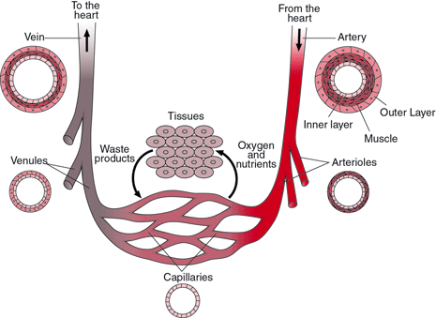

1. Name the vessel that returns blood to the heart.

2. Identify the blood vessel that delivers oxygenated blood to the body.

3. Identify the blood vessel that allows nutrients and oxygen to diffuse across its wall to reach the cells.

4. What type of blood is usually carried in the arteries?

5. Identify the scientific name of the different types of blood cells and describe their role.

Red blood cell ( ______________________ )

White blood cell ( ______________________ )

Platelets ( ______________________ )

6. complete the following table.

 | Structure | Function
Artery
Vein
Capillary

7. Describe three functions of the blood.

8. Why do people in shock fall to the ground?

9. Why most varicose veins take place in the legs?

10. Explain why arteries have a thick muscular layer.

