ATAR BIOLOGY
2017 PROGRAM
UNITS 1 & 2

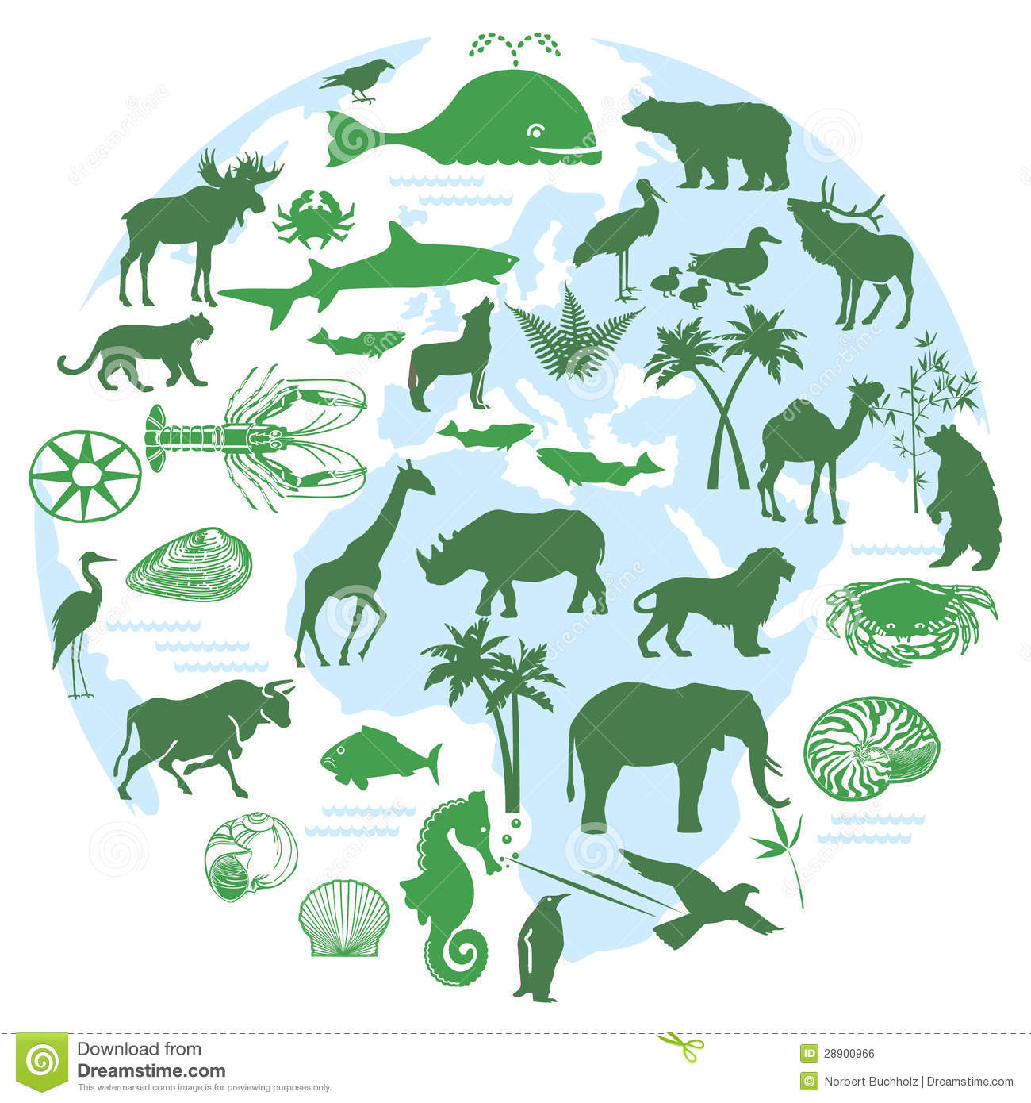
NAME: __________________

  - ATAR BIOLOGY
  - 2017 ASSESSMENT OUTLINE
UNIT 1:
Assessment Type | Topic | Schedule  Friday of: | Weighting | My Mark
SCIENTIFIC INQUIRY  (30%) | Extended Investigation | Term 1,  Week 3-9 | 10
 | Second Hand Data Investigation | Term 2, Week 1 | 5
 | Field work Investigation | Term 2, Week 4 | 15
EXTENDED RESPONSE  (10%) | Scientific Method | Term 1, Week 4 | 5
 | Ecosystems and cycles | Term 1, Week 10 | 5
TEST (20%) | Biodiversity and Classification Test | Term 1, Week 8 | 10
 | Ecosystems test | Term 2, Week 4 | 10
EXAM (40%) | Semester 1 Exam | Term 2,  Weeks 6 & 7 | 40

UNIT 2:
Assessment Type | Topic | Schedule  Friday of: | Weighting | My Mark
SCIENTIFIC INQUIRY (30%) | Microscope and Cells Assessment | Term 2, Week 10 | 10
 | Enzymes Assessment | Term 3, Week 2 | 10
 | Second Hand Data investigation | Term 3, Week 3 | 10
EXTENDED RESPONSE (10%) | Body Systems | Term 3, Week 10 | 10
TEST (20%) | Cell and Cell Metabolism Test | Term 3, Week 5 | 10
 | Animal and Plant Body System Test | Term 4, Week 1 | 10
EXAMINATIONS (40%) | Semester 2 Exam | Term 4,  Week 3 & 4 | 40

Note: Assessment times may change due to other school activities.

  - Rossmoyne Senior High School
  - BIOLOGY PROGRAM FOR UNIT 1 AND 2, 2017
Note: SI = Scientific Inquiry, SHE = Science as a Human Endeavour, ER = Extended Response
WEEK | UNIT CONTENT | OBJECTIVES & OUTLINE | TEXT READINGS & QUESTIONS | ASSESSMENTS
Term 1,  Week 1/2/3 | Introduction  Scientific Inquiry/ Method | Hand out assessment outline and programs.  Expectations: Assessments, study, homework  Absence from scheduled assessments: Medical Cert required  Materials: Textbook, notebook, calculator (scientific only)  - Review terminology  - The Scientific Method: Steps, hypothesising, variables, skills, (fair testing ,validity, reliability, reducing experimental error)  - identify, research and construct questions for investigation; propose hypotheses; and predict possible outcomes (SIS)  - represent data in meaningful and useful ways; (e.g. tabulating, graphing, interpolating, extrapolating)  - organise and analyse data to identify trends, patterns and relationships;  - qualitatively describe sources of measurement error, and uncertainty and limitations in data;  - and select, synthesise and use evidence to make and justify conclusions (SIS) | NELSON BIOLOGY UNITS 1&2  Chapter 13 Scientific Investigations  BIOZONE  Skills in Biology  Activity Number: 1, 2, 3, 4, 5, 8, 9,10, 11, 20 | SI: Extended Investigation  (10%)
Week 4 | Describing biodiversity  Biodiversity  SHE: international agreements about biodiversity encourage international cooperation in the protection of unique locations, including  Classification  of cells | - Define biodiversity  - Three levels of diversity genes, species and ecosystems;  - Measures of biodiversity rely on classification and are used to make comparisons across spatial and temporal scales  - Biodiversity strategies:  - World Heritage sites, for example, Shark Bay, Great Barrier Reef  - biodiversity hotspots, for example, south west WA  - international migration routes and areas used for breeding, for example, by birds, whales, turtles, whale sharks  - Features of all living things. (MRS GREN, cell theory)  - Cells have many features in common, which is a reflection of their common evolutionary past,  - Compare prokaryotic and eukaryotic cells.  - Compare plant, animal and fungi cells  - Eukaryotic cells carry out specific cellular functions in specialised structures and organelles, including:  cell (plasma) membrane, cell wall, cytoplasm, chloroplasts, mitochondria, endoplasmic reticulum (rough and smooth), nucleus, Golgi apparatus, lysosomes, ribosomes, vacuoles | NELSON BIOLOGY UNITS 1&2  Chapter 1 Biodiversity  BIOZONE  Changes in Ecosystems  Activity Number:275, 276,277,  BIOZONE  Classification  Activity Number: 177  BIOZONE  Habitat and Niche  Activity Number: 178, 180  NELSON BIOLOGY UNITS 1&2  Chapter 7 Cells  BIOZONE  Cell Structure  Activity Number: 29, 30, 31,32, 33, 38, 39,  BIOZONE  Cell Structure  Activity Number: 40, 41, 42, 43, 44, 45R | ER: Scientific Method  (5%)
Week 5 | Microscopes  SIS: conduct investigations, including microscopy techniques and chemical analysis  SHE : developments in microscopy and associated preparation techniques have contributed to more sophisticated models of cell structure and function | - History of microscopy  - Using a microscope (staining, viewing, measuring, etc.)  - Calculation of magnification and field of view of a microscope,  - Estimation of the size of cells. | NELSON BIOLOGY UNITS 1&2  Chapter 7 Cells  BIOZONE  Cell Structure  Activity Number: 34, 35, 36, 37,  Skills in Biology  Activity Number: 13
Week 6/7 | Classification  SIS: select, construct and use appropriate representations, including classification keys , to communicate conceptual understanding, solve problems and make predictions  SHE : classification systems are based on international conventions and are subject to change through debate and resolution; changes are based on all currently available evidence | - Importance of classification and development of system  - Biological classification is hierarchical and based on molecular sequences, different levels of similarity of physical features and methods of reproduction.  - Biological classification systems reflect evolutionary relatedness between groups of organisms  - The main classification groups used in biology – kingdom, phylum, class, order, family, genus, species.  - Main features of the five kingdoms  - Most common definitions of species rely on morphological or genetic similarity or the ability to interbreed to produce fertile offspring in natural conditions – but in all cases, exceptions are found  - Binomial nomenclature and the use of taxonomic keys to classify organisms. | NELSON BIOLOGY UNITS 1&2  Chapter 2 Classifying Biodiversity  BIOZONE  Classification  Activity Number: 168, 169, 170, 171,172,173,174,  BIOZONE  Classification  Activity Number: 175, 176,
Week 8 | Ecosystems and interrelationships  SHE: keystone species theory has informed many conservation strategies. However, there are differing views about the effectiveness of single-species conservation in maintaining complex ecosystem dynamics | - Components of an ecosystem  - Biotic and abiotic factors,  - Naming ecosystems  - Types of ecosystems  - relationships and interactions within a species and between species in ecosystems include predation, competition, symbiosis (mutualism, commensalism and parasitism), collaboration and disease  - role of keystone species | NELSON BIOLOGY UNITS 1&2  Chapter 3 Biodiverse Ecosystems  BIOZONE  Habitat and Niche  Activity Number: 179,  BIOZONE  Communities  Activity Number:250, 251, 252, 254, 255, 256,  BIOZONE  Changes in Ecosystems  Activity Number: 284 | TEST: Biodiversity and Classification  (10%)
Week 9 | Ecosystem dynamics  Energy and matter in Ecosystems  SIS: select, construct and use appropriate representations, including, food webs and biomass pyramids, to communicate conceptual understanding, solve problems and make predictions | - Flow of energy in an ecosystem.  - Food chains, food webs and pyramids  - Cycling of matter, carbon and nitrogen | NELSON BIOLOGY UNITS 1&2  Chapter 4 Energy and Matter in Ecosystems  BIOZONE  Communities  Activity Number:237, 238, 239, 240,241, 242, 244, 245, 246, 247, 248, 249,
Week 10 | Dynamic Populations  SIS: conduct investigations, including using ecosystem surveying techniques (quadrats, line transects and capture-recapture) safely, competently and methodically for the collection of valid and reliable data | - the dynamic nature of populations influence population size, density, composition and distribution  - Use of surveying techniques. | NELSON BIOLOGY UNITS 1&2  Chapter 5 Population Dynamics  BIOZONE  Populations  Activity Number: 259, 260,261, 262,263, 264, 265, 266, 267, 268,  Habitat and Niche  Activity Number: 186, 187, 188, 190, 191, 192 ,193, 195 ,196,197 | ER: Ecosystems and cycles  (5%)
Term 2,  Week 1 | Dynamic Populations | - Habitats and niches of species or populations  - Ecosystems carrying capacities  - Ecological succession | NELSON BIOLOGY UNITS 1&2  Chapter 5 Population Dynamics BIOZONE  Habitat and Niche  Activity Number: 179, 181, 182, 185  Population dynamics  Activity Number:280, 282, 268 | SI: Second Hand Data Investigation  (5%)
Week 2/3 | Impact of Human Activity | - human activities that can affect biodiversity and can impact on the magnitude, duration and speed of ecosystem change include examples of  - habitat destruction, fragmentation or degradation  - the introduction of invasive species  - unsustainable use of natural resources  - the impact of pollutants, including biomagnification  - climate change  - fire is a dynamic factor in Australian ecosystems and has different effects on biodiversity  - Primary and secondary succession | BIOZONE  Changes in Ecosystems  Activity Number: 285, 286,287, 288, 289, 290, 291, 292, 293, 294, 295, 296  BIOZONE  Environment and Adaptations  Activity Number: 234
Week 4 | Conservation Strategies  SHE: identification and classification of an ecological area as a conservation reserve also requires consideration of the commercial and recreational uses of the area, as well as Indigenous Peoples’ usage rights  SHE: Australia’s Biodiversity Conservation Strategy 2010–2030 presents a long-term view of the future and the actions that need to be implemented to conserve biodiversity  SHE: contemporary technologies, including satellite sensing and remote monitoring enable improved monitoring of habitat and species population change over time. | - conservation strategies used to maintain biodiversity are  - genetic strategies, including gene/seed banks and captive breeding programs  - environmental strategies, including revegetation and control of introduced species  - management strategies, including protected areas and restricted commercial and recreational access | BIOZONE  Changes in Ecosystems  Activity Number: 278, 279 | SI: Field Work  Excursion  (15%)  TEST: Ecosystems  (10%)
Week 5 |  | CATCH UP / REVISION / ASSESSMENT FREE WEEK
Week 6/7 |  | EXAMS |  | SEMESTER 1 EXAM  (40%)
Week 8 | Review  Cells as the basis of life  Cells requirements  Cell Membrane Structure and Function  SHE 1: the cell membrane model has been continually reconceptualised and revised since the mid-nineteenth century and the currently accepted model, based on the evidence from improved technologies, is the fluid mosaic model  SIS: select, construct and use appropriate representations, including diagrams of structures and processes, and images from different imaging techniques, to communicate conceptual understanding, solve problems and make predictions | Review Exams  - Review of cell components and microscopes  - Cell requirements for life.  - Define metabolism  - Structure of cell membrane and function  - Draw a diagram of cell membrane | Exam Review & Reflections  NELSON BIOLOGY UNITS 1&2  Chapter 8 Cells in their Environment  BIOZONE  Cellular Processes  Activity Number: 46, 47,
Week 10 | Transport across the Membrane | - movement of materials across membranes occurs via  - passive processes, including diffusion, facilitated diffusion, osmosis  - active processes, including active transport, endocytosis and exocytosis  - factors that affect exchange of materials across membranes include  - the surface area to volume ratio of the cell  - concentration gradients  - the physical and chemical nature of the materials being exchanged | BIOZONE  Cellular Processes  Activity Number: 48, 49, 51, 52, 53, 55 | SI: Microscopes and Cells Assessment  (10%)

Term 3, Week 1 | Biological Molecules  Membranes  Enzymes | - biological molecules are synthesised from monomers to produce complex structures, including carbohydrates, proteins and lipids  - biochemical processes in the cell are controlled by factors, including the  - nature and arrangement of internal membranes,  - and the presence of specific enzymes | BIOZONE  Cell Structure  Activity Number: 21, 22, 23, 25, 26  NELSON BIOLOGY UNITS 1&2  Chapter 9 Inside Cells
Week 2 | Enzymes | - enzymes have specific functions which can be affected by factors, including  - temperature  - pH  - presence of inhibitors  - concentrations of reactants and products  - two models that are used to explain enzyme action are the lock and key model and the induced fit model | BIOZONE  Cell Structure  Activity Number: 27 | SI: Enzymes Assessment  (10%)
Week 3 | Photosynthesis | - photosynthesis is a biochemical process that uses light energy to synthesise organic compounds; light dependent and light independent reactions occur at different sites in the chloroplast; and make up separate parts of the overall process that can be represented as a balanced chemical equation  - the rate of photosynthesis can be affected by the availability of light and carbon dioxide, and temperature | BIOZONE  Plant and Animal Nutrition  Activity Number: 68, 69, 70, 71, 72, 73, | SI: Second Hand Data Investigation  (10%)
Week 4 | Respiration  - SHE 4: current research for the production of food, beverages and biofuels, and the breakdown of rubbish, involves the control of cellular respiration and photosynthesis  SHE: the use of probes technologies and computer analysis has further advanced the understandings of vital chemical processes in cells | - cellular respiration is a biochemical process that occurs in different locations in the cytosol and mitochondria, and metabolises organic compounds, aerobically or anaerobically, to release useable energy in the form of ATP; products of anaerobic respiration vary between organisms (plants, yeast, bacteria, animals); the overall process of aerobic respiration can be represented as a balanced chemical equation  - the rate of respiration can be affected by the availability of oxygen and glucose, and temperature
Week 5 | Multicellular organisms  Organisation  Animal Respiratory Systems | - multicellular organisms have a hierarchical structural organisation of cells, tissues, organs and systems  - in animals, the exchange of gases between the internal and external environments of the organism is facilitated by the structure of the exchange surface(s), including spiracles, gills, alveoli and skin | NELSON BIOLOGY UNITS 1&2  Chapter 10 Cells to Multicellular Organisms  BIOZONE  Cellular Processes  Activity Number: 62, 63, 64  NELSON BIOLOGY UNITS 1&2  Chapter 11 Animal Systems for Life  BIOZONE  Gas Exchange  Activity Number: 97, 100, 101, 102, 103, 105, 107 | Test  Cell and Cell Metabolism  (10%)
Week 6/7 | Animal Digestive  Systems | - in animals, the acquisition and processing of nutrients is facilitated by the structure of the digestive system; animals may have a gastrovascular cavity with one opening or a specialised alimentary canal with two openings; specialisation of alimentary canals is related to diet, for example, herbivores and carnivores | BIOZONE  Plant and Animal Nutrition  Activity Number: 67, 79, 80, 81, 83, 85
Week 8 | Animal Circulatory Systems | - in animals, the transport of materials within the internal environment for exchange with cells is facilitated by the structure of open and closed circulatory systems according to the different metabolic requirements of organisms and differing environments | BIOZONE  Internal Transport  Activity Number:115, 117, 118, 119
Week 9/10 | Plant Systems | - in vascular plants, gases are exchanged via stomata and the plant surface  - transport of water and mineral nutrients from the roots occurs via xylem through root pressure, capillary action (adhesion and cohesion), transpiration;  - transport of the products of photosynthesis and some mineral nutrients occurs by translocation in the phloem  - Australian plants are adapted to minimise water loss in an arid environment | NELSON BIOLOGY UNITS 1&2  Chapter 12 Plant Systems for Life  BIOZONE  Plant and Animal Nutrition  Activity Number: 98, 99,  BIOZONE  Internal Transport  Activity Number: 108, 109, 110, 111, 112, 113,114 | ER: Body Systems  (10%)

Term 4,  Week 1 | Animal Ethics  SIS: conduct investigations, including microscopy techniques, real or virtual dissections and chemical analysis, safely, competently, ethically and methodically for the collection of valid and reliable data | - SHE: ethical treatment of animals, including the three strategies of replacement, reduction and refinement, forms the basis of many international guidelines in animal research. |  | Test  Animal and Plant Body System  (10%)
Week 2 |  | CATCH UP /REVISION / ASSESSMENT FREE WEEK
Week 3/4 |  | EXAMS |  | SEMESTER 2  EXAM (40%)

