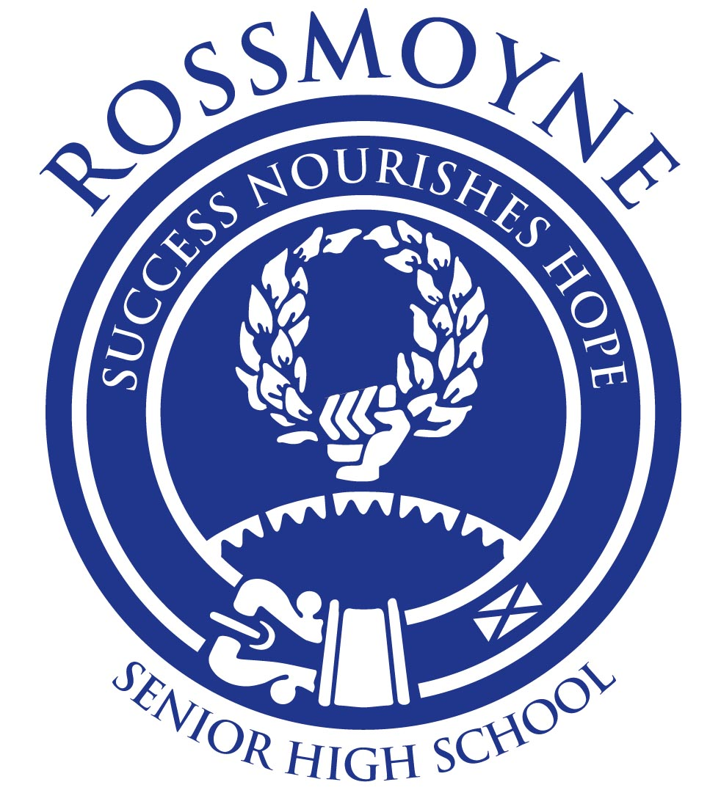
Chinese: Second Language – ATAR Year 11

Assessment outline

Units 1 and 2
Assessment type  (from syllabus) | Assessment  type weighting  (from syllabus) | Assessment task weighting | When | Assessment task
Oral communication | 20% | 10% | Term 1  Week 5 | Task 2: 3 minute role-play conversation in Chinese, related to The Individual: Having fun.
Oral communication | 20% | 5% | Term 3  Week 3 | Task 9: 4–5 minute conversation in Chinese with a Chinese speaker, related to The individual: Tales of travel.
Oral communication | 20% | 5% | Term 3  Week 8 | Task 11: 3 minute discussion in Chinese of stimulus, related to The Chinese-speaking communities: Western Australia as a travel destination.
Practical (oral) examination | 10% | 5% | Term 2  Week 6&7 | Task 6: Approximately 7 minutes, using a modified examination design brief from the Year 12 syllabus ‘Part C: Conversation’ only.
Practical (oral) examination | 10% | 5% | Term 4  Week 3&4 | Task 13: Approximately 10 minutes, using the examination design brief from the Year 12 syllabus.
Response: Listening | 15% | 7% | Term 1  Week 7 | Task 3: Listen to spoken texts in Chinese, related to The Individual: Having fun and The Chinese-speaking communities: Student’s daily life and respond to questions in English.
Response: Listening | 15% | 8% | Term 3  Week 2 | Task 8: Listen to spoken texts in Chinese, related to The individual: Tales of travel and respond to questions in English.
Response: Viewing and reading | 20% | 5% | Term 1  Week 9 | Task 4: Read texts in Chinese, related to The Chinese-speaking communities: Student’s daily life and respond to questions in English.
Response: Viewing and reading | 20% | 5% | Term 2  Week 3 | Task 5: Read texts in Chinese, related to The changing world: Technology and leisure and respond to questions in English.
Response: Viewing and reading | 20% | 10% | Term 3  Week 10 | Task 12: Read texts in Chinese, related to The individual: Tales of travel and The changing world: China as a travel destination and respond to questions in English.
Written communication | 15% | 7% | Term 1  Week 4 | Task 1: Write an account of approximately 100 Chinese characters, related to The Individual: Having fun.
Written communication | 15% | 8% | Term 3  Week 6 | Task 10: Write an email of approximately 120 Chinese characters, related to The Chinese-speaking communities: Western Australia as a travel destination.
Written examination | 20% | 10% | Term 2  Week 6&7 | Task 7: 1.5 hours, using a modified examination design brief from the Year 12 syllabus: Section One (30%) three short and one longer spoken text in Chinese; Section Two (40%) three print texts in Chinese;  Section Three (20%) two questions – short written responses in Chinese.
Written examination | 20% | 10% | Term 4  Week 3&4 | Task 14: 2.5 hours using the examination design brief from the Year 12 syllabus.
Total | 100% | 100%

