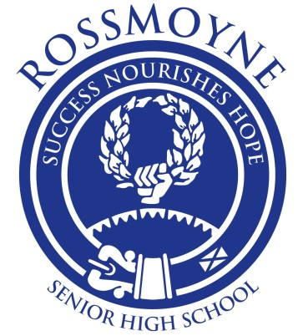
Year 11 ATAR HUMAN BIOLOGY
2017 PROGRAM
UNITS 1 & 2

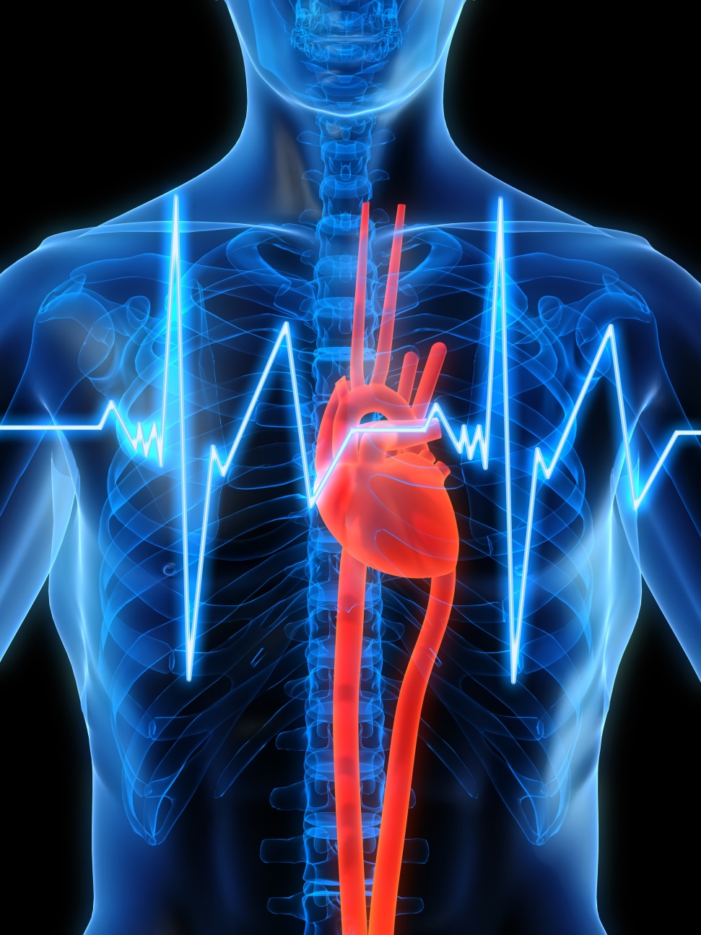

NAME: __________________

  - RSHS 2017 ASSESSMENT OUTLINE
UNIT 1 * Please note this outline is subject to change *
Assessment Type | Topic | Schedule | Weighting | My Mark
SCIENTIFIC INQUIRY (20%) | Microscope & Tissues Investigation | Term 1, Week 3 | 10
 | Second Hand Data Investigation | Term1, Week 10 | 10
EXTENDED RESPONSE (15%) | Digestion & Lifestyle  Extended Response | Term 1, Week 8 | 7.5
 | Musculoskeletal System  Extended Response | Term 2, Week 4 | 7.5
TEST & EXAMINATIONS (25%) | Period Zero: Cell Test  (Topic 1) | Term 1, Week 6 | 12.5
 | Period Zero: Systems Test  (Topic 2 & 3) | Term 2, Week 2 | 12.5
EXAM (40%) | Semester 1 Exam | Term 2,  Weeks 6 & 7 | 40
UNIT 2
Assessment Type | Topic | Schedule | Weighting | My Mark
SCIENTIFIC INQUIRY (20%) | Cancer Investigation | Term 3, Week 3 | 10
 | Hormones Investigation | Term 3, Week 8 | 10
EXTENDED RESPONSE (15%) | Protein Synthesis  Extended Response | Term 2, Week 10 | 7.5
 | Sexually Transmitted Infections & Contraception Extended Response | Term 3, Week 10 | 7.5
TEST (25%) | Period Zero: DNA & Inheritance Test (Topic 5 & 6) | Term 3, Week 5 | 12.5
 | Period Zero: Human Reproduction Test (Topic 7) | Term 4, Week 1 | 12.5
EXAMINATIONS (40%) | Semester 2 Exam | Term 4,  Week 3 & 4 | 40

  - ROSSMOYNE SENIOR HIGH SCHOOL - PROGRAM FOR UNIT 1 AND 2, 2017
* Please note this program is subject to change * Note: SIS = Scientific Inquiry Skills, SHE = Science as a Human Endeavour
WEEK | TOPIC | OBJECTIVES & OUTLINE |  | RESOURCES/SUGGESTED ACTIVITIES/QUESTIONS | ASSESSMENTS & IMPORTANT DATES
Term 1,  Week 1 | Introduction  Start Topic #1  1a.  Scientific Inquiry  Microscopes | Programs & Syllabus  http://senior-secondary.scsa.wa.edu.au/syllabus-and-support-materials/science/human-biology  RSHS Upper School Assessment Policy  http://www.rossmoyne.wa.edu.au/about-us/policies/assessment-and-reporting-policy/  Investigating Scientifically:  - Review terminology  - identify, research and construct questions for investigation; propose hypotheses; and predict possible outcomes (SIS)  - represent data in meaningful and useful ways; organise and analyse data to identify trends, patterns and relationships; qualitatively describe sources of measurement error, and uncertainty and limitations in data; and select, synthesise and use evidence to make and justify conclusions (SIS)  Microscopes:  - Calculate magnification, field of view, estimate cell size |  | Materials: Textbook, Study Guide, Past Exam Papers  TEXTBOOK: UNIT 1&2 HUMAN BIOLOGY ATAR  Chapter 1 & 2, Pages 3-26  Scientific Method Terminology  Homework: Scientific Method Questions  Microscope Practice & Labs  Calculation Worksheets  Homework for weekend – Review cell organelles (Yr 10)
Week 2 | 1b.  Cells &  Cell Transport  Tissues | Cells:  - Review organelles from Year 10  - Hierarchy (cells, tissues, organs, systems), structures and functions  - Label cell organelles and outline function/s  Cell Membrane & Transport of materials:  - Structure of Cell membrane  - Fluid Mosaic Model  - Transport: Diffusion, Osmosis, Facilitated Diffusion, Active Transport, Vesicular transport  - Factors affecting exchange of materials across the membrane:  - Surface area to volume ratio  - Concentration gradients  - Nature of materials being exchanged  Tissues:  - The various tissues of the human body perform specific functions and can be categorised into four basic tissue types:  - Epithelial  - Connective  - Muscular  - Nervous  - SIS – Use images of various tissues to communicate conceptual understanding and make predictions |  | TEXTBOOK: UNIT 1&2 HUMAN BIOLOGY ATAR  Chapter 3-5, Pages 27-61  Cell worksheets, Cell Transport flow chart  STAWA STAGE 2: BODY WORKS  Activity: SA:Vol – why is it important?  Activity 4: The exchange of materials (Part A: Diffusion DEMO)  Egg & Osmosis video/ activity  https://www.youtube.com/watch?v=SrON0nEEWmo  Create a comparison table of Tissue types (Types, where found in the body, description, special features)  Worksheet – Predicting tissues
Week 3 | 1c  Cellular Metabolism | Cellular Metabolism:  - Cellular respiration to release energy in form of ATP  - Catabolism vs. Anabolism  - ATP & its uses  - Aerobic vs. Anaerobic – reactants, products, location, amount of ATP |  | TEXTBOOK: UNIT 1&2 HUMAN BIOLOGY ATAR  Chapter 6, Pages 67-73  Comparison table – Aerobic vs. Anaerobic  STAWA STAGE 2: BODY WORKS  Activity 7: Respiration – Aerobic and Anaerobic | Investigation: Microscopes & Tissues  10%
Week 4 | 1d.  Nutrients  Enzymes | Nutrients:  - Cells require nutrients including: Carbohydrates, proteins, lipids etc.  Enzymes:  - Structure  - How they work – lock and key, activation energy  - Factors affecting – pH, temperature, concentration, co-factors and co-enzymes |  | TEXTBOOK: UNIT 1&2 HUMAN BIOLOGY ATAR  Chapter 6, Pages 63-67, 71  STAWA STAGE 2: BODY WORKS  Act 20: Contents of my food  Act 19, 21 or 22 (Food and nutrients)  Act 27: Effective Enzymes
Weeks  5 + 6 | Start Topic #2  2a. Digestion | Digestive System:  - Digestion involves the breakdown of large molecules to smaller ones by mechanical digestions and chemical digestion (by enzymes)  - Structure and Function  - The sequence of organs is important in the efficient digestion of food and absorption of nutrients in providing the appropriate conditions and enzymes.  - Absorption & Efficiency of surfaces – large surface area of Small intestines aids in absorption, structure of villi  - Elimination is the removal of undigested material and some metabolic wastes from the body  - (SHE) Dysfunctions e.g. diarrhoea, constipation  - (SHE) Consequences of lifestyle – malnutrition, obesity, anorexia |  | TEXTBOOK: UNIT 1&2 HUMAN BIOLOGY ATAR  Chapter 9, Pages 107-121  Tripe Dissection  STAWA STAGE 2: BODY WORKS  Act 23: Inside the Digestive System  Act 24: Digestion Simulation  Act 26: Why is there acid in my stomach?  Act 28: Digestion of fats | WEEK 6  PERIOD ZERO:  Cell Test  (Topic 1)  12.5%
Week 7 | 2b. Excretion | Excretion:  - Structure and function of organs involved  - Macrostructure of the kidney & urinary system  - Introduce structure of the nephron – filtration, reabsorption and secretion (no hormones req. For year 11)  - SHE: effect of performance enhancing drugs  - Urine composition with respect to volume & concentration. Hydrated vs. Dehydrated. Urine colour charts?  - The role of the liver and process of deamination |  | TEXTBOOK: UNIT 1&2 HUMAN BIOLOGY ATAR  Chapter 10, Pages 122-134  Kidney Dissection  STAWA STAGE 2: BODY WORKS  Act 32: Urine Production
Week 8 | Start Topic #3  3a. Respiratory System | Respiratory System:  - Structures and functions  - Gas exchange – Alveoli suited for function, internal vs. external respiration, how exchange is maintained  - SHE: dysfunctions of Resp system – diagnosis & treatment (Asthma, Emphysema)  - SHE: Consequences of life choices on the individual & foetus e.g. Smoking |  | TEXTBOOK: UNIT 1&2 HUMAN BIOLOGY ATAR  Chapter 8, Pages 97-106  Lung Dissection  STAWA STAGE 2: BODY WORKS  Activity 12: Respiratory Volumes | Extended Response: Digestion & Lifestyle  7.5%
Weeks  9 + 10 | 3b. Cardiovascular System | Circulatory System:  - The transport of materials within the internal environment for exchange with cells is facilitated by the structure and function of the circulatory system at the cell, tissue and organ levels.  - Heart structures and functions  - Outline the types and describe the structure and function of the different blood vessels and blood components  - Describe the pathway of systematic and pulmonary circulation  - Understand the role of the lymphatic system – return excess fluid to the CV system  - SHE: Blood transfusions rely on determining blood groups and can be used to treat many different diseases and conditions  - Blood groups ABO & Rh+/- blood systems – blood matching of donor and recipient. Maternal & foetal incompatibility due to Rhesus  - SHE: consequences of lifestyle choices, including being active or sedentary |  | TEXTBOOK: UNIT 1&2 HUMAN BIOLOGY ATAR  Chapter 7, Pages 75-96  Heart Dissection  STAWA STAGE 2: BODY WORKS  Activity 17: Cardiovascular Disease (Data Interpretation) | WEEK 10  Investigation: Second Hand Data 10%
WEEK | TOPIC |  | OBJECTIVES & OUTLINE | RESOURCES/SUGGESTED ACTIVITIES/QUESTIONS | ASSESSMENTS & IMPORTANT DATES
Term 2, Week 1 | 3b. |  | Finish Cardiovascular System  Revision for Systems Test (Week 2)
Weeks  2 + 3 | Start Topic #4  4a. Musculoskeletal System |  | Musculoskeletal System:  - Describe and label the macroscopic structure of the bone. (Compact vs. Cancellous)  - Names and label the bones of the human body (Axial and Appendicular)  - Describe and label the Haversian System  - Describe the different types of joints in the body – types, locations, features, range of movements  - SHE: strains and breaks  - Outline and describe the different types of cartilage  - Osteoarthritis & Osteoporosis – causes, impacts, symptoms, treatments  - Describe and compare the different types – skeletal, cardiac & smooth  - Label a Macroscopic skeletal muscle  - Explain muscles working in pairs - Agonist vs. Antagonistic movement | TEXTBOOK: UNIT 1&2 HUMAN BIOLOGY ATAR  Chapter 11-12  Pages 135-163  Long bone dissection  STAWA Stage 3: Changing Bodies  Act 26: Bones & Osteoporosis  Act 27: Joints and Arthritis  Act 28: Muscle Movement | WEEK 2  PERIOD ZERO:  Systems Test (Topic 2 & 3)  10%
Week 4 | Musculoskeletal System |  | - Label a microscopic view/sarcomere – actin, myosin and the zones/lines/bands  - Explain in detail the sliding filament theory – contraction vs. relaxation.  Rest of week: Catch-up | Videos ‘Sliding Filament Model’ | Extended Response: Osteoporosis & Osteoarthritis  7.5%
Week 5 | Assessment Free Week. Note: content may still be taught during this time
Weeks  6 + 7 | SEMESTER ONE EXAMINATIONS |  |  |  | SEMESTER 1 EXAM  40%
Weeks  8 + 9 | Start Topic #5  5a. DNA |  | Review Exams (~2 days)  DNA:  - Structure – histones, double stranded, nucleotide composition, base pairing  - Purpose – stores the information for the production of Proteins that determines the structure and function of the cells  - Describe DNA replication  Protein Synthesis:  - Outline the process of Protein Synthesis: Transcription and Translation  - Protein Synthesis involves the transcription of a gene on DNA into mRNA in the nucleus, and translation into an amino acid sequence at the ribosome with the aid of tRNA.  - SIS: Use construct models of transcription & translation to communicate | Exam Review & Reflections  TEXTBOOK: UNIT 1&2 HUMAN BIOLOGY ATAR  Chapter 13  Pages 165-179  STAWA STAGE 2: BODY WORKS  Act 34: DNA – Life’s Master Molecule  STAWA Stage 3: Changing Bodies  Act 13: Protein Synthesis and mutations  Videos – Protein Synthesis
Week 10 | 5b. Epigenetics |  | Epigenetics:  - Epigenetics is the study of phenotypic expression of gene, which depends on the factors controlling transcription and translation during protein synthesis, the products of other genes and the environment  - Describe histone modification and DNA methylation  - SHE: discoveries made through modern biotechnological techniques have increases understandings of DNA & gene expression | STAWA STAGE 2: BODY WORKS  Act 41: Nature vs. Nurture  STAWA Stage 3: Changing Bodies  Act 14: Epigenetics and Gene expression | Extended Response: Protein Synthesis  7.5%
WEEK | TOPIC |  | OBJECTIVES & OUTLINE | RESOURCES/SUGGESTED ACTIVITIES/QUESTIONS | ASSESSMENTS & IMPORTANT DATES
Term 3,  Week 1 | 5c. Mitosis, Meiosis & Cancer |  | Cell Reproduction  - Describe the stages of mitosis and the events that take place in each phase  - Describe the stages of Meiosis - stages of Meiosis allow for orderly distribution of haploid sets of chromosomes to daughter cells  - Compare Mitosis vs. Meiosis  - Briefly describe the common symptoms of cancer and treatments available.  - Outline the preventative tests available for Cancer screening – mammogram, pap smear, prostate check | TEXTBOOK: UNIT 1&2 HUMAN BIOLOGY ATAR  Chapter 14 & 15  Pages 181-190, 197-200  STAWA STAGE 2: BODY WORKS  Act 33: Meiosis – Dividing to multiply
Week 2 | Start Topic #6  6a. Inheritance, Punnett Squares |  | Inheritance:  - Inheritance terminology & definitions  - Describe the different types of inheritance  - DNA profiling identifies the unique genetic make-up if individuals and can be used in determining parentage  - Probable frequencies of genotype and phenotype of offspring can be predicted using Punnett squares and by taking into consideration patterns of inheritance, including the effects of dominance/recessive, co-dominance, autosomal or sex-linked alleles and multiple alleles  - Examples: Huntington’s Disease, phenylketonuria (PKU), ABO blood groups, red-green colour blindness, haemophilia | TEXTBOOK: UNIT 1&2 HUMAN BIOLOGY ATAR  Chapter 22 & 23  Pages 302-347  Terminology Sheet  Punnet Square practice and predictions  STAWA STAGE 2: BODY WORKS  Act 36: What will my kids look like?  Act 38: Monohybrid crosses

Week 3 | 6a | Continue inheritance  - Pedigree charts can constructed for families with a particular genetic disorder and can be used to reveal patterns of inheritance and assist in determining the probability of inheriting the condition in future generations  - SHE: Select, construct & use appropriate representations, including models of karyotypes to communicate conceptual understanding, solve problems and make predictions | Pedigree worksheets  STAWA STAGE 2: BODY WORKS  Act 39: Family Trees | Investigation: Cancer  10%
Week 4 | Start Topic #7  7a. Reproduction & Gametogenesis | Reproduction  - Outline the purpose of reproduction  - Male and female reproductive structures and functions  - The production of offspring is facilitated by the structure and function of the male and female reproductive systems in producing and delivering gametes for fertilisation and providing for the developing embryo & foetus  - Gametogenesis:  - Human Reproduction: Human gametes are produced through spermatogenesis and oogenesis, which are specific forms of meiosis, but varying significantly in process and products | TEXTBOOK: UNIT 1&2 HUMAN BIOLOGY ATAR  Chapter 15,  Pages 191-196, 200-208  STAWA STAGE 2: BODY WORKS  Act 42: Reproductive Systems
Weeks  5 + 6 | 7b. Reproductive Cycles, Hormones & Fertilisation | - Both male and female reproduction is regulated by hormones including the regulation of the ovarian & menstrual Cycles:  - Hormonal regulation of female menstrual and ovarian cycles: FSH, LH, Oestrogen & Progesterone  - Role of hormones in male reproductive system – FSH, LH, Testosterone  Coitus & Fertilisation:  - Outline sexual intercourse and events that take place  - For the establishment of a pregnancy, conception requires the union of viable sperm and ovum at the optimum time in the ovarian cycle | TEXTBOOK: UNIT 1&2 HUMAN BIOLOGY ATAR  Chapter 16  Pages 209-220  STAWA STAGE 2: BODY WORKS  Act 44: Menstrual Cycles | PERIOD ZERO:  DNA & Inheritance  Test  (Topic 5 & 6)  12.5%
Week 7 | 7d. Development, Teratogens & Stem Cells | Embryonic and Foetal development  - Briefly describe the stages/main events that take place over the embryonic and foetal period (during the 9 months)  - Describe cell differentiation and the development of the three primary germ layers  - Outline the impact of Teratogens on the embryo/foetus  - SHE: lifestyle choices including diet, illicit drugs, alcohol and nicotine may affect foetal development  Stem Cells:  - Define a stem cell  - Outline the 3 types and sources of stem cells (Totipotent, Multipotent and Pluripotent)  - Briefly describe the medical uses of stem cells | TEXTBOOK: UNIT 1&2 HUMAN BIOLOGY ATAR  Chapter 17 - 18  Pages 222-249  STAWA STAGE 2: BODY WORKS  Act 52: Foetal Growth & Development  Act 53: Teratogens – Will this harm my baby?
Week 8 | 7e. Birth, Changes after birth & Breastfeeding | Birth and Change  - Describe the events that take place during the three stages of Labour  - Compare circulatory changes that take place between foetus &. neonate  - Describe and be able to label breast structures and functions  - Describe the milk let down reflex and the hormones involved  - Compare Breast feeding vs. Bottle feeding (advantages and disadvantages on both mother and baby) | TEXTBOOK: UNIT 1&2 HUMAN BIOLOGY ATAR  Chapter 19  Pages 260-272 | Investigation: Hormones  10%
Week 9 | 7c. Contraception & STIs | Contraception and STIs:  - Contraception methods that reduce the probability of the union of gametes or implantation (all have limitation, risks and benefits).  - Outline the different methods: Hormonal, Mechanical barriers, Chemical and Sterilisation (use, effectiveness, advantages and disadvantages)  - Sexually Transmitted infections (STI’s), diseases transmitted through unprotected sex and genital contact, can be prevented through safe sex methods; early detection and treatment of infection are important and, if left untreated, STI’s can lead to serious health consequences  - Outline the STI’s caused by: fungus, bacteria & virus (cause, symptoms, treatments) | TEXTBOOK: UNIT 1&2 HUMAN BIOLOGY ATAR  Chapter 20, 21  Pages 273-287, 289-301  STAWA STAGE 2: BODY WORKS  Act 45: Birth Control  Act 46: STI’s other than HIV/AIDS  Act 47: HIV/AIDS
Week 10 | 7f. Reproductive Technologies &  Ethics | Reproductive Technologies:  - There are a range of techniques available to genetically screen embryos before implantation or during early development  - Describe the different techniques used: Ultrasound, Amniocentesis, Chorionic villus sampling, fetoscopy  - There are a variety of assisted reproductive technologies to help overcome infertility problems, but each has its limitations, risks and benefits  - Discuss the different treatments available to help infertile couples  Ethics:  - Discuss the issues/ethics surrounding stem cells and IVF  - SHE: the use of genetic profiling and genetic screening adults and embryos have ethical considerations | TEXTBOOK: UNIT 1&2 HUMAN BIOLOGY ATAR  Chapter 18  Pages 235-237, 249-259  Act 28: Reproductive Technologies – Decisions  Act 50: Prenatal Testing  Act 51: Maternal & foetal observations | Extended Response: Contraception & STI’s  7.5%

WEEK | TOPIC | OBJECTIVES & OUTLINE | RESOURCES/SUGGESTED ACTIVITIES/QUESTIONS | ASSESSMENTS & IMPORTANT DATES
Term 4,  Week 1 |  | Revision/preparation for test and exams | Past exam papers & Study Guide | PERIOD ZERO:  Human Reproduction Test  (Topic 7)  12.5%
Week 2 | Assessment Free Week - Note: content may still be taught during this time
Weeks  3 + 4 | SEMESTER TWO EXAMINATIONS |  |  | SEMESTER 2 EXAM  40%

