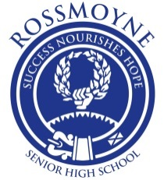

COURSE BOOKLET
11 LITERATURE ATAR
SEMESTER ONE 2017

ATAR LITERATURE COURSE OF STUDY YEAR 11

ASSESSMENT TABLE

SCHOOL CURRICULUM AND ASSESSMENT AUTHORITY |  | ROSSMOYNE SENIOR HIGH SCHOOL
SCASA | Type of assessment | RSHS | Semester One | RSHS | Semester Two
10–30% | Extended written response  This could include analytical, discursive and reflective responses in a number of forms: long essays, research assignments, feature articles or a collection of journal entries. | 15% | Task Two  Long Essay  Novel Study | 15% | Task Two  Long Essay  Intertextuality Study: On concepts and representation of power.
30–50% | Short written response  This could include analytical, discursive and reflective responses in a number of forms: short essays, close readings, short responses to a series of questions or individual journal entries. | 35% | Task One  Short Essays  Journal Entries  Close Readings  The Scarlett Letter, Anglo-Asian poetry and Medea | 30% | Task One  Short Essays  Journal Entries  Close Readings  William Blake and The Crucible
10–20% | Creative production  This could include writing in the three genres of poetry, prose and drama: poems, short stories or scripts.  The new course allows for the use of multimodal techniques (not just writing). | 10% | Task Three  Create a modern tragedy. Write a scene that represents the fall of a modern hero from prosperity into adversity. | 10% | Task Three  Write a short story/prose which addresses themes and issues of  Jasper Jones
10–20% | Oral  This could include oral work in a number of forms: speeches, tutorials, group discussions, panel discussions or performances such as role play or reader’s theatre. | 10% | Task Four  Panel discussion on performance elements, issues and ideas raised in Medea. Make intertextual links to student selected poems. | 15% | Task Four  Deliver a reading/ seminar on Jasper Jones
20–30% | Examinations  This could include extended or short written responses in appropriate forms. | 30% | Examination | 30% | Examination

Semester One Weighting 45%

Semester Two Weighting 55%

Semester 1 Assessment Outline: Literature ATAR Unit 1
Unit 1 develops students’ knowledge and understanding of different ways of reading and creating literary texts drawn from a widening range of historical, social, cultural and personal contexts. Students analyse the relationships between language, text, contexts, individual points of view and the reader’s response.
This unit develops knowledge and understanding of different literary conventions and storytelling traditions and their relationships with audiences. A range of literary forms is considered: prose fiction, poetry and drama. The significance of ideas and the distinctive qualities of texts are analysed through detailed textual study.
Through the creation of analytical responses, students frame consistent arguments that are substantiated by relevant evidence. In the creation of imaginative texts, students explore and experiment with aspects of style and form.
Assessment  Weightings | Assessment Types | Assessment Tasks | Task Weighting | Outcome 1  Reading | Outcome 2  Producing
30-50% | Journal 1: Short Written Response | Task 1: Your journal will be used throughout the year for short essays, journal entries, and close readings.  Some journal tasks are common to both classes. Other tasks are designed by your teacher in response to the needs and interests of your class. Examples of likely common journal tasks are  i)Drama: Close reading of Medea extract, focusing on dramatic elements  ii) Poetry: Close study of and response to a sight unseen poem, by an Australian poet  iii) Novel: Short essay response to one of five questions. | Medea Term 1 Week 3  Migrant Poetry Term 1 Week 8  Scarlet  Letter  Term 2  Monday Week 3  35%
10-20% | Creative Production  1 Task | Task 2: Create a modern tragedy. Write a scene that represents the fall of a modern hero from prosperity into adversity. Ensure the causes that lie within the individual are in relation to the outward forces of their world. Be prepared to write a brief critique of your work and that of your peers. | 10%  Term 1 Week 5
10-30% | Extended  Written Response  1 Task | Task 3: 1000 word essay; Power structures and representations in Semester 1 texts.  Question provided in advance. Draft in class. In class assessment – 60 minutes, no notes | 15%  Term 2 Week 5
10-20% | Oral Production  3 | Task 4: Drama and Poetry; Panel discussion and exam revision on performance elements, issues and ideas raised in Medea (social constructs of family, childhood, parents, gender), making intertextual links to student selected poems and novel. | 10%  Term 2 Week 4
30% | Exam | Weeks 7 and 8 Term 2 | 30%

Unit 1 Unit description
Unit 1 develops students’ knowledge and understanding of different ways of reading and creating literary texts drawn from a widening range of historical, social, cultural and personal contexts. Students analyse the relationships between language, text, contexts, individual points of view and the reader’s response. This unit develops knowledge and understanding of different literary conventions and storytelling traditions and their relationships with audiences. A range of literary forms is considered: prose fiction, poetry and drama. The significance of ideas and the distinctive qualities of texts are analysed through detailed textual study. Through the creation of analytical responses, students frame consistent arguments that are substantiated by relevant evidence. In the creation of imaginative texts, students explore and experiment with aspects of style and form.

Learning outcomes.
By the end of this unit, students:
•understand how language, structure and stylistic choices are used in different literary forms
•examine the ways in which contexts shape how a text is produced then received and responded to by readers/audiences
•create oral, written and multimodal responses that explore the structure and style of literary texts.

Unit content
This unit includes the knowledge, understandings and skills described below.
Investigate and reflect on different ways of reading literary texts, including:
•the degree to which individual viewpoints, experiences and contexts shape readings of texts. A reading of a text refers to a meaning that can be made of a text. In responding to a literary text, readers might consider the context of the writer, the society and culture in which the text was produced, their own experience of reading and their own way of thinking about the world
•how the production and reception of texts is informed by an understanding of the conventions usually associated with a genre
•the differences between initial personal responses and more studied and complex responses
•how there are different reading practices or strategies, such as reading with an emphasis on various representations; or reading with a focus on different contexts; or reading intertextually, that is, reading that focuses on connections between texts. Different reading strategies produce different readings.

Analyse distinctive features in literary texts, including:
•how text structures, language features and stylistic elements shape meaning and create particular effects and nuances, including through allusions, paradoxes and ambiguities
•approaches to characterisation, including the use of archetypal figures, authorial intrusion, the dramatisation of a character’s inner life and the use of interior monologue
•different narrative approaches, including multiple narrators, the unreliable narrator, the omniscient narrator and the use of specific characters’ points of view
•the use of figurative language, including simile, metaphor, symbolism, metonymy and synecdoche to represent concepts; and rhetorical devices to shape texts, including irony, hyperbole and exclamation
•the use of sound and visual devices in literary texts to create particular effects, including alliteration, assonance, prosody, rhyme, imagery, typography, music, set design, properties and lighting.

Create analytical texts, including:
•structuring arguments using relevant textual evidence
•using appropriate linguistic, stylistic and critical terminology to respond to texts
•using stylistic features to craft and articulate readings/interpretations
•experimenting with different modes, media and forms.
Create imaginative texts, including:
•developing connections between real and imagined experiences
•drawing on knowledge and understanding of storytelling, style and the structure of texts
•experimenting with aspects of style and form to achieve particular effects
•reflecting on familiar and emerging literary forms for particular audiences and purposes.

Student Brief: TASK ONE: Part ii) 10 marks of Journal
GENRE: Poetry  Suggested Texts/Poets: Les Murray, Peter Skrzynecki, Ania Walwicz, Arundhathi Subramaniam.  As an introduction to Asian , Indian and migrant poetry, students will be focusing on poetry that represents groups other than Anglo-Celts and their role history and culture . Until multiculturalism was institutionalised by the Whitlam government, Australian was infamous for its mono-cultural attitudes. The poems that you will study will help you develop an inward and outward reassessment of post-colonial and national culture, and comfortably use terms like diaspora, assimilation, identity and other like terms that help you explore national and ethnic constitutions.  The resource text, Studying Poetry and your text book Literary Terms and Criticisms by Peck and Coyle will be useful aids in developing an understanding of the appropriate terminology and concepts for this task.  - Read a range of poems by, and conduct biographical research on, the aforementioned poets.  - Practise making multiple readings of poems.  - Explore the ways in which poems rely on contextual understanding for multiple reading practices to occur.  - Develop a repertoire of literary and poetic terms and generic conventions and use these to deconstruct poems.  - Where possible, make links between poems’ themes and ideas to those expressed in other texts and genres studied.  - Apply your knowledge of context and conventions through close readings of a number of poems in class.  - In class and at home, practise deconstruction of essay-type questions and writing thesis statements.  Assessment Task: 60 minutes, no notes.  You will be given a sight-unseen poem by an Australian poet to closely annotate. You will be given an exam-type question to respond to using the given poem as your primary* text.  *You may be required to refer to one or more poems, so ensure familiarity with several poems in the lead up to this assessment.  Submit for assessment the Student Brief as a cover sheet, your plan plus the annotated poem.  http://identities.asiaeducation.edu.au  http://www.johnkinsella.org/essays/multicultural.html | TYPE:  Short Written Response  OUTCOMES:  READING, PRODUCING  CONTENT:  - Language and generic conventions  - Contextual understandings  - Producing texts  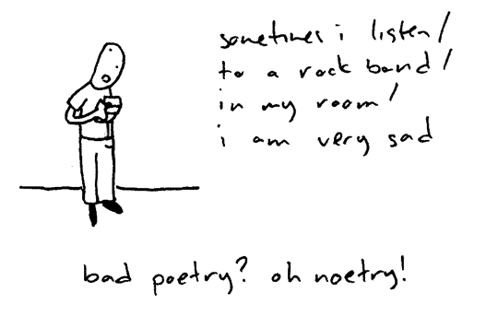  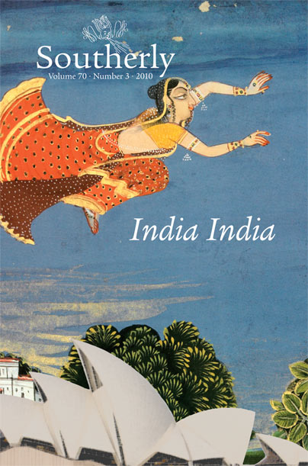  “Australia” by Ania Walwicz, “The Migrant Face” by Eric Noth, “To the Welsh Critic Who Doesn't Find Me Identifiably Indian” by Arundhathi Subramaniam, “Be Good Little Migrants” by Uyen Nhu Loewald, “Special Menu” by Mei Yen Chua, “Migrants” by Margaret Scott.
Student Brief: TASK ONE: Part iii) 20 marks of Journal
GENRE: Prose Fiction - novel  Text: The Scarlet Letter by Nathaniel Hawthorne  An introduction to the concerns of American writing, through a focus on Nathaniel Hawthorne’s The Scarlet Letter.  In addition to the in-class novel, students will also be expected to watch and read extracts from the work of other American fiction writers of the 1800s such as Herman Melville and Emerson.  - Complete a study of when and why the Puritans came to America. Compare the adultery laws of England in the 1600s where adultery was treated as a civil matter to the Puritans who implemented harsh corporal punishments.  - Read The Scarlet Letter to understand the representations of American identity. Take detailed notes on how the novel constructs colonial America’s religious values and the extensive entanglement between church and state.  - Analyse the novel's structural devices which explore the binary oppositions between Society / Individual and Religion / Love, with a look at the two characters of Dimmesdale / Hester and the two colours of Sable / Gules.  - Research the conventions of the Gothic Horror genre employed by writers such as Edgar Allan Poe and H.P. Lovecraft. Study how the novel conforms to and challenges the conventions of romance, realism and historical fiction.  - Students will explore the way the novel constructs representations of power as well as enhance their reading practices skills by looking at the novel through a number of different lenses or perspectives.  - Read the novel to detect the influence of Transcendentalism; a philosophy that stressed the use of intuition rather than religious doctrine to understand reality.  Journal Task: 60 minutes, students’ own annotated extracts  You are required to prepare plans for at least four of the questions below.  On the day of the assessment, one will be selected for you to complete under in-class conditions. You may have one page of notes only (One side, size 12 font)for the following questions:  - The Scarlet Letter revolves around a strong central female character. Explore how readers may consider her role as a statement about the status of women. What was the status of Puritan women as represented in The Scarlet Letter and what was the changing status of mid-19th century women, the period in which the novel was written?  - Explore how The Scarlet Letter is a novel that condemns “a repressive Puritan community” and explores “the beginnings of an independent civil society”. How is The Scarlet Letter a lesson in civics and citizenship?  Consider in your answer how:  “The Scarlet Letter as civic myth does not advocate obedience to the state or even primary loyalty to the nation. Instead, it illustrates how important it is for liberal democracies to maintain the space of an independent civil society in which alternative obediences and loyalties are allowed a chance to flourish" (Citizen Hester: The Scarlet Letter as Civic Myth by Brook Thomas).  - Explain how the style of The Scarlet Letter “articulates a complex, ironic view of American history and culture”.  In your answer you should consider:  - The use of Romantic writing to represent Puritan behaviour and thinking.  - How Hawthorne” scrutinizes the foundation myths of America—its exceptionalism, its entrenched innocence, its sentimentality, its violence, and its cavalier attitude toward the past.”  - “ the literary symbol is a concrete and untranslatable presentation of an idea, or an experience that cannot find its way into consciousness except through the mediation of the symbol”  Discuss how the symbolism with in The Scarlett Letter is the means by which the novel mediates its ideas.  - Discuss how The Scarlet Letter a moral and religious novel : “Hawthorne is not overly concerned with the sin that has been committed; he is more concerned with the results of the sin, with its effect on the persons involved”.  Submit for assessment the Student Brief as a cover sheet and your selected annotated extracts. | TYPE:  Short Written Response  OUTCOMES:  READING, PRODUCING  CONTENT:  - Language and generic conventions  - Contextual understandings  - Producing texts  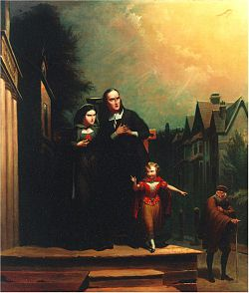  Further Reading: Moby Dick or Billy Budd by Herman Melville, The Tell Tale Heart by Edgar Allan Poe, Each and All by Ralph Waldo Emerson, Roger’s Version by John Updike and Easy A directed by Will Gluck.  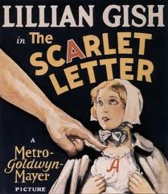

Student Brief: TASK TWO

GENRE: Poetry, Prose Fiction, Drama  Suggested Texts: Those studied throughout the semester that provide relevant support for your reading and response to the task.  - As a consolidation of students’ knowledge of representations of power and the use of multiple reading practices when making interpretations of texts, students will be adding The Scarlet Letter to their reading repertoire as well as reviewing the poets and poetry studied for Task Four and the drama text studied in Task Three.  - Read additional poems from the Australian poets studied that raise similar representations of power to those from The Scarlet Letter and other examples of American fiction they have read. Consider how power and weakness are two sides of the same coin and how one enables the other.  - Refer back to the notes and discussions made about drama texts and the dramatic elements that constructed readings of power and other representations.  - Produce a number of alternative readings of the texts used for this task based on your knowledge of multiple reading practices. Ensure your readings are well substantiated with textual references and personal contextual evidence, wherever possible.  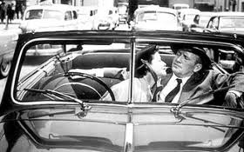  Assessment Task: Maximum length of 1000-1200 words.  Complete a long essay response/planning in class and then draft a polished response to ONE of the following questions, using The Scarlet Letter and at least one other text:  - Explain how literature enables students to understand the invisible manipulation of power in society by the powerful.  In your answer you should consider the maintenance of power: “first as an unconscious psychological process that is cultural and internalised, and the second a more conscious, wilful and coordinated strategy of domination”.  - Does intertextuality awareness have any positive effects on reading literary texts? Discuss the positive effects of comparing the issues in at least two texts you have studied this semester. Your answer should also consider how a reader’s awareness of intertextuality and its underlying elements and components in a literary text may help him/her to produce a more reliable and acceptable meaning and interpretation of a specific text’s ideas.  - Humans have evolved to function in groups, and thus experience a strong need to feel close and connected to others. Explain how your reading this semester has helped your understand the vast consequences being excluded from a social structure.  All of the materials which you reference in your response must be cited using professional academic standards. Remember to recognise formally the ideas and the words of other writers! A detailed bibliography must accompany the essay.  Submit for assessment the Student Brief as a cover sheet, your plans and process work and your signed Declaration of Authenticity. | TYPE:  Extended Written Response  OUTCOMES:  READING, PRODUCING  CONTENT:  - Language and generic conventions  - Contextual understandings  - Producing texts  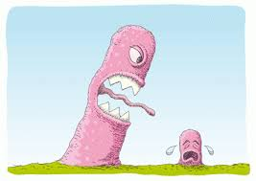

Student Brief: TASK ONE and TASK THREE

GENRE: Drama  Text: Medea by Euripides  As a consolidation of the research into the Ancient Greek theatre done for Task One, students will study a full length drama and the performance elements of drama as they have evolved through the ages. The drama text studied in this task, Medea, by Euripides, raises some confronting social issues. These will be explored in a broader social, cultural and temporal context, as well as their links to contemporary society to further students’ understanding of the links between text, context and meanings made.  - To commence the task, students will read and research the era and works of Euripides, focusing on Medea.  - The performance elements of drama will be looked at in terms of the influence they have on the staging of this play and on drama performances through the ages.  - Discuss the representation of gender and family and compare this to an interpretation of the values and attitudes that are conveyed by the play and may be received by audiences through the ages.  - Present readings of some contemporary plays that deal with similar issues or ideas and compare the use of dramatic elements in positioning the audience to form judgements and responses to characters, events and the social mores of the time of each text’s production.  Assessment Task: In class, 60 minutes, no notes  Journal (Task One: Part i)) 10 marks of Journal  Write a close reading of a teacher-selected extract from Medea in which you pay close attention to the use of dramatic elements for effect and meaning. Where relevant, make reference to your wider reading and knowledge of the drama genre and drama texts to support your reading.  Task Three:  Create a modern tragedy. Write a scene that represents the fall of a modern hero from prosperity into adversity. Ensure the causes that lie within the individual relate to the outward forces of their world. (10%) | TYPE:  Short Written Response  OUTCOMES:  READING, PRODUCING  CONTENT:  - Language and generic conventions  - Contextual understandings  - Producing texts  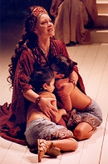  Further reading: Oedipus Rex by Sophocles, The Oresteia by Aeschylus, Prometheus Bound by Aeschylus, Antigone by Sophocle and Alcestis by Euripedes.

Student Brief: TASK FOUR

GENRE: Drama, Prose and Poetry  Texts: Medea by Euripedes, The Scarlet Letter by Hawthorne and your choice of Diaspora poets  To consolidate your understanding of your drama texts and to review both prose and poetry covered this semester, you are to produce an oral presentation for this task. A significant focus on generic conventions and how they are used to convey ideas is required for this assessment.  - Revise the Reading Practices covered this semester and selectively apply those which apply to this task and the texts.  - Choose a theme or idea that is raised in Medea and two or more poems studied. Ensure your chosen poems are suitable for the intertextual component of this task.  - Revise the performance elements of drama as they apply to the staging of Ancient Greek theatre.  - Analyse the conveyance of theme/idea via the writers’ use of poetic, technical and performance elements.  - Make intertextual readings of your chosen texts based on your knowledge of reading practices and the way genres can overlap in the use of conventions.  - Once you have gathered sufficient evidence from the texts to support your theme, prepare your material for presentation to the class. Your panel discussion must present your analysis of the ways in which the techniques of the texts/genres animate the theme or idea you have chosen.  - A portion of your panel discussion must incorporate different readings of the texts; this may necessitate the introduction of additional ideas or themes, or you may present an alternate perspective on the central theme or idea around which you have built your thesis.  Assessment Task:  Develop a thesis which argues/debates one of the questions from the following list. Ensure that your oral is presented as tutorial/seminar in which your class mates can revise the genre, values and readings we have applied to the texts we have studied this semester.  You will be nominated a question and further questions will be provided to suit the size of the class. | TYPE:  Oral Production  OUTCOMES:  READING, PRODUCING  CONTENT:  - Language and generic conventions  - Contextual understandings  - Producing texts
- How has the intertextual study of Literature enabled you to interrogate ideas about self and society?  - Explore how Literature can construct a vivid representation of a nation’s complex values and behaviours.  - Explain how the central figure of a novel gives readers an understanding a human nature; specifically how our motives are the result of social conditions.  - Discuss how the most powerful examples of Literature explore the nature of heroism in repressive societies.  - How does at least one text you have studied use humour to engage its readers with the key ideas of the text?  - Explain how the generic form and conventions of a text you have studied affected its ideas and values.  - Literary meanings are not timeless and universal, but vary across times, places and other contexts. Discuss with reference to one or more works you have studied.  - Literary texts often suggest meaning through patterns of imagery and/or recurring devices. Discuss with reference to one or more works you have studied.  - Explore the ways and reasons why Literature makes violent moments particularly gripping.  In what ways do you think poets make criticisms of society through the lyricism and figurative expressions of their poems?  - Poetry often presents us with troubled people in a disturbing world. Explain your response to this statement be referring to the style and subject matter of at least one poem you have read this semester.  Submit for assessment the Student Brief as a cover sheet plus an overview or summary of the main content and ideas presented by you in your panel discussion. | TYPE:  Short Written Response  OUTCOMES:  READING, PRODUCING  CONTENT:  - Language and generic conventions  - Contextual understandings  - Producing texts  