Events Across 100 Years That Completely Changed The World
The article recalls the events of modern history that proved to bring about a massive change in the world. These are days on which political revolutions, technological breakthroughs, unforeseen natural disasters and sporting triumphs took place, and whose effects were felt the world-over. Get ready to relive history like you've never done before.
44. Violent Anti-Vietnam Riots in London (1968)
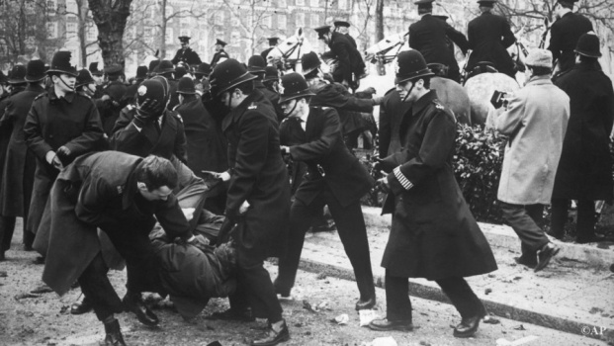
Police struggle with anti Vietnam War demonstrators outside the Embassy of the United States in Grosvenor Square, London, Mar. 17, 1968.
On March 17th 1968, 80,000 demonstrators congregated in central London. It was a peaceful demonstration until thousands broke away and headed to the American embassy. What followed was the worst violence seen on the capital's streets for decades.
45. Concorde Flies for the First Time (1969)
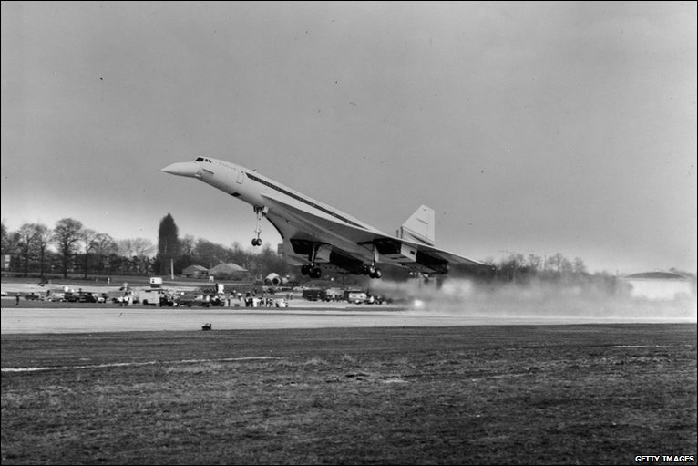
On March 2 1969, the Anglo-French supersonic Concorde made its first flight.
46. Armstrong Sets Foot on the Moon (1969)
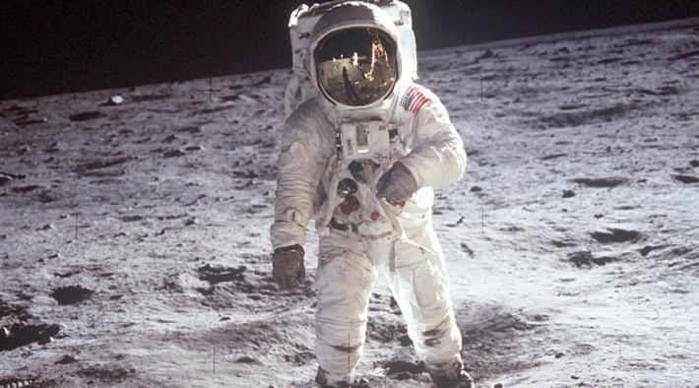
On July 21 1969, Neil Armstrong takes the first steps on the moon. As he put his left foot down first Armstrong declared: "That's one small step for man, one giant leap for mankind.".
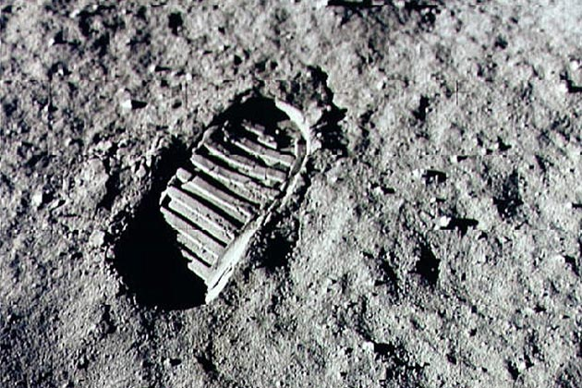
First human footprint on the moon : Neil Armstrong.
47. Bloody Sunday in Northern Ireland (1972)
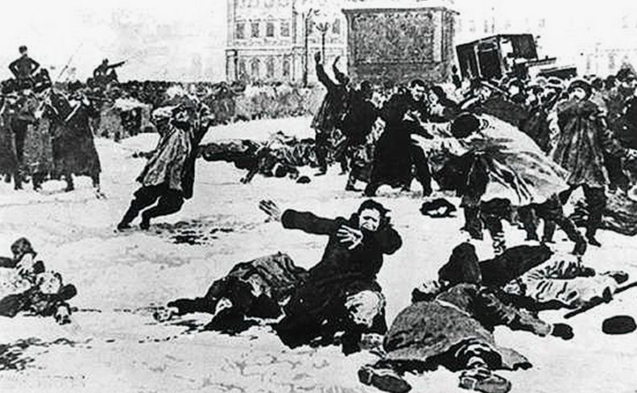
On January 30 1972, British troops shoot unarmed protesters in Northern Ireland, killing 13 civilians. It was to be known as the Bogside Massacre.
48. Nixon Resigns in Shame (1974)
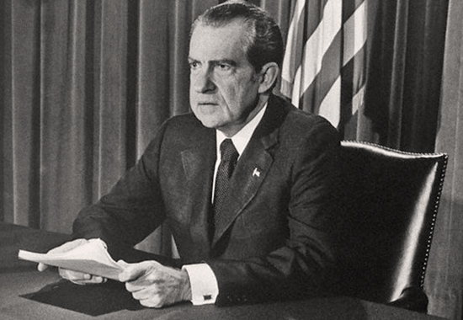
In the wake of the Watergate scandal, Nixon becomes the first president in US history to resign from office.
49. Exiled Religious Leader Ayatollah Khomeini returns to Iran (1979)
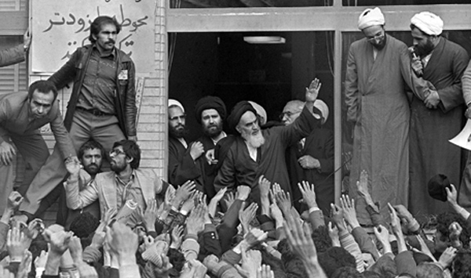
On February 1 1979, the religious leader Ayatollah Khomeini returns to Iran after 14 years in exile. 5 million people lined the streets of Tehran to witness the homecoming of the Shia Muslim imam.
50. Lord Mountbatten Assassinated by IRA (1979)
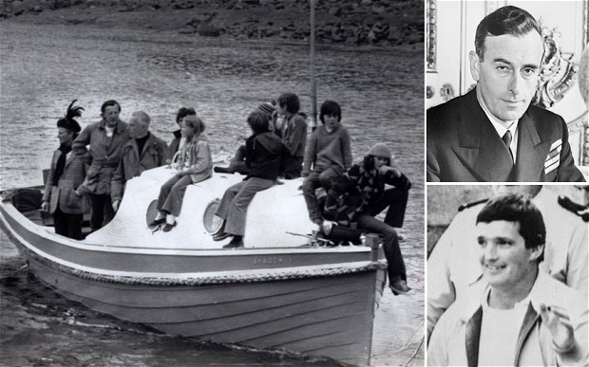
August 1979: Lord Mountbatten (top right) with members of his family aboard the boat that was blown up by members of the IRA and Thomas McMahon (bottom)
Lord Mountbatten is assassinated by IRA terrorists while on holiday in County Sligo, Ireland.
51. Ethiopian Famine (1984)
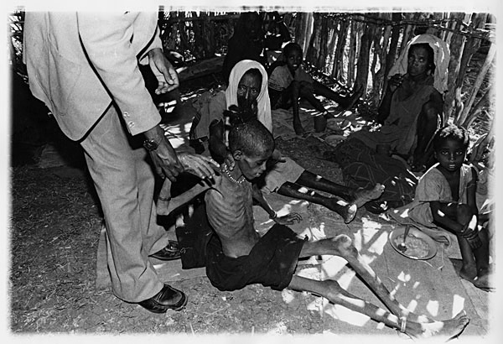
On 23rd October 1984, Ethiopia was hit by the world's worst famine yet. The world's eyes are opened to Ethiopia's famine plight by BBC reports, sparking an enormous public response.
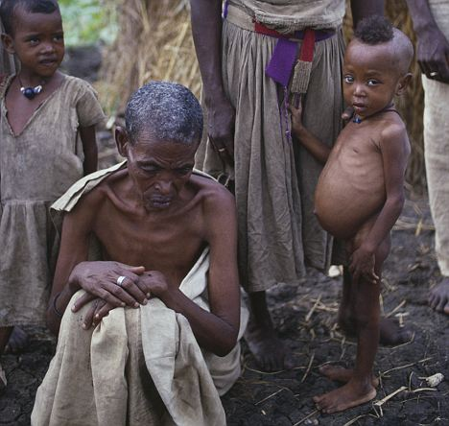
A starving family in a famine-ravaged village in Ethiopia at the height of the disaster in 1985.

52. Heysel Stadium Disaster (1985)
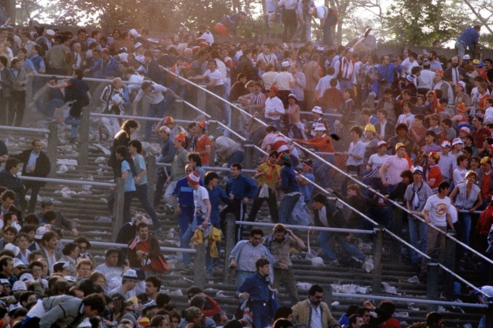
On, 29 May 1985, one hour before the European Cup final between Juventus and Liverpool, Liverpool fans breached a fence. Escaping Juventus fans were pressed against a wall in the Heysel Stadium in Brussels, Belgium. Thirty-nine Juventus fans died and 600 were injured.
53. Challenger Spacecraft Explodes (1986)
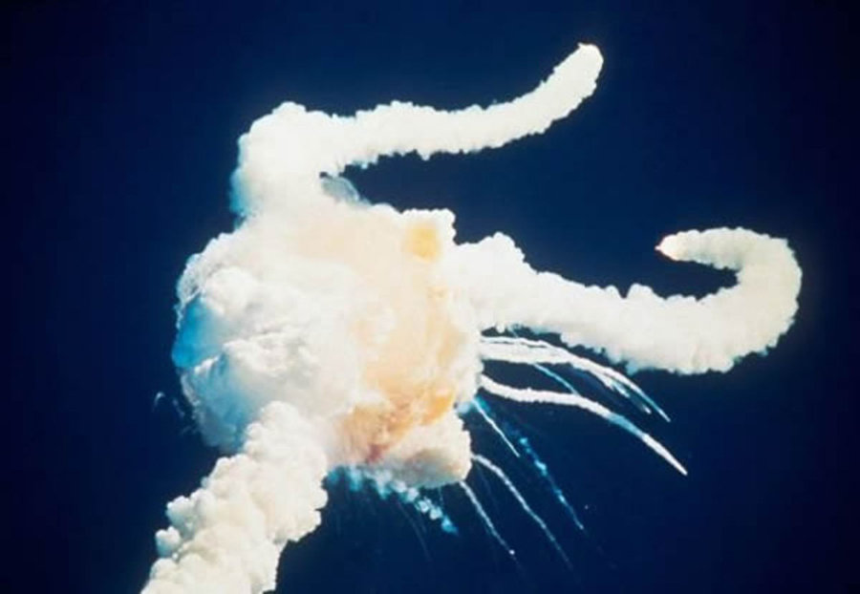
On January 28, 1986, Space Shuttle Challenger disintegrated 73 seconds into its flight leading to the death of all 7 members of the crew.
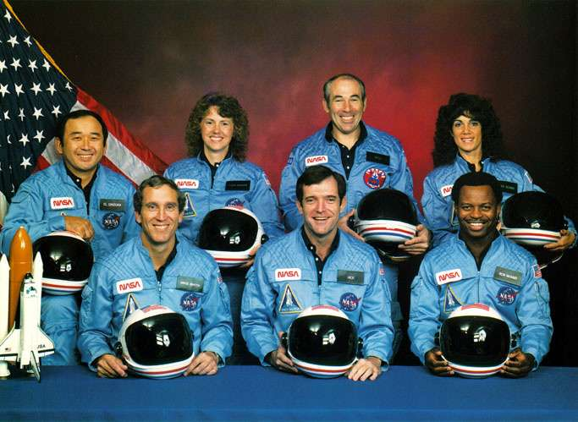
The crew members of the doomed space shuttle Challenger.
54. Chernoybl Nuclear Disaster (1986)
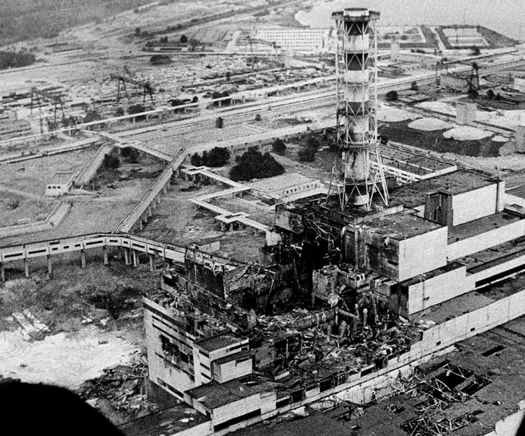
The Chernobyl nuclear power plant sits crippled two to three days after the explosion in Chernobyl, Ukraine in April, 1986.
On 26 April 1986, an explosion at the Chernobyl Nuclear Power Plant in Ukraine released a huge amount of radioactive particles in to the atmosphere. The incident was catastrophic and is considered the worst nuclear power plant accident in history. Half a million workers were involved in trying to contain the contamination. The official casualty count stands at 31 which is widely disputed. The long term effects on health are still being accounted for.
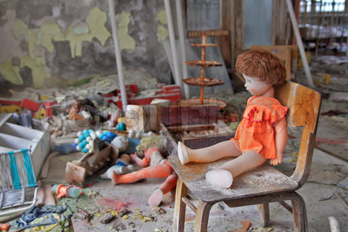
The doll in the kindergarten in the town of Pripyat, abandoned after disaster at the Chernobyl nuclear power plant in 1986

55. Zeebrugge Ferry Disaster (1987)
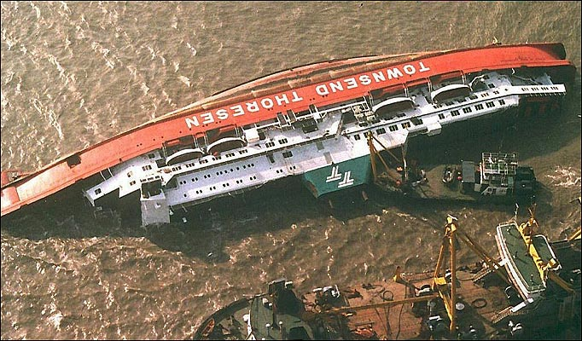
Britain's worst ferry disaster killed 200 people. Towsend Thoresen, Herald of Free Enterprise had left Zeebrugge in Belgium for Dover, England. A mile off shore, the car ferry capsized very quickly. It turned out the doors of the ferry had not been shut.
56. Lockerbie Pan-Am Jet Explosion (1988)
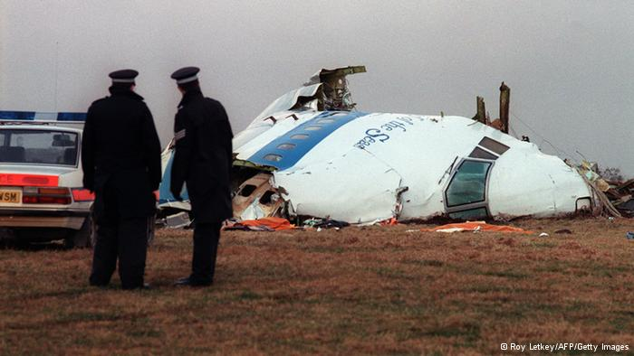
On December 21 1988, Pan Am flight 103 left from Heathrow airport to New York. Shortly in to its flight, the jet was destroyed by a bomb and it crashed in to the Scottish town of Lockerbie, killing all 259 its passengers and crew plus 11 people on the ground.
57. Hillsborough Disaster (1989)
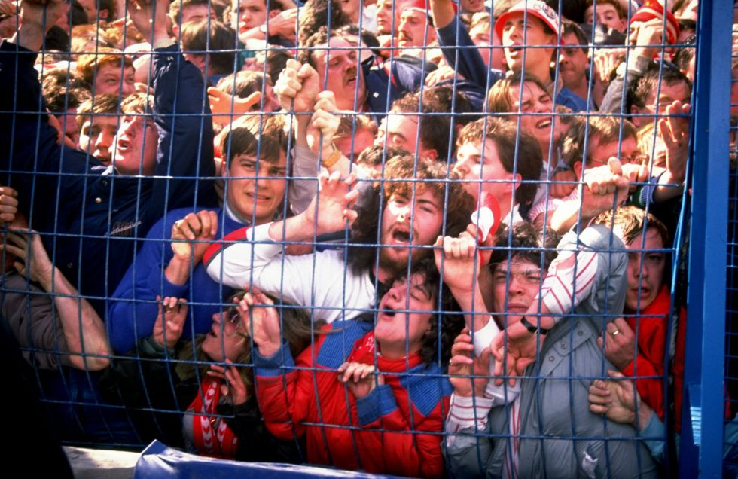
One of the iconic images of the disaster, as several girls are graphically seen crushed against the fence, unable to move a muscle, while dozens around them writhe in anguish
On 15 April 1989, a crush at the Hillsborough Stadium in Sheffield, England resulted in the deaths of 96 people and injuries to 766 others. It is still the worst stadium disaster in British history.
58. Exxon Valdez Oil Spill (1989).
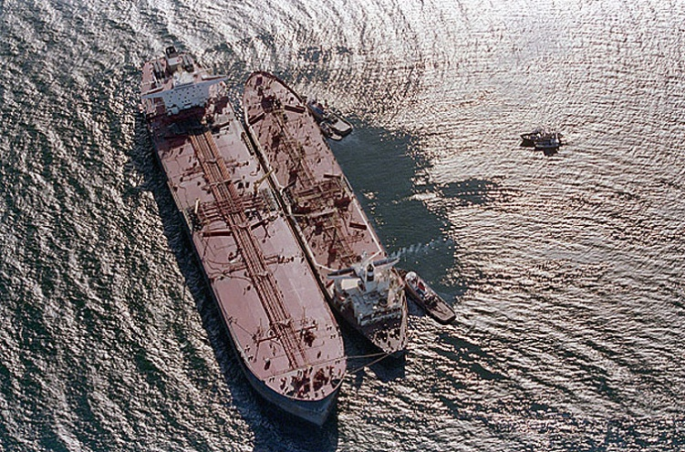
On March 24,1989, the oil tanker Exxon Valdez ran aground in Prince William Sound, Alaska spilling 750,000 barrels of crude oil.
59. Tiananmen Square Massacre (1989)
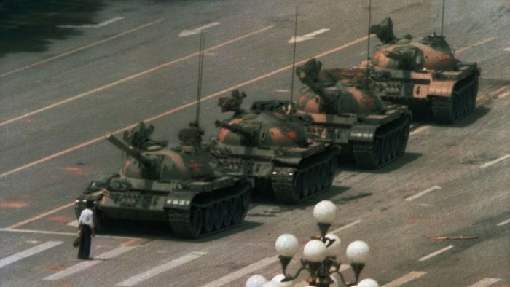
The famous photograph of the Tank man who stood alone in protest of hundred of tanks approaching towards him.
On June 4 1989, soldiers from the Chinese People's Army massacred hundreds of their own people.

60. Fall of Berlin Wall (1989)
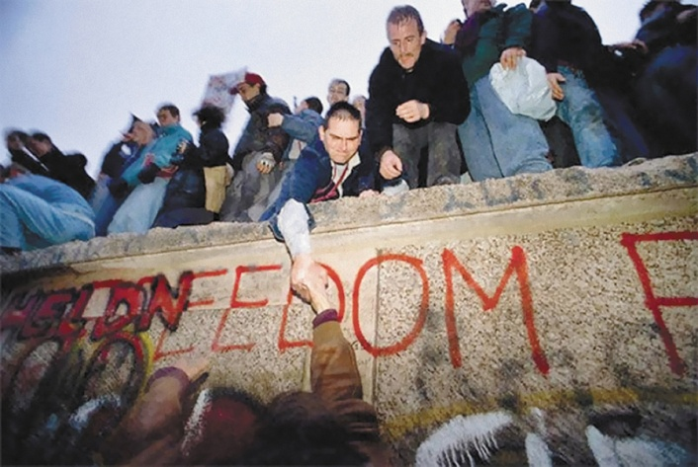
On November 9, The Berlin Wall was breached after nearly three decades of keeping East and West Berliners apart.
61. Romanian Dictator Overthrown (1989)
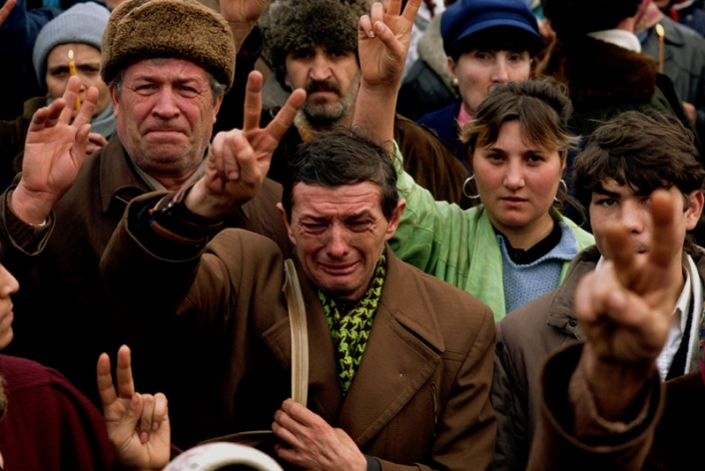
Romanians during the overthrow of the despotic Romanian dictator Nicolae Ceausescu. Bucharest, Romania, 1989
Nicolae Ceausescu is overthrown as the President of Romania. He and his wife are then executed by firing squad.
62. Nelson Mandela Released from Prison (1990)
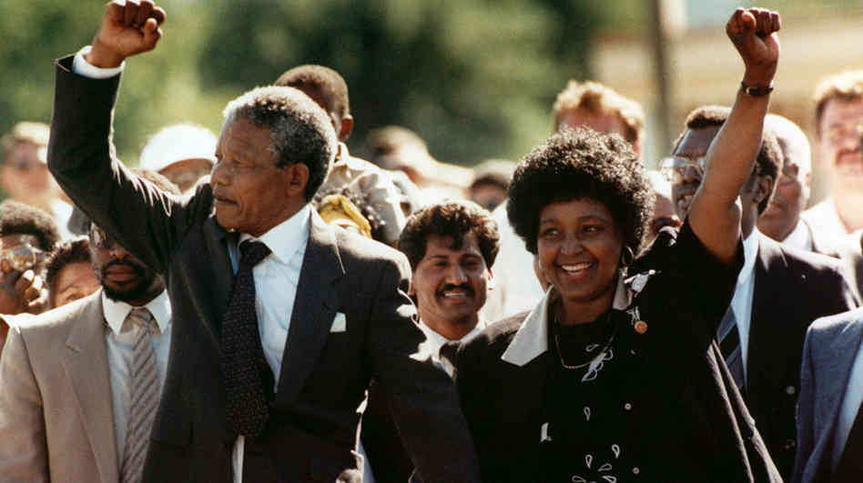
Nelson Mandela, with his wife, Winnie, walks to freedom after 27 years in prison on Feb. 11, 1990, in Cape Town.
On 11 February 1990, Nelson Mandela is released from Victor Verster prison after 27 years of confinement.
63. Operation Desert Storm - Start of Gulf War (1990)
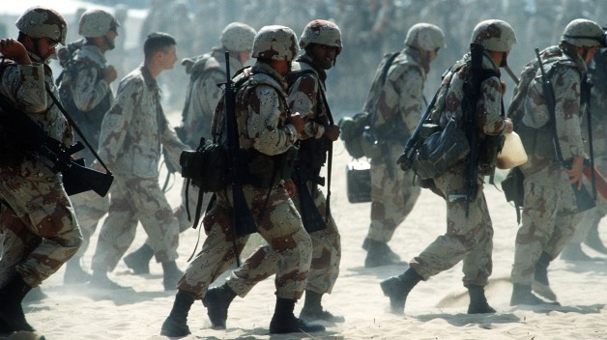
A U.N. authorized coalition force from thirty-four nations led by the United States, against Iraq in response to Iraq's invasion of the State of Kuwait.
64. Princess Diana Dies in Paris Car Crash (1997)
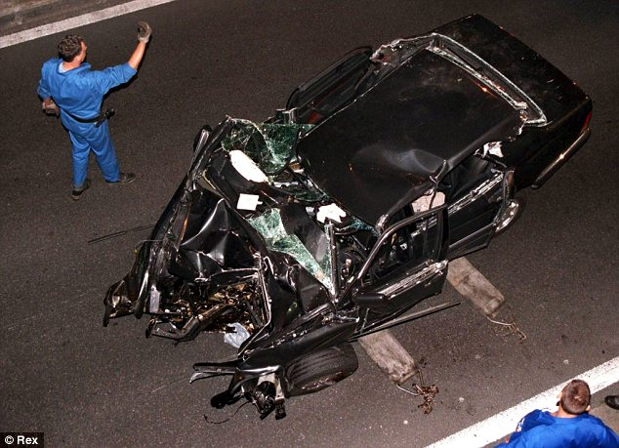
Diana, Princess of Wales died as a result of injuries sustained in a car accident along with lover Dodi al Fayed
On 31st August 1997, Princess Diana, aged 36, was killed in a car accident. The unexpected tragedy shocked the world.

65. Funeral of Diana, Princess of Wales (1997)
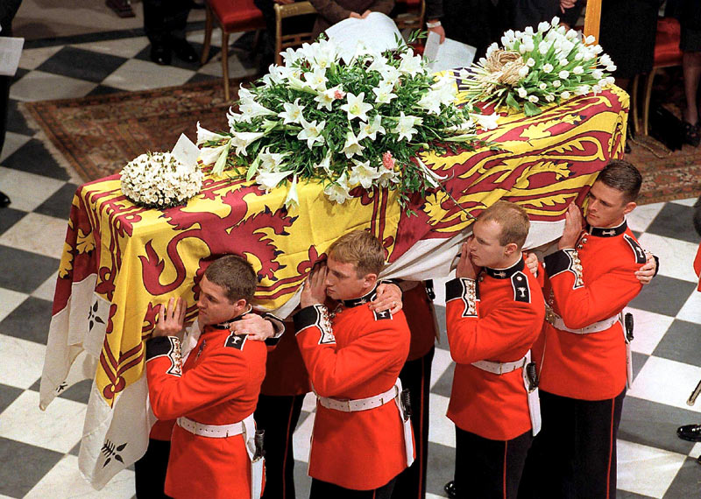
Princess Diana's funeral was watched by 2.5 billion people worldwide.
Princess Diana died on 31 August 1997, her funeral was at Westminster Abbey on 6 September 1997 and she was buried at her family home in the grounds of Althorp House in Northamptonshire.
66. 9/11 - A Day that Shook the World (2001)
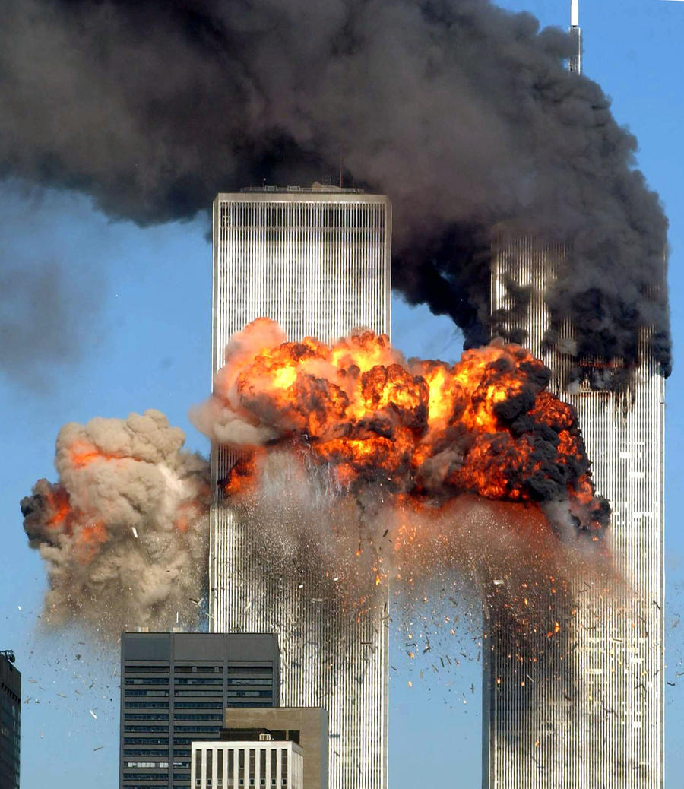
On September 11, 2001 at 8.46am, American Airlines flight 11 crashed into the North tower of the World Trade Centre. It was the start of four coordinated suicide attacks on the USA. Nearly 3000 people died on that day. It became a day that changed the world.
67. The Capture of Saddam Hussein (2003)
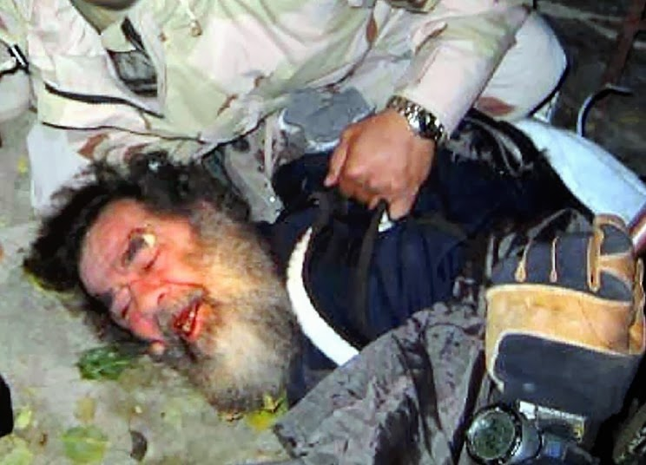
Saddam's last stand: The 'Ace of Spades' is finally captured by U.S. troops in December 2003 after hiding in a hole dug by Alaa Namiq
Operation Red Dawn was launched in order to locate and capture Saddam Hussein, who they believed was hiding in the town of ad-Dawr, Iraq, near Tikrit. The operation was conducted by 1st Brigade Combat Team, which included elements of Special Operations teams. Saddam was found with, a pistol and an AK-47 Assault Rifle along with 750,000 dollars in cash. He showed no resistance however.
68. Beslan School Massacre, Dramatic Scenes (2004)
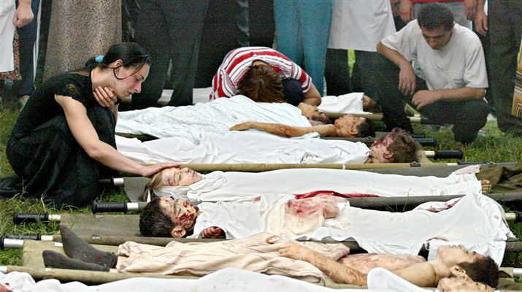
Bodies of children lie as relatives weep in grief over the loss of their children in the tragic Beslan school massacre of 2004.
On 1st September 2004, 32 armed and masked terrorists stormed School Number 1 in Beslan, North Ossetia-Alania (Russia). The terrifying ordeal lasted 3 days for 1200 adults and children. They were packed in to the school gymnasium where the terrorists had bombs and guns. 331 people died including 186 children. More than 700 were injured.
69. Facebook Founded (2004)
It was the beginning of the greatest social networking revolution that would hook on 1.3 billion active users all around the globe. Facebook was founded on February 4, 2004 by Mark Zuckerberg with his college roommates and fellow Harvard University students Eduardo Saverin, Andrew McCollum, Dustin Moskovitz and Chris Hughes.The founders had initially limited the website's membership to Harvard students, but later expanded it to colleges in the Boston area, the Ivy League, and Stanford University It gradually added support for students at various other universities before it opened to high-school students, and eventually to anyone aged 13 and over.
70. Indian Ocean Earthquake and Tsunami Disaster (2004)
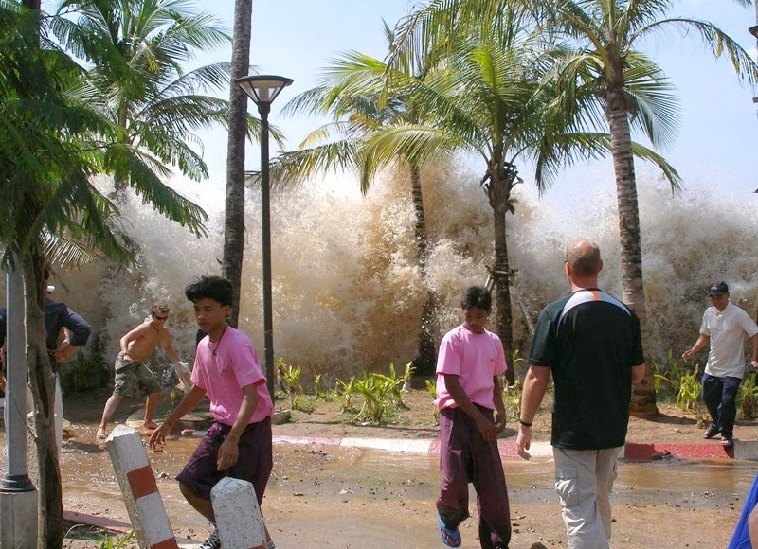
Killing more than 300,000 people, after an under sea quake off Sumatra, the Indonesian Tsunami of 2004, was one of the deadliest natural disasters in recorded history. Indonesia was the hardest-hit country, followed by Sri Lanka, India, and Thailand. It killed people over fourteen countries, and inundated coastal communities with waves up to 30 meters (100 ft) high. With a magnitude of Mw 9.1–9.3, it is the third largest earthquake ever recorded on a seismograph. The earthquake had the longest duration of faulting ever observed, between 8.3 and 10 minutes. It caused the entire planet to vibrate as much as 1 cm (0.4 inches) and triggered other earthquakes as far away as Alaska. Its epicentre was between Simeulue and mainland Indonesia.The plight of the affected people and countries prompted a worldwide humanitarian response. In all, the worldwide community donated more than $14 billion (2004 US$) in humanitarian aid.
71. Hurricane Katrina (2005)
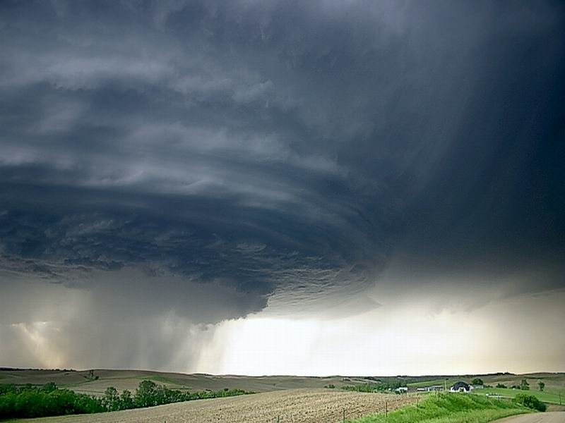
With the power of a nuclear explosion, Hurricane Katrina made landfall in Louisiana on the 29th August 2005. 125mph winds caused widespread devastation. When the hurricane hit New Orleans, many of the city's levees breached. Soon 80% of New Orleans was submerged in water. Thousands were stranded and many headed to the super dome for refuge. Food and water was in short supply and a national scandal ensued when relief failed to get through to the residents.

72. Apple unveils iPhone (2007)
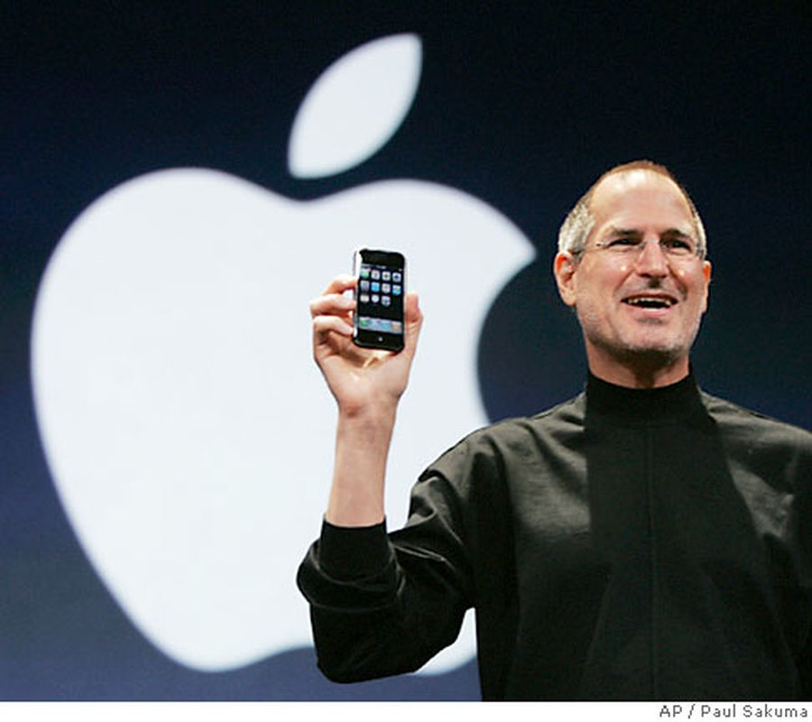
A phone that reinvented the 'phone' and created an almost instant worldwide brand bringing down the then leader Nokia and dominating the cellphone markets till today. It brought about the 'Touch Revolution' changed the world of software distribution, unified music and phones, addicted the world to motion and orientation sensors, shattered the myth that japanese consumers buy only japanese phones and all but killed the mobile gaming market.
73. Global Financial Crisis (2008)
It is considered by many economists the worst financial crisis since the Great Depression of the 1930s. It resulted in the threat of total collapse of large financial institutions, the bailout of banks by national governments, and downturns in stock markets around the world. In many areas, the housing market also suffered, resulting in evictions, foreclosures and prolonged unemployment. The crisis played a significant role in the failure of key businesses, declines in consumer wealth estimated in trillions of U.S. dollars, and a downturn in economic activity leading to the 2008–2012 global recession and contributing to the European sovereign-debt crisis.
74. Barack Obama Elected as The First Black President of America (2008)
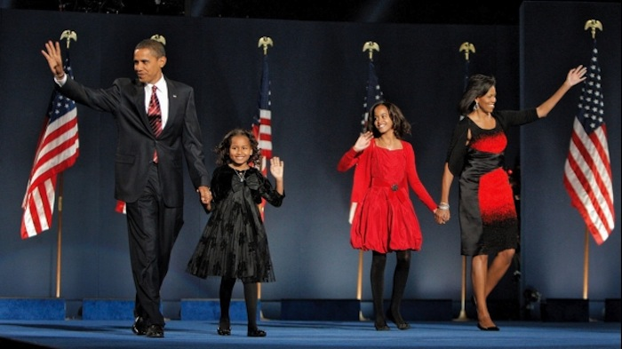
Barack Obama was elected as the president of the United States of America. Barack Obama is the first Afro -American who was elected as the president of the United States of America
75. Japanese Earthquake and Tsunami (2011)
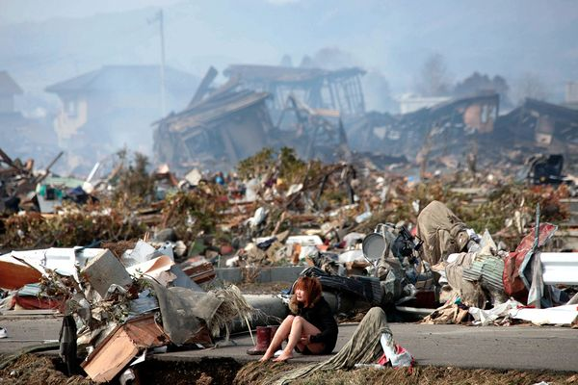
On 11th March 2011, a 9.0-magnitude quake and subsequent tsunami hit the east of Japan, killing over 15,000 and leaving another 9,000 missing. It was the most powerful earthquake ever recorded to have hit Japan, and the fifth most powerful earthquake in the world since modern record-keeping began in 1900.The earthquake triggered powerful tsunami waves that reached heights of up to 40.5 metres (133 ft) in Miyako in Tohoku's Iwate Prefecture,and which, in the Sendai area, travelled up to 10 km (6 mi) inland. The earthquake moved Honshu (the main island of Japan) 2.4 m (8 ft) east and shifted the Earth on its axis by estimates of between 10 cm (4 in) and 25 cm (10 in), and generated sound waves detected by the low orbiting GOCE satellite. The tsunami caused nuclear accidents, primarily the level 7 meltdowns at three reactors in the Fukushima Daiichi Nuclear Power Plant complex, and the associated evacuation zones affecting hundreds of thousands of residents. Early estimates placed insured losses from the earthquake alone at US$14.5 to $34.6 billion.The Bank of Japan offered US$183 billion to the banking system on 14 March in an effort to normalize market conditions.The World Bank's estimated economic cost was US$235 billion, making it the costliest natural disaster in world history.
76. The Death of Osama Bin Laden (2011)
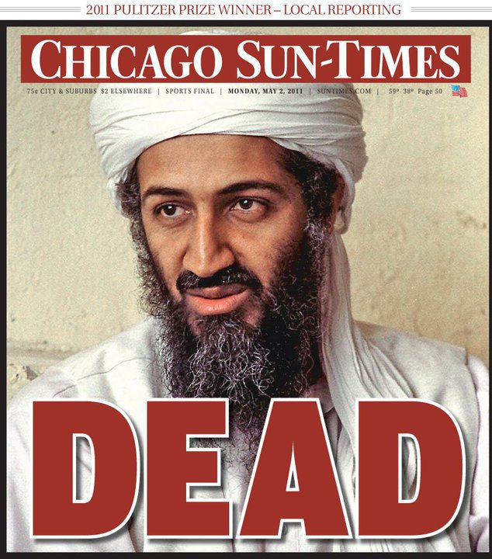
After a decade long search to catch the most wanted criminal on the planet, the pursuit came to an end on May 2 2011, when Osama Bin Laden, the man behind the deadly 9/11 attacks was killed in Abbottabad, Pakistan, shortly after 1:00 am local time by a United States special forces military unit. The operation, code-named Operation Neptune Spear, was ordered by United States President Barack Obama and carried out in a U.S. Central Intelligence Agency (CIA) operation by a team of United States Navy SEALs from the United States Naval Special Warfare Development Group (also known as DEVGRU or informally by its former name, SEAL Team Six) of the Joint Special Operations Command, with support from CIA operatives on the ground.The raid on bin Laden's compound in Abbottabad, Pakistan was launched from Afghanistan. After the raid, U.S. forces took bin Laden's body to Afghanistan for identification, then buried it at sea within 24 hours after his death.The United States had direct evidence that the ISI chief, Lt. Gen. Ahmad Shuja Pasha, knew of Bin Laden’s presence in Abbottabad, Pakistan.
77. Nelson Mandela Dies (2013)
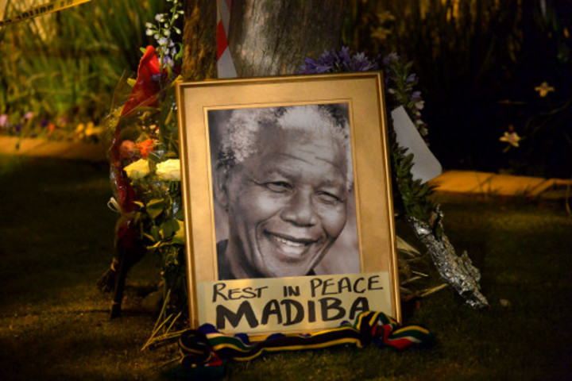
On 5 December 2013, Nelson Mandela, the first President of South Africa elected in a fully representative democratic election, died at the age of 95 after suffering from a prolonged respiratory infection. He died at around 20:50 local time (UTC 2) at his home in Houghton, Johannesburg, South Africa, surrounded by his family. South Africa observed a national mourning period of 10 days. During this time numerous memorial services were conducted across the country. The official memorial service was held at FNB Stadium, Johannesburg, on 10 December. His body lay in state at the Union Buildings in Pretoria from 11 to 13 December 2013. A state funeral was held on 15 December 2013 in Qunu in the Eastern Cape province, where his body was buried.
78. Malaysian Airliner MH370 Vanishes Without a Trace (2014)
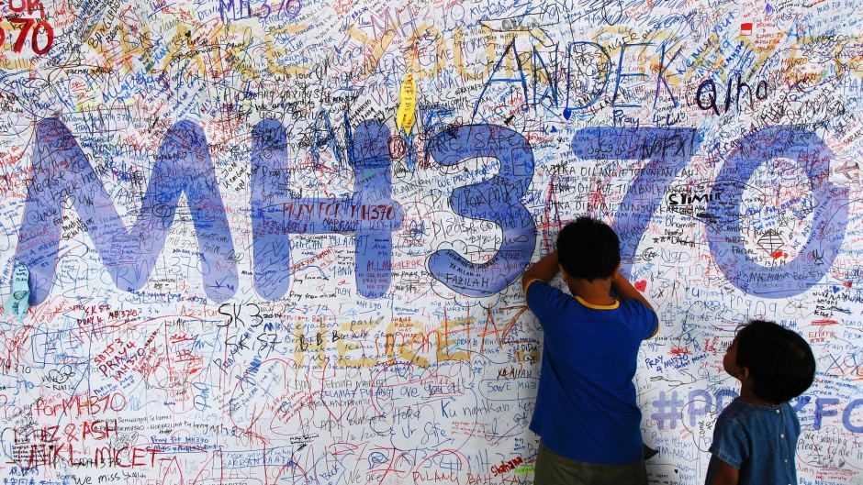
In what is regarded as the greatest aviation mystery of all time, Malaysia Airlines Flight 370 was a scheduled international passenger flight from Kuala Lumpur to Beijing that lost contact with air traffic control on 8 March 2014 at 01:20 MYT, less than an hour after takeoff. At 07:24, Malaysia Airlines reported the flight missing.The aircraft, a Boeing 777-200ER, was carrying 12 Malaysian crew members and 227 passengers from 14 nations. There has been no confirmation of any flight debris and no crash site has been found. A multinational search and rescue effort, later reported as the largest in history,began in the Gulf of Thailand and the South China Sea.The search has been laborious with just a few clues to carry on the mission. No debris or body has been found as of now.

