Top 10 People Who Changed The World

http://topyaps.com/top-10-people-who-changed-the-world
This topic is just like debating that who is greatest — Jesus or Muhammad? Both of them have their respective specifications and they can’t be equated with each other. In an attempt to focus some greatest souls across the world, TopYaps lists top 10 famous people, better known for their unparalleled contribution in changing the course of world, the course of history.

10. Bill Gates:
Bill Gates created his first computer program while still at high school, co-founded Microsoft in 1977, and by 1993 was the richest man on Earth. In 2000 Gates and his wife formed the Bill & Melinda Gates foundation, which is the largest charity in the world. One of its aim is to exempt the Third World of polio and other deadly diseases.
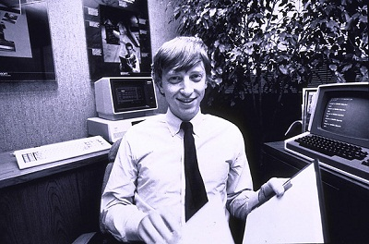
×

9. Martin Luther King, Jr.:
Martin Luther King was a Baptist minister who campaigned against the segregation of blacks in the Southern states of the United States. He was influenced by Gandhi and believed in peaceful protest. He won the Nobel Peace Prize in 1964. King was assassinated in 1968, but will always be remembered for his dignified, passive resistance to an unjust society.
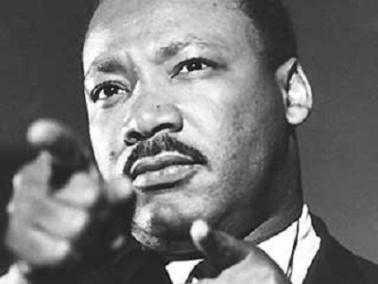

8. Nelson Mandela:
Nelson Mandela dedicated his life to the fight against apartheid – a policy which kept black and white South Africans apart and denied black citizens the vote. He was imprisoned in 1964 for his aggressive opposition to South Africa’s racist government and was held for 26 years. In 1990, after his release, Mandela was elected President of the African National Congress. In 1993 he won the Nobel Peace Prize for his work to end apartheid.
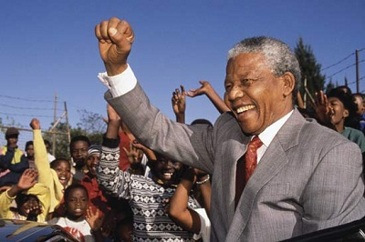

7. Adolf Hitler:
Adolf Hitler was Germany’s leader from 1933 – 1945, during time which he led the world into the most devastating war in history. Hitler’s hatred of Jewish people and his desire for a blue-eyed, blond-haired master race led to the murder of six million people during World War II; most died in concentration camp in Eastern Europe.
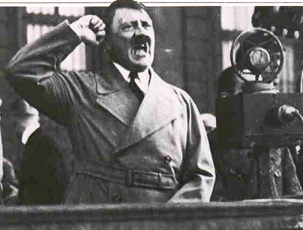

6. Albert Einstein:
Einstein was one of the greatest of all physicists and his name has become a symbol of genius. When his most famous work, the General Theory Of Relativity was proven in 1919, Einstein became the most celebrated scientist in the world and he won the Nobel Prize for Physics in 1921. Einstein was a firm believer in pacifism but his scientific theories helped his adopted country, the USA, to develop the atomic bomb. A week before he died Einstein wrote to Bertrand Russell, a British Philosopher and leading antinuclear campaigner, asking to put his name to a manifesto urging all countries to give up their nuclear weapons.
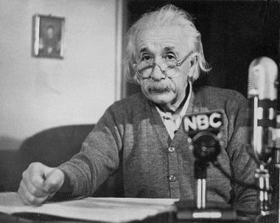

5. Mahatma Gandhi:
Gandhi began his career as a lawyer but became a great political and spiritual leader. He led the peaceful civil disobedience of Indians against British rule in India and negotiated with the British Government until 1947, when India was granted independence. Gandhi became the first icon of a people’s struggleagains oppression. His simple lifestyle and his belief in religious tolerance have made him a symbol of decency and peace ever since.
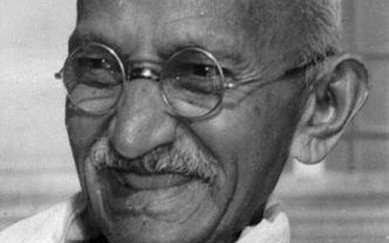

4. Karl Marx:
Karl Marx’s ideas on economic history and sociology changed the world. Marx was a social philosopher who attacked the state and predicted a future in which everyone was equal. He explained his theories in the Communist Manifesto (compiled with Friedrich Engels and published in 1848) and Das Kapital (1867 – 94). His ideas eventually led to the Russian Revolution and communism. By 1950 almost half of the world’s people lived under communist regimes.
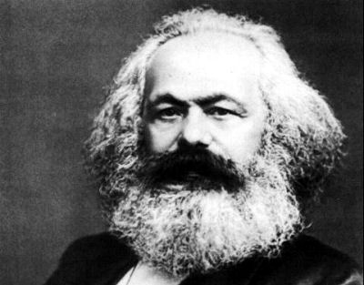

3. Charles Darwin:
Naturalist Charles Darwin established the theory of evolution. He began forming his ideas when he served as official naturalist on a world voyage on HMS Beagle (1831 – 36) and spent the rest of his life back in England developing them. When his famous book The Origin of Species by Means of Natural Selections was published in 1859, there were violent reactions against it. Darwin challenged the Bible’s account of creation and explained that human being are descended from an ape-like ancestor. Another English naturalist, Alfred Russell Wallace, independently developed very similar ideas at the same time as Darwin.
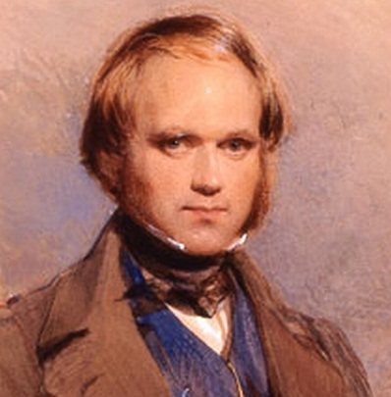

2. William Shakespeare:
William Shakespeare is generally agreed to be the greatest play writer in the English language. He began as an actor and wrote atleast 154 love poems and 37 plays, including Hamlet, King Lear, Romeo and Juliet and Macbeth.Shakespeare also probably introduced more than 1,700 new words to the English Language.
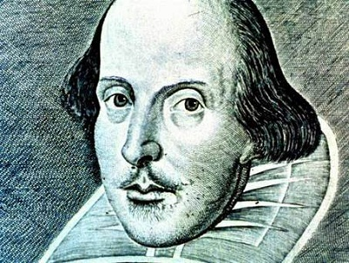

1. Christopher Columbus:
Christopher Columbus is one of the most famous of all explorers. He believed he could reach Asia by sailing west across the Atlantic Ocean and in 1492 he set sail in the Santa Maria to prove his theory. Instead, he landed on the islandsnow known as the West Indies. His discoveries led to the European explorations and settlement of the Americas.
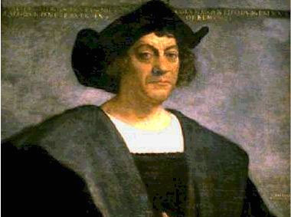

People who changed the world
https://www.biographyonline.net/people/people-who-changed-world.html
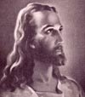
1. Jesus Christ (circa 5 BCE – 30 CE) Spiritual Teacher, central figure of Christianity

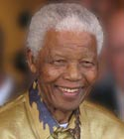
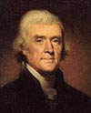
2. Thomas Jefferson (1743 – 1826) American President 1801 – 1809, principle author of Declaration of Independence

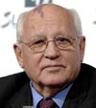
3. Mikhail Gorbachev (1931 – ) Leader of Soviet Union 1985 – 1991, oversaw transition from Communism in Eastern Europe.
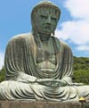
4. Lord Buddha (circa 563 BCE – 483 BCE) Spiritual teacher and founder of Buddhism
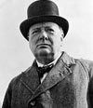
5. Winston Churchill (1874 – 1965) Prime Minister of Great Britain during Second World War

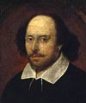
6. William Shakespeare (1564 – 1616) English poet and playwright

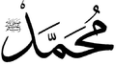
7. Muhammad (570 – 632) Founder of Islam

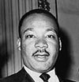
8. Martin Luther King (1929 – 1968) Civil Rights leader

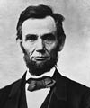
9. Abraham Lincoln (1809 – 1865) American President during civil war, helped end slavery

- Nelson Mandela (1918 – 2013) Anti-apartheid leader, first President of democratic South Africa in 1994

- St Paul (5 BCE – 67 CE) Christian missionary
- Adolf Hitler (1889 – 1945) Dictator of Nazi Germany
- George Washington (1732 – 1799) First President of USA
- Sri Krishna (circa 2000 BCE) Spiritual teacher, prominent figure in Hinduism
- Emperor Constantine (272 – 337) First Roman Emperor to embrace Christianity
- Martin Luther (1483 – – 1546) Key figure in Protestant Reformation
- Socrates (469 BCE – 399 BCE) Greek philosopher
- Mahatma Gandhi (1869 – 1948) Indian nationalist and politician
- Karl Marx (1818 –– 1883) German philosopher, founder of Marxism
- Napoleon Bonaparte (1769 –– 1821) French military and political leader
- Simon Bolivar (1783 – 1830) Liberator of South American countries
- Franklin D. Roosevelt (1882 – 1945) US President 1932-1945
- Charles Darwin (1809 –– 1882) Developed theory of evolution
- Sir Isaac Newton (1642 – 1727) English mathematician and scientist
- Confucius (551 BCE– – 479 BCE) Chinese philosopher
- Akbar (1542 – 1605) Mughal Emperor
- Queen Victoria (1819 –– 1901) British monarch 1837 – 1901
- Konrad Adenauer (1876 – 1967) German Chancellor post WWII
- Jawaharlal Nehru (1889 – 1964) First Prime Minister of India
- Ramses II (1279 BCE – 1213 BCE) Egyptian Pharoah
- Benjamin Franklin (1706 – 1790) American writer and polymath
- Alexander the Great (356 BCE –– 323 BCE) King of Macedonia
- Woodrow Wilson (1856 – 1924) American president during WWI
- Christopher Columbus (1451 – 1506) Italian explorer
- Marcus Aurelius (121 –– 180) Roman emperor and philosopher
- Galileo Galilei (1564 – 1642) Astronomer and physicist
- Plato (424 BCE –– 348 BCE) Philosopher
- Joan of Arc (1412 – 1431) French saint
- Charlemagne (742 – 814) King of Franks and Emperor of the Romans
- Aristotle (384BCE –– 322BCE) Greek philosopher
- Saladin (1138 –– 1193) Leader of Arabs during Crusades
- Babur (1483 – 1531) Founder of Mughal Empire
- Sir Walter Raleigh (1552 –– 1618) English explorer
- Voltaire (1694 – – 1778) French philosopher
- Catherine the Great (1729 –– 1796) Empress of all the Russias 1762 – 1796
- Mozart (1756 –– 1791) Austrian composer
- Guru Nanak (1469 – 1539) Spiritual teacher, founder of Sikhism
- Leonardo da Vinci (1452 –– 1519) Italian scientist, artist, polymath
- Louis Pasteur (1822 – 1895) French chemist and Biologist
- Leo Tolstoy (1828 –– 1910) Russian writer and philosopher
- Albert Einstein (1879 –– 1955) German physicist
- Ataturk (1881 – 1938) Founder of the Turkish Republic
- Pablo Picasso (1881 – 1973) Spanish painter and sculptor
- Pope John Paul II (1920 – 2005) Polish Pope from 1978-2005
- Margaret Thatcher (1925 – 2013) British Prime Minister 1979 – 1990
- Mohammed Ali (1942 – 2016) American boxer and human rights activist
- John F. Kennedy (1917 –– 1963) American President 1961 – 1963
- Boris Yeltsin (1931 –– 2007) First President of Russia 1991 – 1999
- Indira Gandhi (1917 –– 1984) Prime Minister of India 1980 – 1984
- William Tyndale (1494 – 1536) Translated Bible into English
- Tim Berners Lee (1955 – ) Inventor of World Wide Web
- Rosa Parks (1913 – 2005) Civil Rights activist
- Benazir Bhutto (1953 – 2007) Prime Minister of Pakistan 1993 – 1996
- J.S. Bach (1685 – 1750) German composer
- 14th Dalai Lama (1938 – ) Spiritual and political leader of Tibetans
- Malcolm X (1925 – 1965) Black Civil Rights activist
- Lech Walesa (1943 – ) Leader of Polish solidarity movement
- Charles de Gaulle (1890 – 1970) French politician
- Joseph Stalin (1879 – 1953) Leader of the Soviet Union 1922 – 1952
- Marie Curie (1867 – 1934) Chemist and physicist
- Giuseppe Garibaldi (1807 – 1882) Independence leader in Italy and South America
- Johann Gutenberg (1395 – 1468 Inventor of the printing press
- Oliver Cromwell (1599 – 1658) British Parliamentarian
- Vladimir Lenin (1870 – 1924) Leader of Russian Revolution in 1917
- Sigmund Freud (1856 – 1939) Austrian neurologist, psychoanalyst
- Mother Teresa (1910 – 1997) Macedonian Catholic nun and missionary
- Bill Gates (1955 – ) Founder of Microsoft
- Ernest Hemingway ( 1899 – 1961) American author
- John Lennon (1940 – 1980) British musician and member of the Beatles
- Genghis Kahn (1162 – 1227) Ruler of Mongol Empire
- Haile Selassie (1892 – 1975) Emperor of Ethiopia 1930 – 1974
- John M Keynes (1883 – 1946) Influential economist
- Susan B. Anthony (1820 – 1906) American political activist
- George Orwell (1903 – 1950) English author
- Thomas Edison (1847 – 1931) Inventor and businessman
- Kofi Annan (1938 – ) United Nations Secretary General 1997 – 2006
- Dwight Eisenhower (1890 – 1969) Supreme Allied Commander WWII
- Eleanor Roosevelt (1884 – 1962) helped to draft UN declaration of human rights
- Dr. B.R. Ambedkar (1891 – 1956) Indian political activist and social reformer who drafted Indian constitution
- Lyndon Johnson (1908 – 1973) US President 1963 – 1969
- William Wilberforce (1759 – 1833) Campaigner against slavery
- Nikola Tesla (1856 – 1943) Scientist, inventor
- Alexander Fleming (1881–1955) Scottish biologist who discovered antibiotics
- Samuel Johnson (1709 – 1784) British author and creator of the English dictionary
- Eva Peron (1919 – 1952) First Lady of Argentina 1946 – 1952
- Henry Ford (1864 – 1947) American industrialist
- Princess Diana (1961 –– 1997) Humanitarian
- Oscar Wilde (1854 – 1900) Irish author, playwright
- Beethoven (1770 – 1827) German composer
- Aung San Suu Kyi (1945 – ) Burmese opposition leader

15 People Who Changed The World

https://www.forbes.com/2007/05/23/people-changed-world-tech-07rev_cz_tb_0524changers_slide/#27efbec5141b

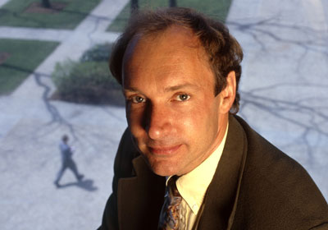
© Louie Psihoyos/CORBIS

Tim Berners-Lee

The World Wide Web
Tim Berners-Lee kick-started the World Wide Web in 1989, designing and building the first Web browser, editor and server. The widely adopted technologies transformed the way information is created and consumed.
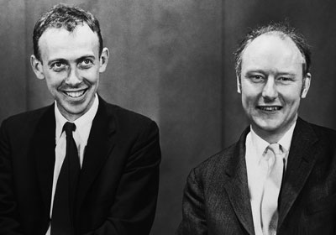
© Bettmann/CORBIS

Francis Crick, James Watson and Rosalind Franklin

Structure of DNA
English-born Francis Crick and his American colleague James Watson made one of the most dazzling discoveries in the history of science in 1953 when they accurately decoded the structure of the DNA molecule. They would not, however, have been able to identify the twisted ladder shape of the DNA double helix without the help of English scientist Rosalind Franklin’s X-ray images, which Watson saw without her knowledge. Franklin, who exposed herself to dangerous levels of radiation to get her X-ray images, died of cancer in 1958 at the age of 37. And so it was her colleague, Maurice Wilkins, who shared the 1962 Nobel Prize for medicine with Watson and Crick.

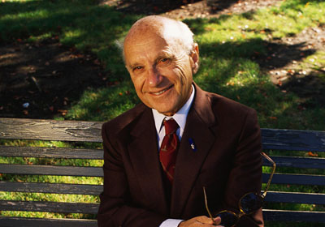
© Ed Kashi/CORBIS

Milton Friedman

Free markets
Economist Milton Friedman’s advocacy of low taxation, limited government and free markets went from the fringe of economic theory in the 1960s to the center of economic policy during the Reagan era. Friedman is best known for arguing that steady, moderate growth in the money supply would produce steady economic growth, and that inflation results when too much money chases too few goods. He was awarded the Nobel Prize in economics in 1976.
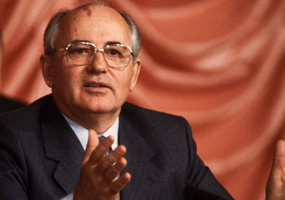
© Peter Turnley/CORBIS

Mikhail Gorbachev

Ending communism
After becoming premier of the Soviet Union in 1985, Gorbachev championed “Glasnost” (openness) and “Perestroika” (reform), which heralded the beginning of the end of communism and the Cold War. But his first attempt at radical reform as premier was an utter failure: he tried to stamp out alcoholism.
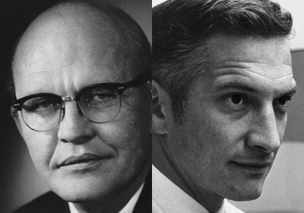
© Texas Instruments / Intel Museum

Jack Kilby and Robert Noyce

The microchip
Kilby and Noyce independently invented the single integrated circuit in 1959, clearing one of the greatest obstacles to faster and more powerful computers. The microchip heralded a revolution in technological miniaturization. Though Kilby got there first and won the Nobel Prize, it was Noyce’s silicon-based chips that caught on. Noyce co-founded Intel in 1968, and it is today the world’s largest manufacturer of semiconductors. That same year, Kilby built the world’s first personal calculator.
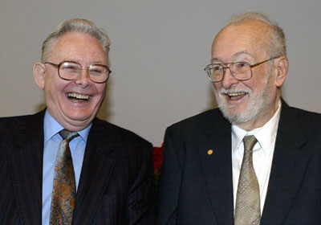
© SVENNACKSTRAND/AFP/Getty Images

Paul Lauterbur and Peter Mansfield

Magnetic Resonance Imaging
Lauterbur and Mansfield won the Nobel Prize for medicine in 2003 for the invention of magnetic resonance imaging. MRI enable ssurgeons to see inside the body’s soft organs without conducting invasive surgery or subjecting the patient to X-rays.
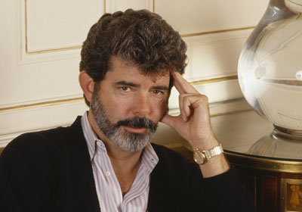
© Sergio Gaudenti/Kipa/Corbis

George Lucas

Star Wars
Filmmaker George Lucas founded Industrial Light and Magic in 1975 to bring his vision of Star Warsto life. ILM went on to revolutionize special effects in the movies, pioneering motion control camera techniques and spearheading the computer-generated imaging revolution in the 1980s. Perhaps more important, Lucas’ original trilogy of movies redefined the economics of the movie industry.

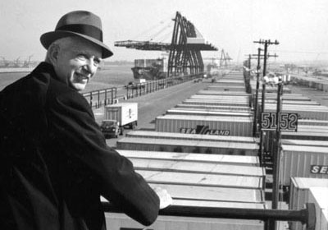
© Courtesy Maersk-Sealand

Malcolm McLean

The shipping container
Shipping entrepreneur McLean had a great idea: It would be much more efficient if dock cranes were able to pick up the entire trailer part of a truck and place it onto a ship, rather than continue with the hugely expensive and time-consuming method of loading (and unloading) a ship crate by crate. His invention, the standardized shipping container, transformed the global economy.
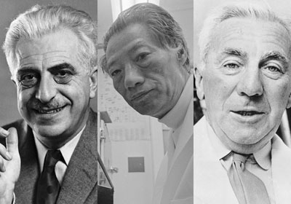
© Bettmann/Corbis / © AP Photo

Gregory Pincus, M.C. Chang, and John Rock

The birth control pill
In 1953 Pincus and his colleague Min-Chueh Chang proved that hormones could prevent ovulation in animals. Similar work was being undertaken by Dr. John Rock at Harvard, and he and Pincus joined efforts to conduct human trials in 1956. In 1960, the U.S. Food and Drug Administration approved Enovid, the first contraceptive pill.

People who changed the world for the better
Martin Luther King Helped create a powerful, non-violent civil rights protest movement. His speeches and organisation laid the framework for change in society. This led to the civil rights legislation of the late 1960s and helped to slowly erode the racism and segregation of the US.
Nelson Mandela – Pivotal figure in the fight to end apartheid in South Africa. Symbol of hope and forgiveness. Accepted transition to full democracy with remarkable lack of bitterness.
Rosa Parks – Rosa Park’s stand against the segregation on Montgomery buses helped create a pivotal moment in the US civil rights struggle.
Princess Diana – One of the world’s most photographed people in the world. She became an influential humanitarian and figurehead campaigning for various charities and humanitarian projects.
Desmond Tutu – Campaigner against apartheid in South Africa. Awarded nobel peace prize in 1984
Kofi Annan – United Nations secretary general. Noted for his calm and patient approach to diplomacy, even in the most testing times.
Dalai Lama – Promoted policy of non-violent resistance to Chinese occupation of his native Tibet.
Marie Curie – Awarded the Nobel Prizes for medicine and physics. Amongst other discoveries helped to monitor radiation which led to creation of X Ray machine.
Mother Teresa. Dedicated her life to serving the poor and disadvantaged.
Pele – The best footballer of the twentieth century.
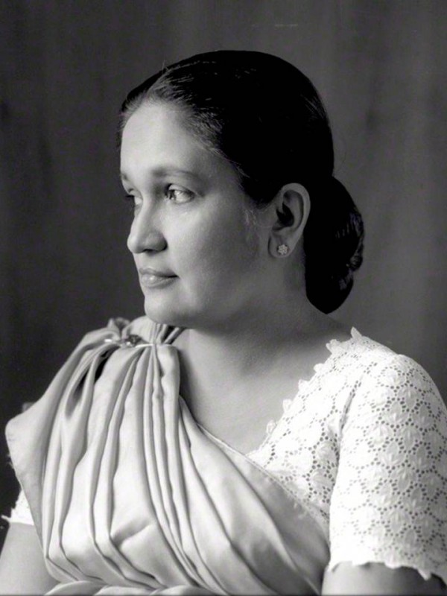
Sirima Ratwatte Dias Bandaranaike 17 April 1916 – 10 October 2000), commonly known as Sirimavo Bandaranaike, was a Sri Lankan stateswoman and politician and the modern world's first female head of government. She served as Prime Minister of Ceylon and Sri Lanka three times, 1960–65, 1970–77 and 1994–2000, and was a long-time leader of the Sri Lanka Freedom Party.

