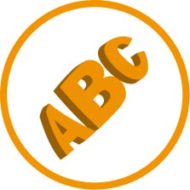
Activity 1 – Part 3
You can either:
- print this activity out and handwrite your answers or
- type directly into the document and print your answers.
Look at the following graphic images and write or type in the space below each image which element of design has been used.
Choose from:
• space • line • shape • texture • tone • colour • 3-D form.
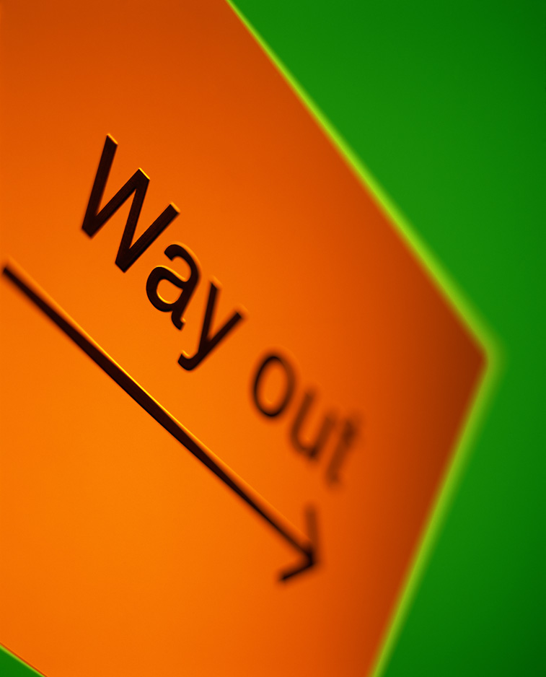 |  | 
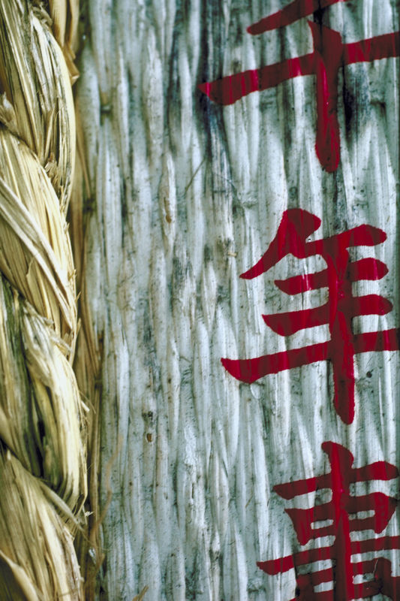 |  | 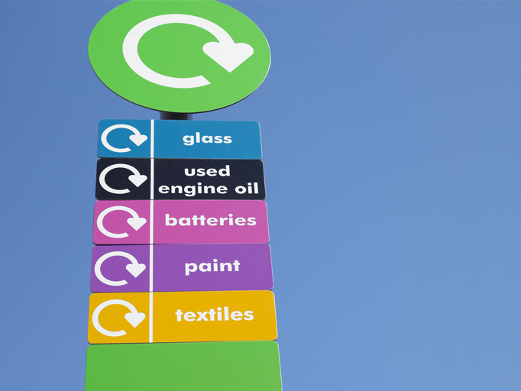

 |  | 