Layout
Layout is the term used to describe the arrangement of objects. A photographer may move objects around to create a perfect still-life picture. A painter may sketch lines on a canvas to compose their painting while a gardener may draw a plan before planting a garden. How the objects in each case are arranged (their layout) determines not only how good the final composition will look, but how easy it is to understand.
When using computers, we are either composing for a page that will be printed out or for a screen that people will read. Each of these compositions requires basic layout guidelines to be followed.
Before computers, newspaper publishing was performed with scissors, paper and glue. Layout artists cut and pasted typed stories and printed pictures onto newspaper pages manually. These pages were then photographed and transferred to metal sheets and loaded onto a printing press.
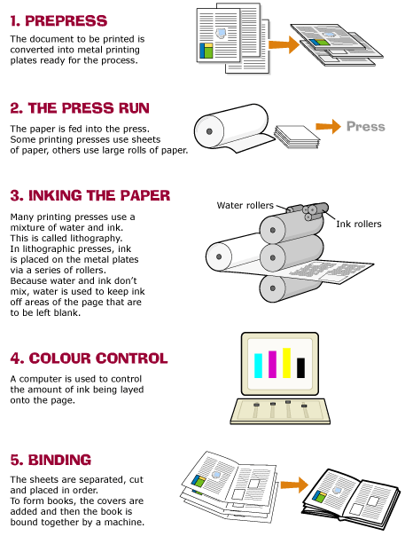

With the introduction of computers and the invention of page layout software, the desktop publisher was born. Desktop publishing is the process of using a computer, especially a personal computer, to produce fully designed printer-ready pages for the printing press. Desktop publishing allows anyone with basic computer skills to design, create and produce documents.

Layout Conventions
A convention is a general rule, method, or practice established by general consent or usage. A convention means that people have an expectation of how a printed or online page should look. Layout conventions help people concentrate on the content. When the presentation is familiar it doesn’t require extra effort to understand.
Basic layout conventions change according to culture and situation. In western culture, reading from left to right is the norm, in middle-eastern cultures it is the reverse.
In western cultures some basic conventions are used. These include:
• that reading occurs from the top left to the bottom right of a page
• that things at the top are considered to be more important than things at the bottom
• that the larger an object is the more important it must be
• that one space is added after a full stop
• that underlining is used for web/email addresses and links.

Screen verses printed page
Most layout conventions were developed before computers were in use however many of them still apply to both printed and online pages. A variety of tools are available to assist us to produce easy to read pages in different formats.
Printed pages:
• use of headings at the top of the page
• placing large amounts of text into columns
• selecting easy to read fonts styles and sizes.

Screen and web pages
• use of colour to highlight important objects
• placing pictures and text into tables
• using a grid to plan the position of objects on screen
• selecting fonts that display clearly on screen.

Using grids
The use of grids is universal in publishing, both online and printed pages. Grids are the simplest tools to use when planning a composition. A grid is a collection of horizontal and vertical lines designed to give fixed points of reference. These reference points can then be used to anchor objects onto a screen or page. Grids are great for positioning headlines, text, pictures and numbers. A grid will help balance a design or layout before the individual objects are put into position.

Using tables and columns
Tables can be used to position objects adjacent to each other and group similar objects together. Depending on the type of table used, it can also have the effect of placing a border around objects. A table in a webpage commonly includes a picture in one column and corresponding text in another. Tables provide a frame to help the viewer read the information.
Columns are used for large amounts of text and to restrict the length of the lines on a page. By dividing the page into columns, line length is reduced making it easier to read. It doesn’t matter how wide or tall the columns are and they don’t even have to be the same. Using columns to organise text also makes it easier to place images. It is possible to uses a combination of columns and images to squeeze more information onto the page. A combination can also improve the appearance of a page. Newspapers use this technique to break the page up into separate stories without the need for lines.
