Page layout
Page layout describes the position of text and graphics on the page. Good page layout uses some basic conventions which you have already investigated. It also uses basic principles to enhance a page’s appearance. The position of text, headings, pictures and graphics should attract attention and aid the reader to view the information presented.
During your studies you may have or may be required to write reports, design posters, create webpages and produce presentations. Anywhere there is a need for written information, these rules can be applied. However, effective layout is dependant on the subject matter and this will often determine which rules should be used.
A page can be described from two perspectives:
• form and
• function.

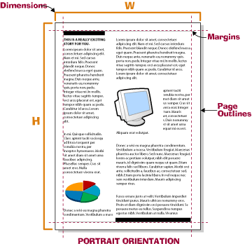 | The form of a page describes its appearance, how big the page is, its orientation (landscape or portrait), the size of the margins and the use of borders.

The function of a page describes the message it is attempting to deliver to the reader. The purpose of the page should be obvious to the reader and the information on it clear to understand.
Good page layout combines both form and function effectively. Let’s consider a poster for a concert. The function of the page is to deliver key information in an eye-catching way. Large letters, short sentences and big, colourful images are needed to get the message across. In this case the function determines the form. The size of the poster must be large enough to allow for large, wide-spaced letters that are easy to read at a distance. A postcard size poster is not going to deliver the message as effectively.
When you use a computer to create a poster, you can’t increase the screen size to the size of the actual poster. This is where using the rules of page layout become important. A well-designed and balanced page can be scaled up or down to suit its function.

Reading gravity
We need to understand how a reader’s eye behaves when presented with a page to read. When looking at a page, we tend to look at the top left hand corner first. This position is called the Primary Optical Area. Our eyes then travel down the page scanning from left to right before our eyes arrive at the bottom, right hand corner of the page. This position is called the Terminal Anchor. It’s the place that our eye stops on after all of the information has been read.
This principle is called Reading Gravity. It is the way our eyes fall from the top of the page to the bottom while scanning from side to side.
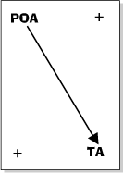

Look at the diagram above. It clearly shows the reading gravity of a page. Notice the inclusion of the + signs. These indicate areas of least interest. These areas are where charts, pictures and diagrams should be placed. Using these areas of least importance for things other than text ensures that a viewer’s reading gravity is not interrupted.

Black to white ratio
The Black to White ratio is a principle that compares the amount of text, graphics and pictures on a page (the black space) to the amount of unused space (white space). As a rule of thumb 60% of the page should be text and graphics (black space). If a page looks too black, you can increase the leading of the text or select a lighter typeface or font.

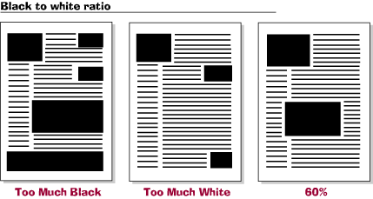

Kerning is the name for the space between the letters. The kerning can be adjusted in most word or design software packages.

KERNING

KERNING

KERNING

Typeface Bold
Typeface Normal
Typeface Italics

Using headlines and titles
The position of headlines and titles is an important principle in maintaining the readability of a page. Headlines and titles are designed to attract attention, stand out and be understood. The use of a heading should describe the text and at the same time ‘sell’ it to the reader. Typically they should attract a reader’s attention at the beginning of the story and not disturb the reading gravity.

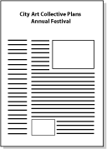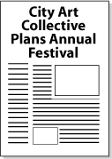

Pull Quotes
Pull Quotes are sections of text copied from the main text and placed elsewhere on the page and then highlighted. Pull Quotes highlight key points. If a reader is skimming an article they should read a pull quote. An effective pull quote makes the reader want to read the story.

