Reviewing sites
Now you are armed with information on basic design guidelines and structures for good webpages, you need to make a list of sites you think use these structures well.
1. Try to find one good website for each of the following:
• Tables
• Frames
• Layers
• Anchors
• Rollovers

You will need to identify which of the techniques the site has used to lay out the information on the page, and why this is helpful to its design.
Go back to Lesson 4 and use the Internet Resource Sheet to record your sites and information.
2. Navigation is the structure used to lay out and link between the pages of a website. Have a look at the navigation map for the SIDE website which follows.

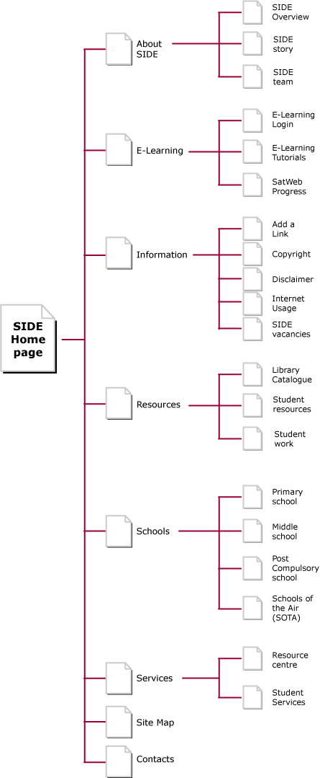
Select one of the websites that you have chosen above and create a navigation map showing all of the pages within the site and how they are linked.

Save your work as (your initials)_sites into your Week 9 Portfolio.
Send me a copy at the end of the week.

