Website design
We have all stumbled across sites on Internet with fantastic graphics, nifty animations and interactive menus that make you want to explore every page on the site. These sites are the result of careful and deliberate planning. The appearance and style of the site reflects a clear image of the company or business that the site is supporting. What is it that makes these sites so appealing? How can you design a website that makes people come back time and time again?
The challenges to website design are really two fold. On one hand you have the responsibility of delivering a message through your design. If the website is for just for you, understanding what you want the website to do is easy. If however you are creating the design for a company or business, things become a little trickier. To design a website for a traditional business requires you to look at how the business operates and listen to the needs of the owner and customers. You then have to work out how to get people to visit the site, find the information they need and return to the site again and again.
Once you have people at the site, what is going to keep them there? How do you let visitors know what is important? These questions can all be answered by following some basic webpage design guidelines.

Navigation  Navigation is the term used to describe how a user can move through a website. Navigation is made possible via tools. These tools can be buttons, hyperlinks and icons. More complex sites include a search function as a navigation tool.  Buttons are familiar tools to all of us: we understand that when we push a button an action occurs, therefore buttons are good tools for navigating most websites. | 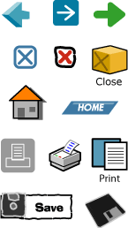
Hyperlink is a term given a piece of text or an image in a webpage which is connected to another webpage. Hyperlinks can also link to another place in the same webpage. A universal design convention for hyperlinking text is that it always appears blue and underlined.
Icons are pictures that represent meaning. An example of an icon is the picture of the house used in your web browser which represents the browser’s home page. Other icons include the pictures of a printer, file or folder on your desktop. Icons can replace text and make it easy for anyone to navigate a site. However, some icons can be confusing because they can have more than one meaning. For example: the icon for search is often a magnifying glass, but a magnifying glass can also be used to mean zooming in or out on an image.

Site Structure
Site structure means how the pages of a site are created and displayed. Structure often affects navigation, and both of these affect where and how information is displayed on the screen. To understand site structure, first you need to understand the terms sequential and hierarchy.
In websites, sequential means that each page is access in a fixed order, much like storytelling. Sequential websites guide the user through the pages in a fixed order.

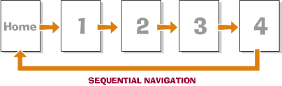

Hierarchy means placing things in order according to importance. The most important page in a website is the Home Page, therefore it is the first page of the site, and all other pages are placed behind this page. The home page organises all other the pages in the website. Think of a website as a pyramid, with the home page at the top. Beneath this page might be three more pages and beneath each of these pages, there may be others.
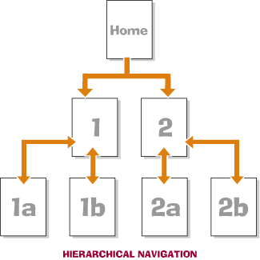

Page layout
Webpage layout, while it looks similar to a page from a book, can include animations, sounds and interactive buttons. Webpage layout design objects like tables, layers, named anchor, frame and rollovers improve the way information can be read from the page.
Tables are used to position text, pictures and graphics in a simple, easy to read format. Using tables on a website is similar to using columns in a newspaper. Each row contains a new line and each line is the same length.

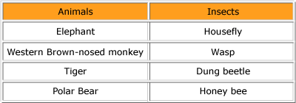

Layers are like transparent plastic sheets that lie over the page. Each sheet can have pictures, graphics or text on them. Using layers allows the webpage to have images and text piled up on top of each other. If layers were used in a magazine it would create a jumbled mess of colours and shapes, but because the web is dynamic and can include animations, layers have many uses. An image placed on one layer can be made to move around on a page, fade in or out, appear and disappear. Because layers are dynamic and not fixed in position on a page, they allow lots of information that would not normally fit to be presented on the same screen.
Named anchor is a unique term used in websites. It is both a navigation and layout aid. A named anchor is placed within a webpage to break pages into sections. Webpages that include lots of text and images often have information running off the bottom of the screen. When information runs off the screen, a scroll bar appears to allow the user to scroll through the information. It is not good web design to have too much scrolling as users become frustrated. Using named anchors splits a long page into little jumps. These jumps are presented at the top of the page and when clicked on, jump to an anchor point within the page.
The words ‘Back to Top’ are often used to return the user to the top of the page. Jumping down the page and back is quicker and easier than constant scrolling.
Frames are used in websites to divide the screen into sections. Each frame is actually is a separate webpage. A Frameset is a web term for the group of frames within a website. Think of a frameset like a special type of book. This book has the cover, contents page and story all presented in sections on the same page.
Using frames in websites can make it easy for a user to navigate the site but can be very confusing for the developer. Each frame is really another webpage and these pages need to be linked carefully together. Websites that use frames are often tricky to print out as each frame prints out separately.

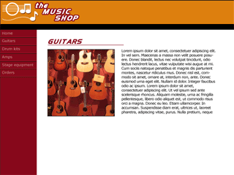

Rollovers are buttons or graphics specially designed to alert the user to an interactive element. Interactive elements are objects on screen, like buttons that allow the user some form of control. This control could be jumping to a different page, playing a music file or using a drop down menu.
Buttons are the most common form of rollover used. They usually change size or colour when the mouse hovers over them. The change is designed to inform the user that there is a function built into this webpage and that they can control this function.

